IT Programming
Year 2025 - 2026
Panasiuk, Jesse
NSCC V0.0.10
Contents
Introduction to Class Notes 14
PROG1700 Logic and Programming 15
Python 15
Variables 15
If Statements 15
While Loops 16
Functions 17
Lists 20
NETW1027 Introduction to Networking and Security 20
Network Components 20
Host Rules 20
Peer-to-peer 21
End Devices 22
Intermediary Devices 23
Network Media 24
Network Representations and Topologies 25
Network Representations 25
Topology Diagrams 27
Common Types of Networks 28
Networks of Many Sizes 28
LANs and WANs 29
The Internet 32
Intranet and Extranets 33
Internet Connections 34
Internet Access Technologies 34
Home and Small Office Internet Connections 34
Business Internet Connections 36
The Converging Network 37
Reliable Networks 38
Network Architecture 38
Fault Tolerance 39
Scalability 39
Quality of Service 40
Network Security 41
Network Trends 42
Recent Trends 42
Bring Your Own Device (BYOD) 43
Online Collaboration 43
Video Communications 43
Cloud Computing 44
Technology Trends in the Home 45
Powerline Networking 45
Wireless Broadband 46
Network Security 47
Security Threats 47
Security Solutions 48
Basic Switch and End Device Configuration 49
Cisco IOS Access 49
Operating Systems 49
GUI 49
Purpose of an OS 50
Access Methods 50
Terminal Emulation Program 51
IOS Navigation 51
Primary Command Modes 51
Configuration Mode and Subconfiguration Modes 52
Navigation Between IOS Modes 53
Note About Syntax Checker Activities 54
The Command Structure 54
Basic IOS Command Structure 54
IOS Command Syntax Check 55
IOS Help Features 56
Hot Keys and Shortcuts 56
Basic Device Configuration 57
Device Name 57
Password Guidelines 59
Configure Passwords 60
Encrypt Passwords 61
Banner Messages 62
Save Configurations 63
Configuration Files 63
Alter the Running Configuration 64
Capture Configuration to a Text File 64
Ports and Address 66
IP Addresses 66
Interfaces and Ports 68
Configure IP Addressing 70
Manual IP Address Configuration for End Devices 70
Automatic IP address Configuration for End Devices 71
Switch Virtual Interface Configuration 72
Protocols and Models 73
The Rules 73
Communications Fundamentals 73
Communication Protocols 73
Rule Establishment 73
Network Protocol Requirements 74
Message Encoding 74
Message Formatting and Encapsulation 75
Message Size 75
Message Timing 76
Message Delivery Options 76
Protocols 77
Network Protocols Overview 77
Network Protocol Functions 77
Protocol Interaction 78
Protocol Suites 79
Network Protocol Suites 79
Evolution of Protocol Suites 80
TCP/IP Protocol Example 81
TCP/IP Protocol Suite 82
Standard Organizations 85
Open Standards 85
Internet Standards 86
Electronic And Communications Standards 87
Reference Model 87
The Benefits of Using a Layered Model 87
The OSI Reference Model 88
The TCP/IP Protocol Model 89
OSI and TCP/IP Comparison 90
Data Encapsulation 91
Segmenting Messages 91
Sequencing 91
Protocol Data Unites 92
Encapsulation Example 93
De-encapsulation Example 93
Data Access 93
Addresses 93
Layer 3 Logical Address 93
Devices on the Same Network 94
Role of the Data Link Layer Adress – Same IP Network 95
Role of the Network Layer Addresses 96
Role of the Data Link Layer Addresses – Different IP Networks 97
Data Link Addresses 98
Purpose of the Physical Layer 100
The Physical Connection 100
The Physical Layer 102
Physical Layer Characteristics 102
Physical Layer Standards 102
Physical Components 103
Encoding 103
Signaling 104
Encoding 104
Bandwidth Terminology 105
Copper Cabling 106
Characteristics of Copper Cabling 106
Types of Copper Cabling 108
Unshielded Twisted-pair (UTP) 108
Shielded Twisted-pair (STP) 109
Coaxial Cable 110
UTP Cabling 111
Properties of UTP Cabling 111
UTP Cabling Standards and Connectors 112
Straight-through and Crossover UTP 115
Fiber-Optic Cabling 116
Properties of Fiber-Optic Cabling 116
Types of Fiber Media 116
Fiber-Optic Cabling Usage 117
Fiber-Optic Connectors 118
Fiber Patch Cords 120
Fiber versus Copper 120
Wireless Media 121
Properties of Wireless Media 121
Types of Wireless Media 122
Wireless LAN 123
Binary Number Systems 123
Binary and IPv4 Addresses 123
Binary Positional Notation 125
Convert Binary to Decimal 127
Decimal to Binary Conversion 129
IPv4 Addresses 130
Hexadecimal Number Systems 132
Hexadecimal and IPv6 Addresses 132
Decimal to Hexadecimal Conversions 134
Hexadecimal to Decimal Conversions 134
Data Link Layer 134
Purpose of the Data Link Layer 134
Topologies 136
Half-duplex Communications 137
Full-duplex Communications 138
Controlled access 138
Data Link Frame 138
Frame Field 138
Layer 2 Addresses 139
Ethernet Switching 139
Ethernet Frames 139
Ethernet Encapsulation 139
Data Link Sublayers 141
MAC Sublayer 142
Ethernet Frame Fields 143
Ethernet MAC Address 144
MAC Address and Hexadecimal 144
Ethernet MAC Address 146
Frame Processing 147
Unicast MAC address 147
Broadcast MAC Address 148
Multicast MAC address 148
The MAC Address Table 150
Switch Fundamentals 150
Switch Learning and Forwarding 150
Filtering Frames 152
Switch Speeds and Forwarding 154
Frame Forwarding Methods on Cisco Switches 154
Cut-Through Switching 154
Memory Buffering on Switches 155
Duplex and Speed Settings 156
Auto-MDIX 157
Network Layer 158
Network Layer Characteristics 158
The Network Layer 158
IP Encapsulation 160
Characteristics of IP 161
Connectionless 161
Best Effort 162
Media Independent 163
IPv4 Packet 164
IPv4 Packet Header 164
IPv4 Packet Header Fields 165
IPv6 Packet 166
Limitations of IPv4 166
IPv6 Overview 167
IPv4 Packet Header Fields in the IPv6 Packet Header 167
IPv6 Packet Header 169
How a Host Routes 171
Host Forwarding Decision 171
Default Gateway 171
A Host Routes to the Default Gateway 172
Host Routing Tables 172
Introduction to Routing 173
Router Packet Forwarding Decision 173
IP Router Routing Table 175
Static Routing 176
Dynamic Routing 177
Introduction to an IPv4 Routing Table 179
Address Resolution 181
MAC and IP 181
Destination on Same Network 181
Destination on Remote Network 182
Address Resolution Protocol (ARP) 184
ARP Overview 184
ARP Functions 185
ARP Request 185
ARP Operation – ARP Reply 186
ARP Role in Remote Communications 186
Removing Entries from an ARP Tables 187
ARP Tables on Networking Devices 187
ARP Issues – ARP Broadcasts and ARP Spoofing 188
IPv6 Neighbor Discovery 189
IPv6 Neighbor Discovery Messages 189
IPv6 Neighbor Discovery – Address Resolution 190
Basic Router Configuration 191
Configure Initial Router Settings 191
Basic Router Configuration Steps 191
Basic Router Configuration Example 192
Configure Interfaces 194
Configure Router Interfaces 194
Configure Router Interfaces Example 194
Verify Interface Configuration 196
Configuration Verification Commands 196
Configure the Default Gateway 197
Default Gateway on a Host 197
Default Gateway on a Switch 199
OSYS1200 Introduction to Windows Administration 201
The Evolving Role of System Administrators in the Future of Computing 201
Introduction 201
The Impact of Cloud Computing 201
Automation and DevOps 201
Security and Risk Management 201
Emerging Technologies and Skill Requirements 201
Conclusion 202
Windows: Using System and Utilities 202
Settings Overview 202
Administrative Tools 202
Microsoft Management Console 203
Services 204
Command-Line Administration Tools 205
Installing and Configuring Apps 206
The Windows App Landscape 206
Managing Apps and Processes with Task Manager 206
Managing Startup Apps 206
Managing Disks and File System 206
Disk Technology 206
Disk Partition Styles 207
Disk Types 207
Disk Management Tools 208
Adding a New Drive 208
Configuring Storage Spaces Fault Tolerance 208
User Accounts, Passwords and Credentials and User Management 209
User Profiles 209
The Default Profile 210
Mandatory Profile 210
Roaming Profile 210
Public Profile 211
Managing Hardware Devices/Application Support 211
Application Environments 211
The Registry 211
Registry Structure: Registry Hives 212
Registry Editing Tools 212
DBAS1007 Data Fundamentals 213
Databases 213
ACID Properties 214
Best Practices 214
Normalization 215
Normal Forms 215
Normalization Steps 215
ERDs and ERMs 218
Entity Relationship Modeling (ERM) 219
Entity Relationship Diagrams (ERD) 220
Key Differences 220
Components 220
Chen Notation 220
Three Types of Data Models 221
Conceptual Data Model 221
Logical Data Model 221
Physical Data Model 221
SQL 222
SQL Statements & Execution 222
SQL DDL 222
Logical Data Model 223
WEBD1000 Website Development 223
Web Development History 223
Introduction to Web Development 223
The Birth of the Web (1989 – 1991) 223
The Rise of Web Browsers (1993 – 1995) 223
The Browser Wars and Standards (1995 – 1998) 224
The Dot-Com Boom and Bust (1997 – 2001) 224
The Modern Web (2002 – Present) 224
Introduction to Usability 224
Principles of Good Usability 225
Principle of Contrast 225
Applying Contrast Effectively 225
Principle of Repetition 225
Applying Repetition Effectively 226
Principle of Alignment 226
Applying Alignment Effectively 226
Principle of Proximity 226
Applying Proximity Effectively 226
What is Web Accessibility? 227
Importance of Accessibility 227
Understanding WCAG (Web Content Accessibility Guidelines) 227
Accessible Design Components: Perceivable Content 228
Accessible Design Components: Operable Interface 228
Accessible Design Components: Understandable Content 228
Accessible Design Components: Robust Content 228
Tools and Resources for Testing Accessibility 229
Planning and Designing Websites 229
Understanding Project Requirements 229
Gathering Project Requirements 229
Analyzing Content Requirements 230
Designing Based on Criteria 230
Translating Requirements into Design 230
Designing for Content First 231
Balancing Aesthetics and Functionality 231
Importance of Wireframes in Web Design 231
Wireframing Process 232
Key Components of a Wireframe 232
Tools for Wireframing 232
Creating Web Structure Diagram 233
Steps to Create a Web Structure Diagram 233
Best Practices or Wireframing and Structure Diagrams 233
HTML 234
Understanding HTML Tags an Attributes 234
Understanding URLS 234
Creating Hyperlinks with HTML 235
Absolute Vs. Relative URLS 235
Adding Images to Web Pages 235
Using Special Characters in HTML 235
Introduction to CSS (Cascading Style Sheets) 236
Responsive Web Design 236
What is Responsive Web Design? 236
Why Responsive Design is Important. 236
Introduction to Media Queries 237
What are Media Queries? 237
Creating Fluid Layouts 237
Using Media Queries for Responsive Design 238
Responsive Images and Media 239
Fluid Typography 240
Responsive Font Sizing 240
Practical Example: Building a Responsive Layout 240
Introduction to Flexbox 241
Creating Layout with Flexbox 242
Using Float for Layouts 242
Frameworks 242
Summaries 243
PROG1700 Logic and Programming 243
NETW1027 Introduction to Networking and Security 243
Networking Summary 1.0 243
Networking Summary 2.0 243
Networking Summary 3.0 244
Networking Summary 4.0 245
Number System Summary 245
Data Link Layer Summary 246
Ethernet Switching Summary 246
Network Layer Summary 250
Address Resolution Summary 251
Basic Router Configuration Summary 252
OSYS1200 Introduction to Windows Administration 253
DBAS1007 Data Fundamentals 253
WEBD1000 Website Development 253
Glossary 254
PROG1700 Logic and Programming 254
NETW1027 Introduction to Networking and Security 254
OSYS1200 Introduction to Windows Administration 254
DBAS1007 Data Fundamentals 254
WEBD1000 Website Development 254

Introduction to Class Notes

PROG1700 Logic and Programming

Python

Variables
Python, by convention uses snake_case when naming variables as opposed to camelCase.
Python does not require a “;” at the end of each line, unlike other languages (GML, C++, etc)
Variables are used to store information. When this variable is later called, whatever is stored within it, will be used in its place. Variables can take any name you give with (which the exception of some words used specifically for Python). Variables can be used to store Ints, floats, doubles, Booleans and even strings.
You can obtain the type of a variable by using “type(variable_name)” in a “print()” function.
You can also convert a variable by using “type(variable_name)”.
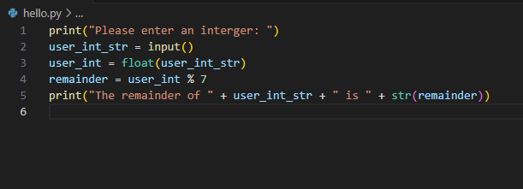

If Statements
If statements are used as a conditional branch to make programs more “interesting” and interactable by having different outcomes based on different variables.
The proper formatting for an if statement would be:
If variable_name (==, >, <, <= or >=) value:
Note: An if statement is checking to see “if something is true or false” and that the statements are always followed by “:”

If statements always check against a Boolean value (True or False) and can have different components to it. An elif (else if) statement may follow an if statement’s first condition, if another condition is to be checked. An else statement may follow an if statement’s first condition, or any subsequent elif statements if we want to have something happen, if the original condition, or any of the previous conditions, are not met.


If statements can also check multiple conditionals by using “and” and “or” in their conditonals.
Unlike C++, if statements in Python do not use “{ }” (curly braces) to contain their results. Instead, Python uses indentations.
i.e. if variable_name > 10 and variable_name < 25:
print(“See how it is indented? This means it is part of the if statement.”)

While Loops
While loops are similar to If statements, in that they perform a block of code based on a Boolean conditional. However, the difference is that while loops don’t have an elif or else component. Instead, when a while loop terminates, if the Boolean conditional is not met, the program will loop back to the beginning of the while loop.
In addition to satisfying the Boolean conditional, you can also use the “break” command. The “break” code will “break” you out of the loop, regardless of if the Boolean conditional of the while loop has been met.

Functions
Functions are like little mini blocks of code. They are good for separating chunks of code out of the “main body” of your script. They are also a great way to DRY (Don’t Repeat Yourself) your code, as anything that must be repeated, can be placed in its own function, so that you only need to call/invoke the function, rather than the entire block of code.
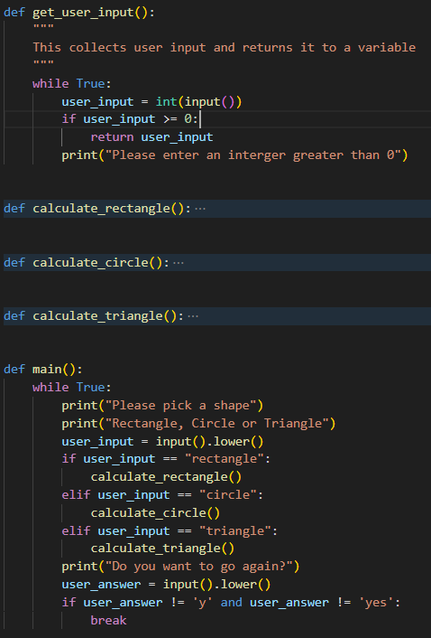

If you look at the above figure, the get_user_input() is responsible for getting our input from the user. Within it, it is asking the user to enter an integer and checking if it meets our requirements (being greater than 0). Now, if we need to ask the user for multiple integers, or if we need to ask for it, again, later down the road, we can simply invoke it by typing get_user_input() instead of re-typing out, everything that is within the function. What’s more, is if we later decide to modify the code to ask for the input an additional time, we just add that “get_user_input()” line.

When creating a function, we use the keyword “def” followed by <function name> an end it with “():”. The “()” is where we are going to pass in arguments, but we’ll discuss that later.
Just like If statements and while loops, everything indented below the “def <function name>()” is what will happen when we invoke the function.
Think of functions like elaborate variables:
If typing “x = 12” replaces x with 12 whenever you call x, then typing:
def call_this():
print(“This is a function”)
replaces “call_this()” with “print(“this is a function”) whenever you call, call_this().

Functions can be called by variables.
Consider the below:
def get_user_input():
print(“Please enter an integer”)
user_input = input()
return user_input

x = get_user_input()
See the “return user_input”? That is “returning” whatever value is in “user_input” when we exit the function. It is then being stored in the variable that invoked the function, which is x. So now, x = user_input.
Now, if you wanted to get another input, you could simply add “y = get_user_input()” beneath “x = get_user_input()

Functions can also be passed “arguments” or “parameters”.
Consider the below:
def add(x, y):
sum = x + y:
print(“The sum is “ + str(sum))

See how add has an “x” and a “y” value? Those are arguments that have been passed to it and will be used as part of it’s “function”. How do we pass them? By adding them to the “()” when we call it, like so:
add(4, 5)

This will call the function “add()” and pass it “4” and “5” as arguments. It will store 4 in x and 5 in y. When the function then goes through it’s code, it’s going to turn sum from “sum = x + y” into “sum = 4 + 5” and this, the print command will print “9”

So, how does this all come together?
Well, consider this:
def get_user_input():
print(“Please enter an integer:”)
user_input = input()
return user_input()

def add(a, b):
sum = a + b
return sum

x = get_user_input()
y = get_user_input()
z = add(x, y)
print(“The sum is “ + str(y))

Okay. So, lets break this down. First, we are defining “get_user_input()” and “add()”, just like we did previous examples. Then, in the main body of our code, we are declaring two variables, “x” and “y”. We are then using those variables to call “get_user_input” for each variable and storing the function’s return value into them. Imagine we entered 4 and 5. X will now equal 4 and Y will now equal 5.
Then we call add(a, b).
Now, this part is going to get confusing. The reason I used “a” and “b” when defining the function “add” is because I wanted to demonstrate that these can be anything. We can call them “Will” and “Gary”. Just because we are passing the values of “x” and “y” into add(a, b) doesn’t mean it has to use “x” and “y”. So, when we call add(), we call it with “add(x, y)” (“x” and “y” being the values we want to pass it) the function will then do “a = x” and “b = y” in the background.
So, when we call add(x, y) it will turn “x” and “y” into “a” and “b”, add the values together (4 and 5, respectively, in our imagination) and then return the value of “sum” and store it into “y”.
When we then get to “print(“The sum is “ +str(y))” it will print “The sum is 9”

Lists

NETW1027 Introduction to Networking and Security

Network Components

Host Rules
All computers that are connected to a network and participate, directly in network communication are classified as hosts. Hots can be called “end devices.” Some hosts are called “clients.” However, the term hosts specifically refer to devices on the network that are assigned a number for communication purposes. This number identifies the host within a particular network. This number is called the ”Internet Protocol (IP)” address. An IP address identifies the host and the network to which the host is attached.
Servers are computers with software that allow them to provide information, like email or web pages, to other end devices on the network. Each service requires separate server software. For example, a server requires web server software to provide web services to the network. A computer with server software can provide services simultaneously to many different clients.
As mentioned before, clients are a type of host. Clients have software for requesting and displaying the information obtained from the server, as shown in the figure.
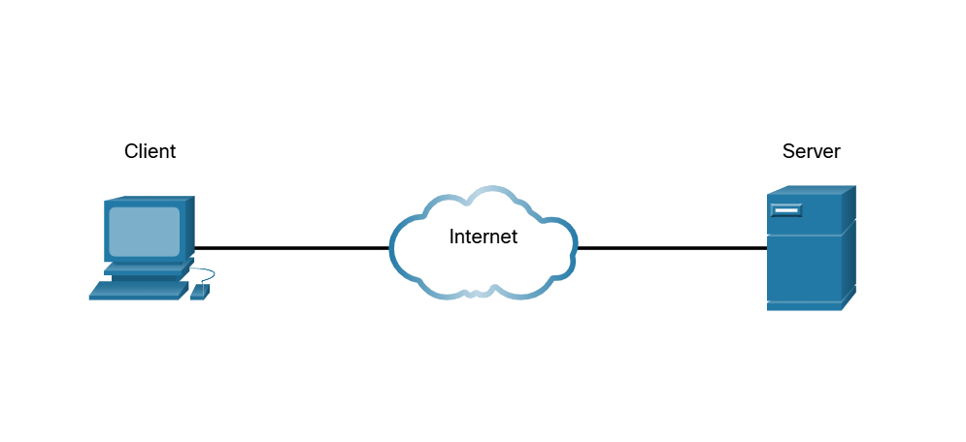
An example of client software is a web browser, like Chrome or Firefox. A single computer can also run multiple types of client software. For example, a user can check email and view a web page while instant messaging and listening to an audio stream. The table lists three common types of software.
Type | Description
Email | The email server runs email software. Clients use mail client software, such as Microsoft Outlook, to acces email on the server.
Web | The web server runs web server software. Clients use browser software, such as Windows Internet Explorer, to access web pages on the server.
File | The file server stores corporate and user files in a central locatin. The client devices access these files with client software such as the Windows File Explorer.

Peer-to-peer
Client and server software usually run on separate computers, but it is also possible for one computer to be used for both roles at the same time. In small businesses and homes, many computers function as the servers and clients on the network. This type of network is called a peer-to-peer network.
In the figure, the print sharing PC has a Universal Serial Bus (USB) connection to the printer and a network connection, using a network interface card (NIC), to the file share PC.
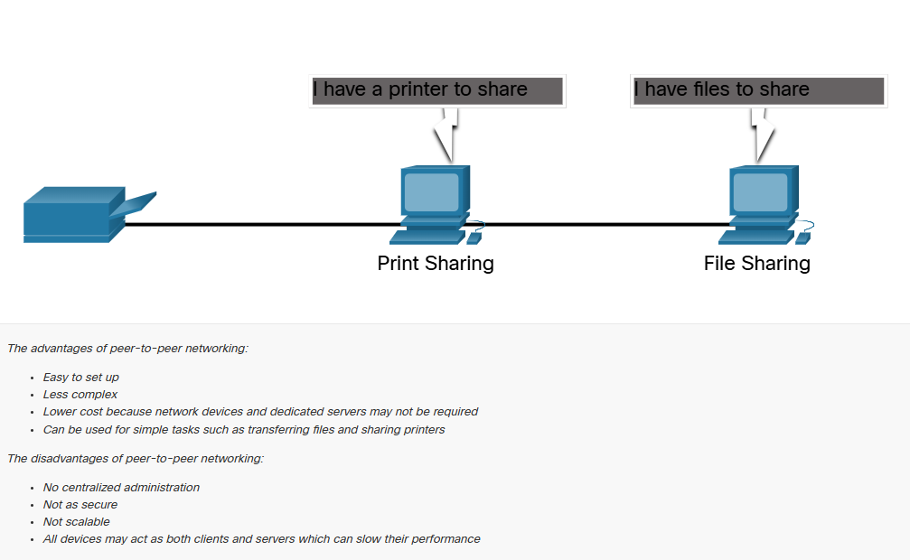

End Devices
The network devices that people are most familiar with are end devices. To distinguish one end device from another, each end device on a network has an address. When an end device initiates communication, it uses the address of the destination end device to specify where to deliver the message.
An end device is either the source or destination of a message transmitted over the network.
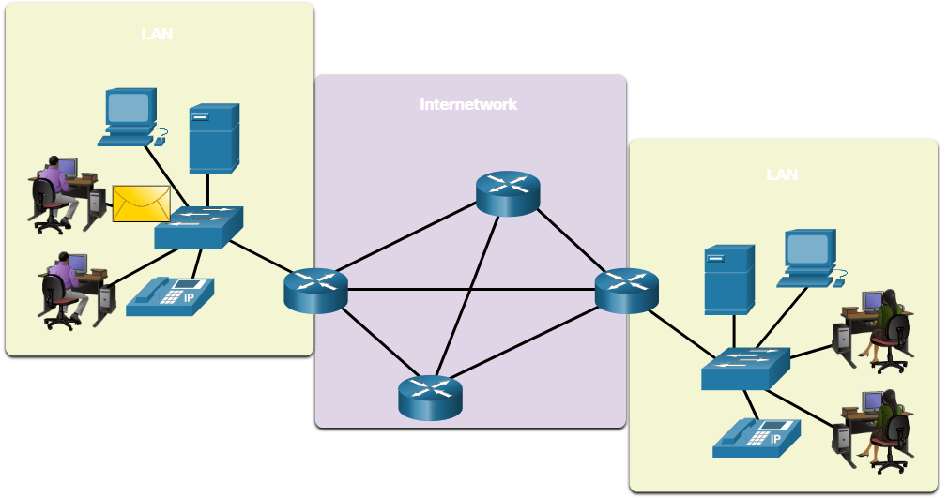

Intermediary Devices
Intermediary devices connect the individual end devices to the network. They can connect multiple individual networks to form an internetwork. These intermediary devices provide connectivity and ensure that data flow across the network.
Intermediary devices use the destination end device address, in conjunction with information about the network interconnections, to determine the path the messages should take through the network. Examples of the more common intermediary devices and a list of functions are shown in the figure.
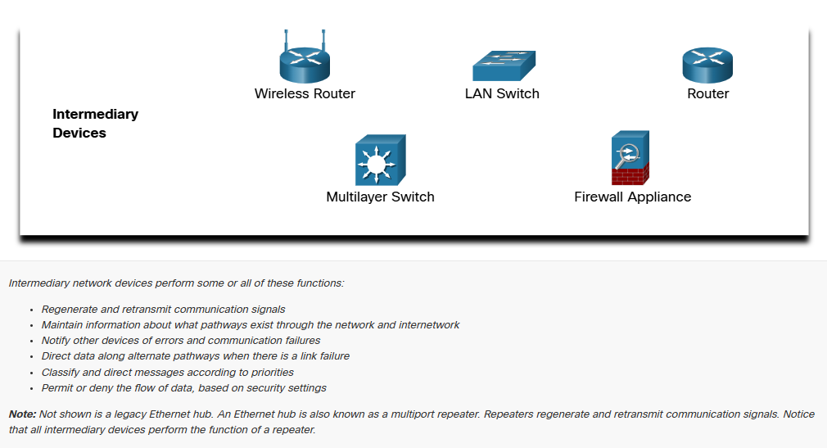
Intermediary network devices perform some or all of these functions:
- Regenerate and retransmit communication signals.
- Maintain information about what pathways exist through the network and internetwork
- Notify other devices of errors and communication failures.
- Direct data along alternate pathways when there is a link failure.
- Classify and direct messages according to priorities.
- Permit or deny the flow of data, based on security settings.
Note: Not shown above is a legacy ethernet hub. An ethernet hub is also known as a multiport repeater. Repeaters regenerate and retransmit communication signals. Notice that all intermediary devices perform the function of a repeater.

Network Media
Communication transmits across a network on media. The media provides the channel over which the message travels from source to destination.
Modern networks primarily use three types of media to interconnect devices, as shown in the figure:
- Metal wires within cables
  - Data is encoded into electrical impulses.
- Glass or plastic fibers within cables (fiber-optic cable)
  - Data is encoded into pulses of light.
- Wireless transmission
  - Bata is encoded via modulation of specific frequencies of electromagnetic waves.
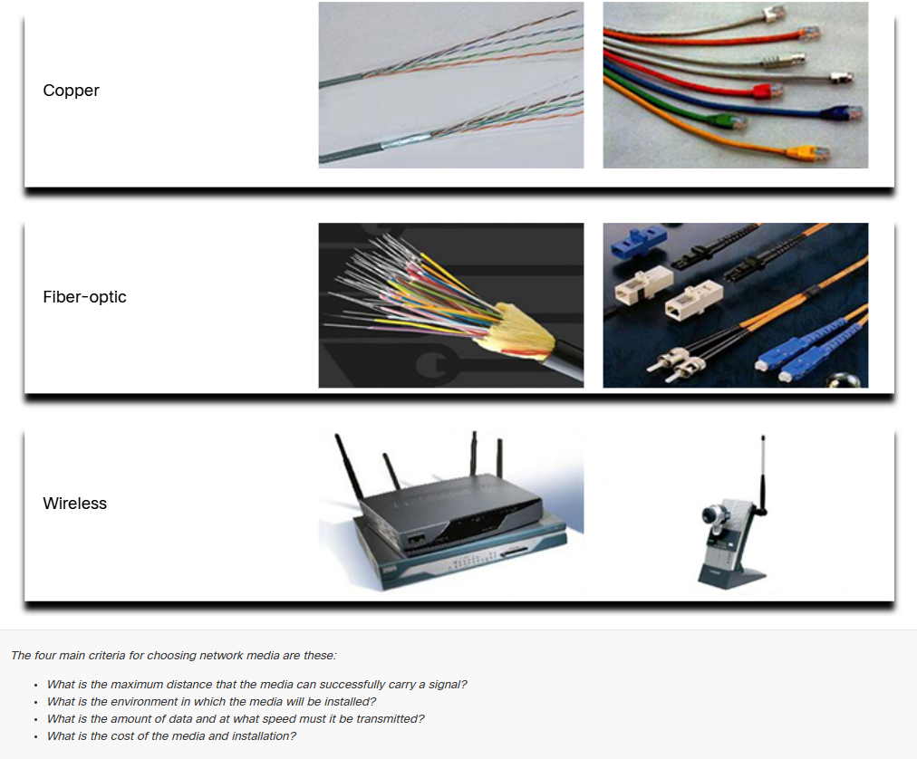
The four main criteria for choosing network media are these:
- What is the maximum distance that the media can successfully carry a signal?
- What is the environment in which the media will be installed?
- What is the amount of data and at what speed must it be transmitted?
- What is the cost of media and installation?

Network Representations and Topologies

Network Representations
Network architects an administrators must be able to show what their networks will look like They need to be able to easily see which components connect to other components, where they will be located, and how they will be connected. Diagrams of networks often use symbols, like those show in the figure, to represent the different devices and connections that make up a network.
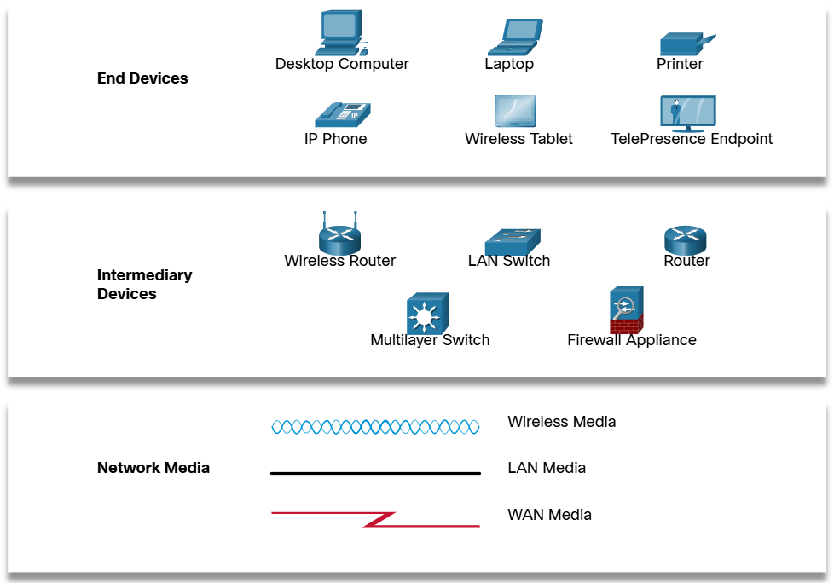

A diagram provides an easy way to understand how devices connect in a large network. This type of “picture” of a network is known as a topology diagram. The ability to recognize the logical representations of the physical networking components is critical to being able to visualize the organization and operation of a network.
In addition to these representations, specialized terminology is used to describe how each of these devices and media connect to each other:
- Network Interface Card (NIC)
  - A NIC physically connects the end device to the network.
- Physical Port
  - A connector or outlet on a networking device where the media connects to an end device on another networking device.
- Interface
  - Specialized ports on a networking device that connect to individual networks. Because routers connect networks, the ports on a router are referred to as network interfaces.
Note: The terms port ad interface are often used interchangeably.

Topology Diagrams
Topology diagrams are mandatory documentation for anyone working with a network. They provide a visual map of how the network is connected. There are two types of topology diagrams: physical and logical.
Physical Topology Diagrams
Physical topology diagrams illustrate the physical location of intermediary devices and cable installation, as shown in the figure. You can see that the rooms in which these devices are locate are labeled in this physical topology.
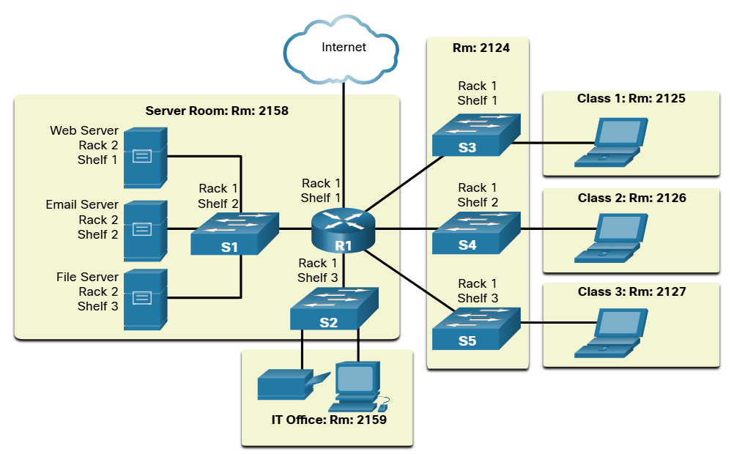
Logical Topology Diagrams
Logical topology diagrams illustrate devices, ports and the addressing scheme of the network, as shown in the figure. You can see which end devices are connected to which intermediary devices and what media is being used.
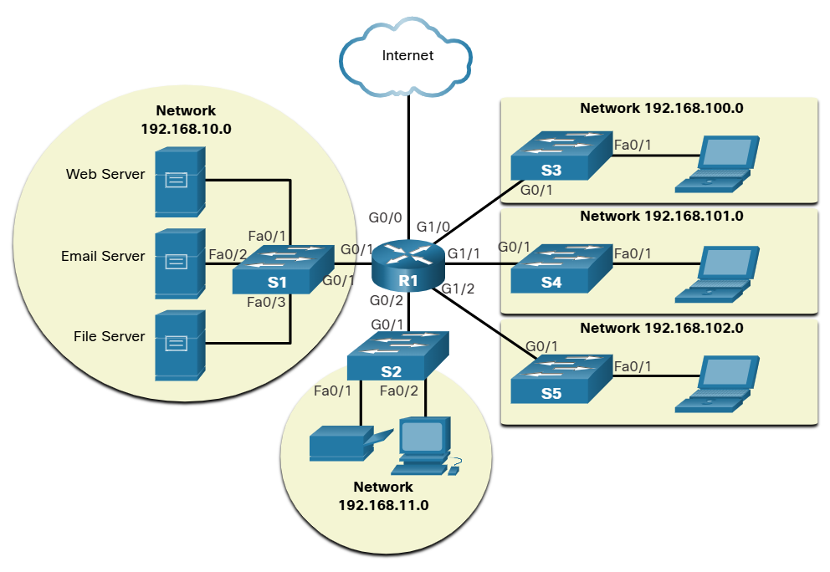

Common Types of Networks

Networks of Many Sizes
Now that you are familiar with the components that make up networks and their representations in physical and logical topologies, you are ready to learn about the many different types of networks.
Networks come in all sizes. They range from simple networks consisting of two computers, to networks connecting millions of devices.
Simple home networks let you share resources, such as printers, documents pictures, and music, among a few local end devices.
Small office and home office (SOHO) networks allow people to work from home, or a remote office. Many self-employed workers use these types of networks to advertise and sell products, order supplies, and communicate with customers.
Businesses and large organizations use networks to provide consolidation, storage, and access to information on network servers. Networks provide email, instant messaging, and collaboration among employees. Many organizations use their network’s connection to the internet to provide products and services to customers.
The internet is the largest network in existence. In fact, the term internet means a “network of networks”. It is a collection of interconnected private and public networks.
In small businesses and homes, many computers function as both servers and clients on the network. This type of network is called a peer-to-peer network.
Small Home Networks | Connect a few computers to each other and to the internet
Small Office and Home Office Networks | The SOHO network allows computers in a home office or a remote office to connect to a corporate network, or access centralized, shared resources.
Medium to Large Networks | Medium to large networks, such as those used by corporations and schools, can have many locations with hundreds or thousands of interconnected hosts.
World Wide Networks | The internet is a network of networks that connects hundreds of millions of computers world=wide.

LANs and WANs
Network infrastructures vary greatly in terms of:
  - Size of the area covered
  - Number of users connected
  - Number and types of service available
  - Area of responsibility

The two most common types of network infrastructures are Local Area Network (LANs) and Wide Area Networks(WANs).
A LAN is a network infrastructure the provides access to users and end devices in a small geographical area. A LAN is typically used in a department within an enterprise, a home or a small business network.
A WAN is a network infrastructure that provides access to other networks over a wide geographical area, which is typically owned and managed by a larger corporation or a telecommunications service provider. The figure shows LANs connected to WANs.
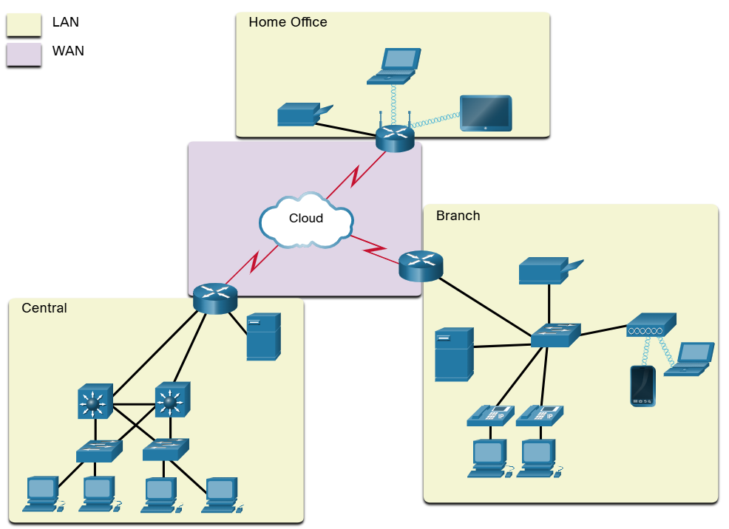

LANS
A LAN is a network infrastructure that spans a small geographical area. LANs have specific characteristics.
  - LANs interconnect end devices in a limited area such as a home, school, office building or campus.
  - A LAN is usually administered by a single organization or individual. Administrative control is enforced at the network level and governs the security and access control policies.
  - LANs provide high-speed bandwidth to internal end devices and intermediary devices, as shown in the figure.
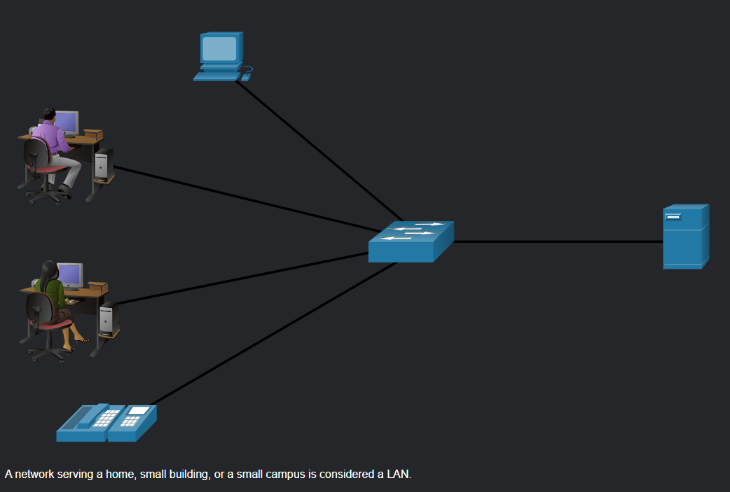
WANS
The figure shows a WAN which interconnects to LANs. A WAN is a network infrastructure that spans a wide geographical area. WANs are typically managed by a Service Provider (SPs) or Internet Service Provider (ISPs)

WANs have specific characteristics:
  - WANs interconnect LANs over wide geographical areas such as between cities, states, provinces, countries or continents.
  - WANs are usually administered by multiple service providers.
  - WANs typically provide lower speed links between LANs
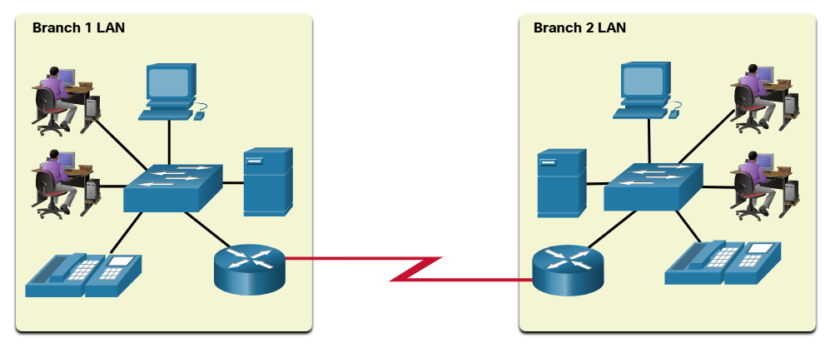

The Internet
The internet is a worldwide collection of interconnected networks (internetwork, or internet for short). The figure shows one way to view the internet as a collection of interconnected LANs and WANs.
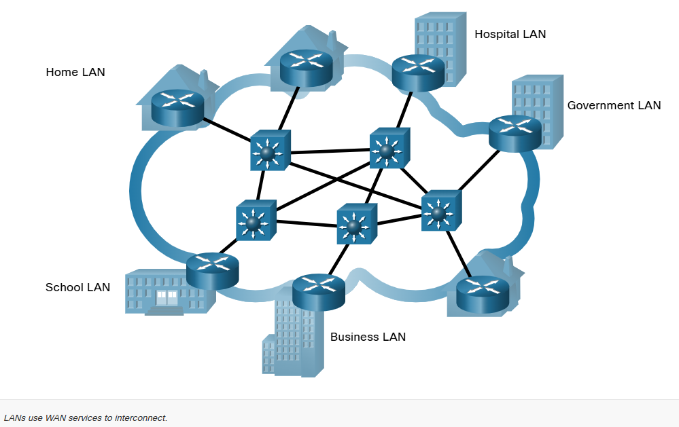
Some of the LAN examples are connected to each other through a WAN connection. WANs are then connected to each other. WANs can connect through copper wires, fiber-optic cables and wireless transmissions (not shown).
The internet is not owned by an individual or group. Ensuring effective communication across this diverse infrastructure requires the application of consistent and commonly recognized technologies and standards as well as the cooperation of many network administration agencies. There are organization that were developed to help maintain the structure and standardization of internet protocol and processes. These organizations include the Internet Engineering Task Force (ETF), Internet Corporation for Assigned Names and Numbers (ICANN), and the Internet Architecture Board (IAB) plus many others.

Intranet and Extranets
There are two other terms which are like the term internet: intranet and extranet.
Intranet is a term often use to refer to a private connection of LANs and WANs that belong to an organization. An intranet is designed to be accessible only to the organization’s members, employees, or others with authorization.
An organization may use an extranet to provide secure and safe access to individuals who work for a different organization but require access to the organization’s data. Here are some examples of extranets:
  - A company this is providing access to outside suppliers and contractors.
  - A hospital that is providing a booking system to doctors so they can make appointments for their patients.
  - A local office of education that is providing budget and personnel information to the schools in its district.
The figure illustrates the levels of access that different groups have to a company intranet, a company extranet, and the internet.
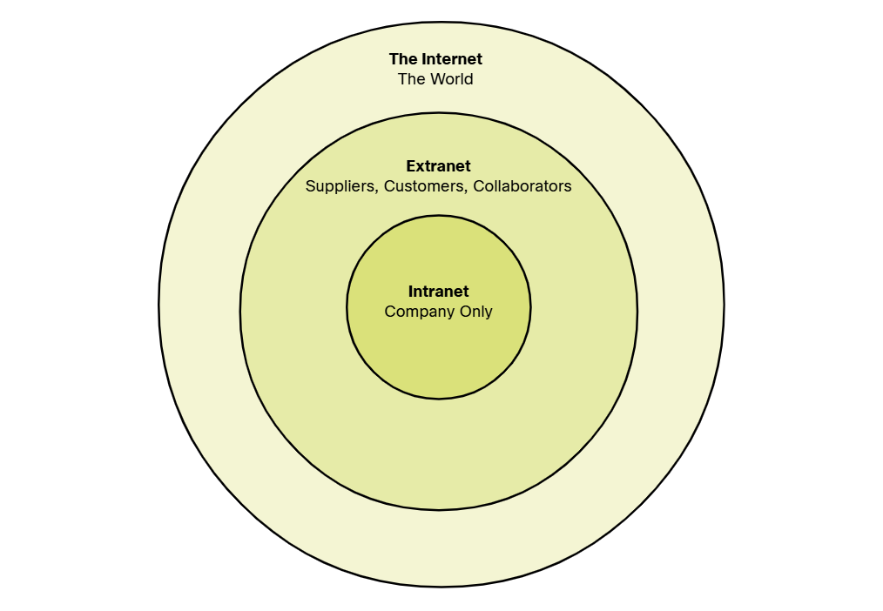

Internet Connections

Internet Access Technologies
So, now you have a basic understanding of what makes up a network and the different types of networks. But how do you actually connect users and organization to the internet? As you may have guessed, there are many different ways to do this.
Home users, remote workers and small offices typically require a connection to an ISP to access the internet. Connection options vary greatly between ISPs and geographical locations. However, popular choices include broadband cable, broadband digital subscriber line (DSL), wireless WANs, and mobile services.
Organizations usually need access to other corporate sites as well as the internet. Fast connections are required to support business services including IP phones, video conferencing and data center storage. SPs offer business-class connection. Popular business-class services include business DSL, leased lines, and Metro Ethernet.

Home and Small Office Internet Connections
The figure below illustrates common connection options for small office and home office user.
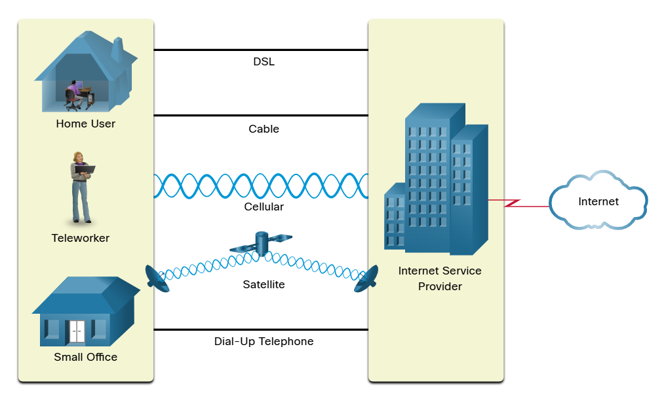
Cable – Typically offered by cable television service providers, the internet data signal transmits on the same cable that delivers cable television. It provides a high bandwidth, high availability and an always-o connection to the internet.
DSL – Digital Subscriber Lines also provide high bandwidth, high availability and an always-on connection to the internet. DSL runs over the telephone line. In general, small office and home office users connect using Asymmetrical DSL (ADSL) which means that the download speed is faster than the upload speed.
Cellular – Cellular internet access uses a cell phone network to connect. Wherever you can get a cellular signal, you can get cellular internet access. Performance is limited by the capabilities of the phone and the cell tower to which it is connected.
Satellite – The availability of satellite internet access is a benefit in those areas that would otherwise have no internet connectivity at all. Satellite dishes require a clear line of sight to the satellite.
Dial-up Telephone – An inexpensive option that uses any phone line and a modem. The low bandwidth provided by a dial-up modern connection is not sufficient for large data transfer, although it is useful for mobile access while traveling.

The choice of connection varies depending on geographical location and service provider availability.

Business Internet Connections
Corporate connection option differ from home user options. Businesses may require higher bandwidth, dedicated bandwidth and managed services. Connection options that are available differ depending on the type of service providers located nearby.
The figure below illustrates common connection options for businesses.
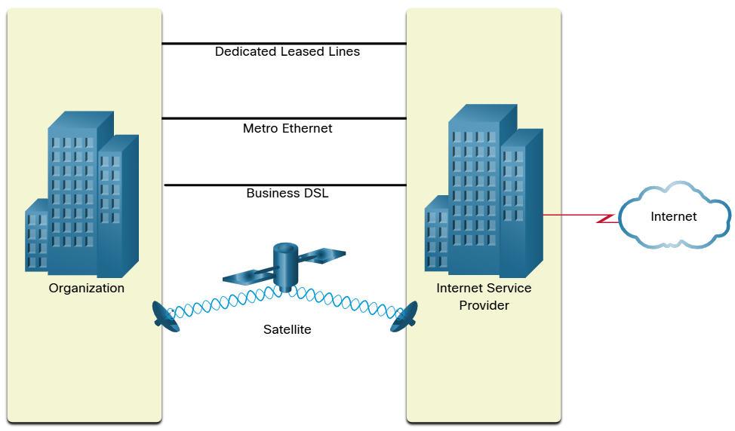

Dedicate Leased Line – Leased lines are reserved circuits within the service provider’s network that connect geographically separated offices for private voice and/or data networking. The circuits are rented at a monthly or yearly rate.
Metro Ethernet – This is sometimes known as Ethernet WAN. In this module, we will refer to it as Metro Ethernet. Metro ethernets extend LAN access technology into the WAN.
Business DSL – Business DSL is available in various formats. A popular choice is Symmetric Digital Subscriber Lines (SDSL) which is similar to the consumer version of DSL but provides uploads and downloads at the same high speeds.
Satellite – Satellite service can provide a connection when a wired solution is not available.

The choice of connection varies depending on geographical location and service provider availability.

The Converging Network

Traditional Separate Networks
Consider a school built thirty years ago Back then, some classrooms were cabled for the data network, telephone network and video network for televisions. These separate networks could not communicate with each other. Each network used different technologies to carry the communication signal. Each network had its own set of rules and standards to ensure successful communication. Multiple services ran on multiple networks.
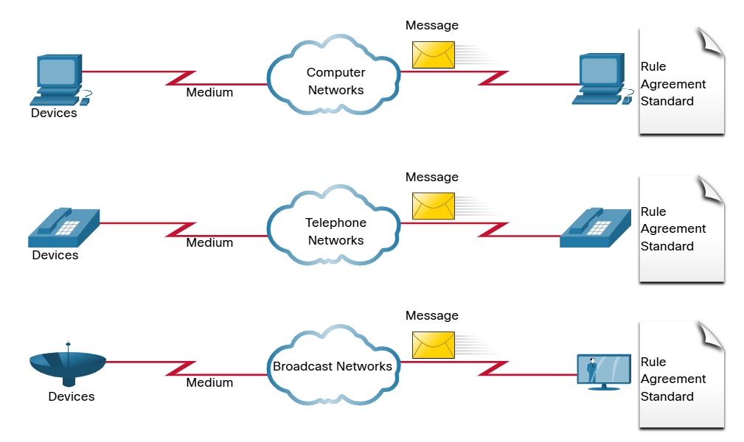
Converged Network
Toay, the separate data, telephone, and video networks converge. Unlike dedicated networks, converged networks are capable of delivering data, voice, and video between many different types of devices over the same network infrastructure. This network infrastructure uses the same set of rules, agreements and implementation standards. Converged data networks can carry multiple services on one network.
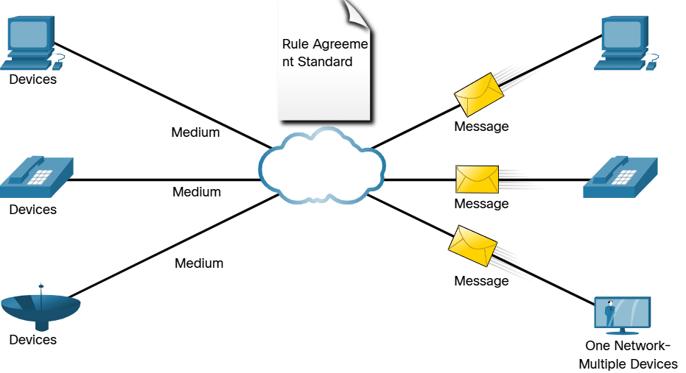

Reliable Networks

Network Architecture
Have you ever been busy working online, only to have “the internet go down”? as you know by now, the internet did not go down, you just lost your connection to it. It is very frustrating. With so many people in the world relying on network access to work and learn, it is imperative that networks are reliable. In this context, reliability means more than your connection to the internet. This topic focuses on the four aspects of network reliability.
The role of the network has changed from a data-only network to a system that enables the connections of people, devices, and information in a media-rich, converged network environment. For networks to function efficiently and grow in this type of environment, the network must be built upon a standard network architecture.
Networks also support a wide range of application and services. They must operate over many different types of cables and devices, which make up the physical infrastructure. The term network architecture, in this context, refers to the technologies that support the infrastructure and the programmed services an rules, or protocols, the move data across the network.
As networks evolve, we have learned that there are four basic characteristics that network architects must address to meet user expectations:
- Fault Tolerance
- Scalability
- Quality of Service (QoS)
- Security

Fault Tolerance
A fault tolerant network is one that limits the umber of affected devices during a failure. It is built to allow quick recovery when such a failure occurs. These networks depend on multiple paths between the source and destination of a message. If one path fails, the messages are instantly sent over a different link. Having multiple paths to a destination is known as redundancy.
Implementing a packet-switched network is one way that reliable networks provide redundancy. Packet switching splits traffic into packets that are routed over a shared network. A single message, such as an email or a video stream, is broken into multiple message blocks, called packets. Each packet has the necessary addressing information of the source and destination of the message. The routers within the network switch the packets based on the condition of the network at that moment. This means that all the packets in a single message could take very different paths to the same destination. In the figure, the user is unaware and unaffected by the router that is dynamically changing the route when a link fails.
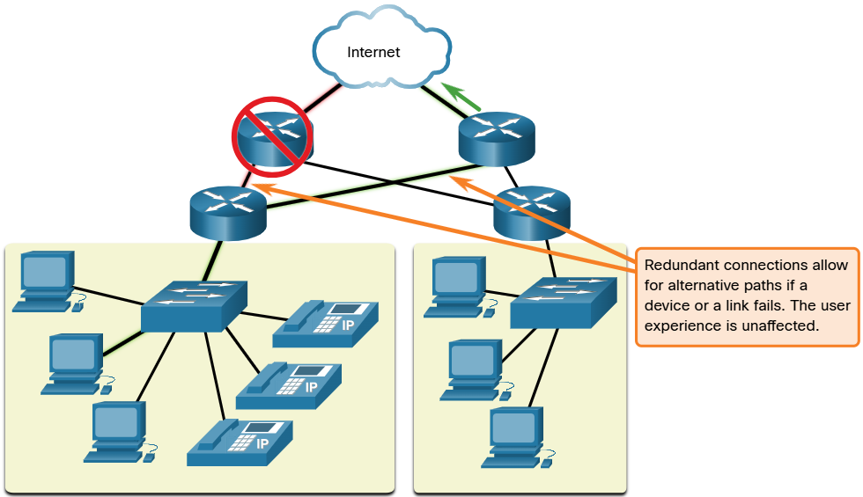

Scalability
A scalable network expands quickly to support new users and applications. It does this without degrading the performance of services that are being accessed by existing users. The figure shows how a new network is easily added to an existing network. These networks are scalable because the designers follow accepted standards and protocols. This let software and hardware vendor focus on improving products and services without having to design a new set of rules for operating within the network.
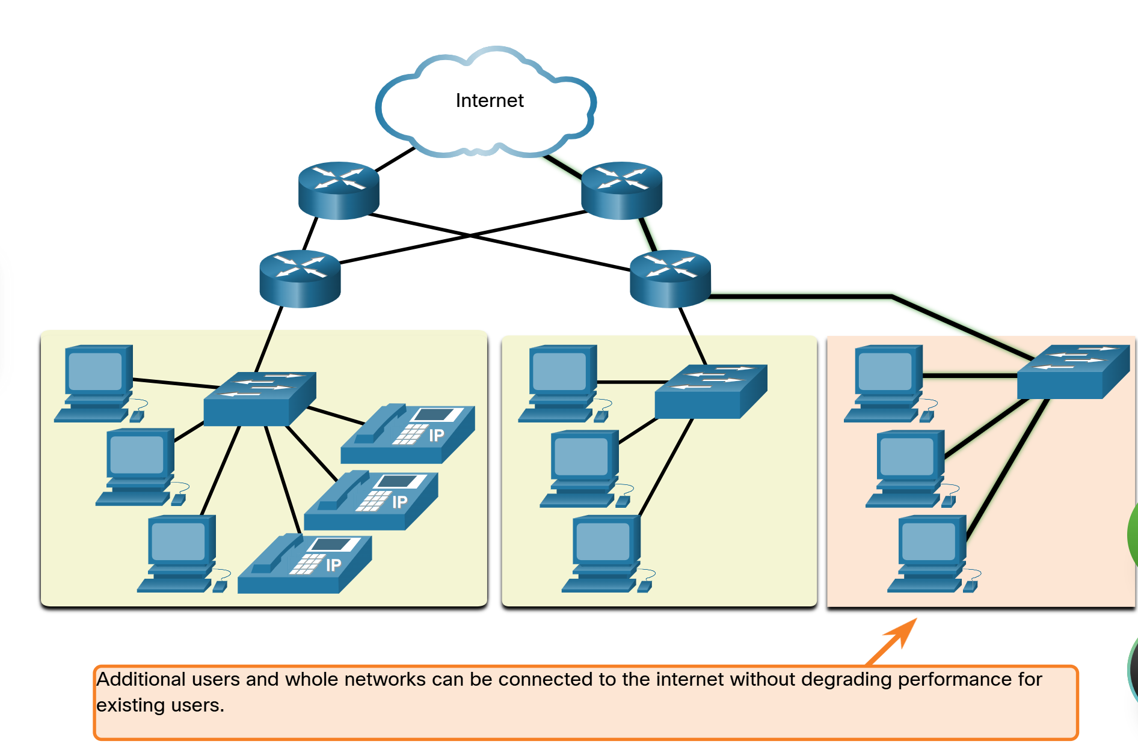

Quality of Service
Quality of Service (QoS) is an increasing requirement of networks today. New applications available to users over networks, such as voice and live video transmissions, create higher expectation for the quality of the delivered services. Have you ever tried to watch a video with constant breaks and pauses? As data, voice and video content continue to converge onto the same network, QoS becomes a primary mechanism for managing congestion and ensuring reliable delivery of content to all users.
Congestion occurs when the demand for bandwidth exceeds the amount available. Network bandwidth is measured in the umber of bits that can be transmitted in a single second, or bits per second (bps). When simultaneous communications are attempted across the network, the demand for network bandwidth can exceed its availability, creating network congestion
When the volume of traffic is greater than what can be transported across the network, devices will hold the packets in memory until resources become available to transmit them. In the figure, one user us requesting a web page, and another is on a phone call. With a QoS policy in place, the router can manage the flow of data and voice traffic, giving priority to voice communications if the network experiences congestion. The focus of QoS is to prioritize time-sensitive traffic. The type of traffic, not the content of traffic, is what is important.
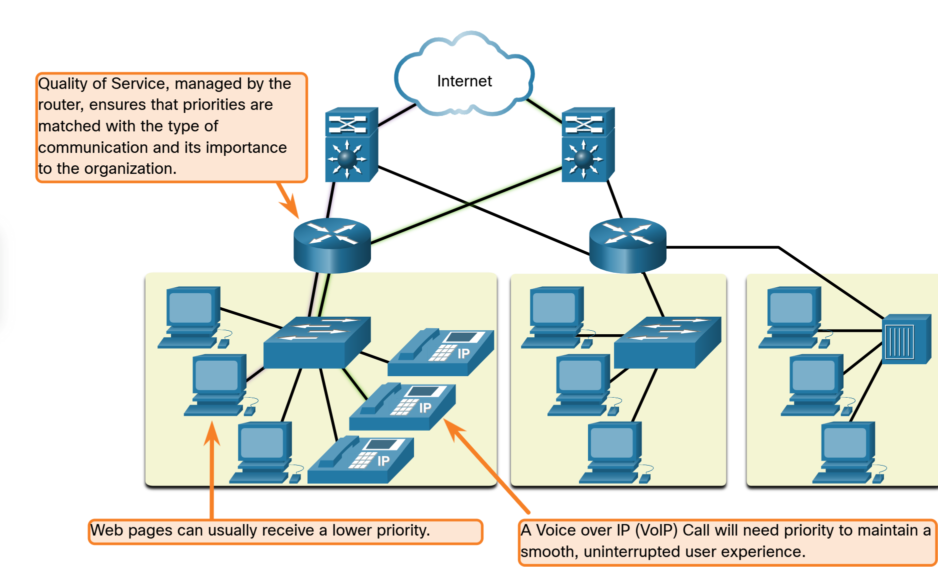

Network Security
The network infrastructure, service, and the data contained on network-attached devices are crucial personal and business assets. Network administrators must address two types of network security concerns: network infrastructure security and information security.
Securing the network infrastructure includes physically securing devices that provide network connectivity and preventing unauthorized access to the management software that resides on them, as shown in the figure.
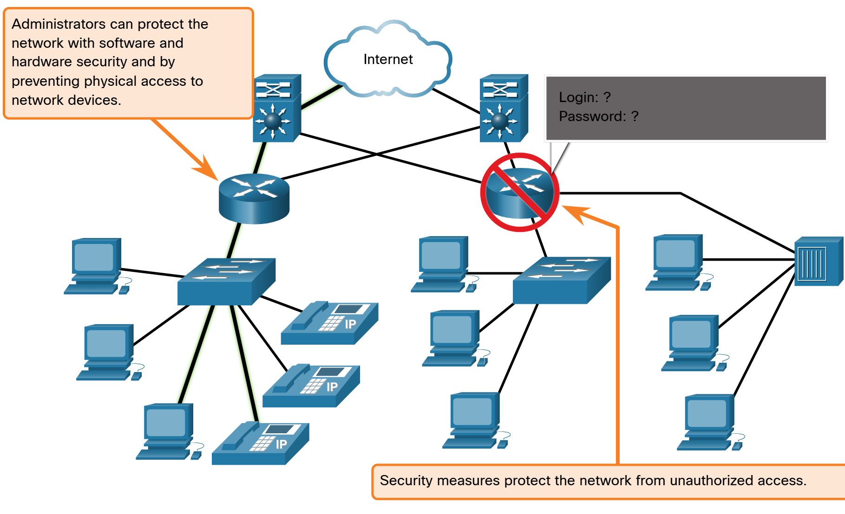

Network administrators must also protect the information contained within the packets being transmitted over the network, and the information stored on network attached devices. In order to achieve the goals of network security, here are three primary requirements.
  - Confidentiality – Data confidentiality means that only the intended and authorized recipients can access and read data
  - Integrity – Data integrity assures users that the information has not been altered in transmission, rom origin to destination.
  - Availability – Data availability assures users of timely and reliable access to data services for authorized users.

Network Trends

Recent Trends
You know a lot about networks now, what they are made of, how they connect us and what is needed to keep them reliable. But networks, like everything else, continue to change. There are a few trends in networking that you, as a NetAcad student, should know about.
As new technologies and end-user devices come to market, business and consumers must continue to adjust to this ever-changing environment. There are several networking trends that affect organizations and consumers:
- Bring Your Own Device (BYOD)
- Online collaboration
- Video Communications
- Cloud Computing

Bring Your Own Device (BYOD)
The concept of any device, for any content, in any manner, is a major global trend that requires significant changes to the way we use devices and safely connect them to networks. This is called Bring Your Own Device (BYOD).
BYOD enables end users with the freedom to use personal tools to access information and communicate across a business or campus network. With the growth of consumer devices, and the related drop in cost, employees and students may have advanced computing and networking devices for personal use. These include laptops, notebooks, tablets, smart phones and e-readers. These may be purchased by the company or school, purchased by the individual, or both.
BYOD mean any device, with any ownership, used anywhere.

Online Collaboration
Individuals want to connect to the network, not only for access to data applications, but also to collaborate with one another. Collaboration is defined as “the act of working with another or others on a join project.” Collaboration tools, like Cisco WebEx, give employees, students, teachers, customers and partners a way to instantly connect, interact and achieve their objectives.
Collaboration is a critical and strategic priority in education. Students need to collaborate to assist each other in learning, to develop the team skills used in the workforce, and to work together on team-based projects.
Cisco WebEx Teams is a multifunctional collaboration tool that lets you send instant messages to one or more people, post images, and post videos and links. Each team ‘space’ maintains a history of everything that is posted there.

Video Communications
Another facet of networking that is critical to the communication and collaboration effort is video. Video is used for communications, collaboration, and entertainment. Video calls are made to and from anyone with an internet connection, regardless of where they are located.
Video conferencing is a powerful tool for communicating with others, both locally and globally. Video is becoming a critical requirement for effective collaboration as organization extend across geographic and cultural boundaries.

Cloud Computing
Cloud computing is one of the ways that we access and store data. Cloud computing allows us to store personal files, even backup an entire drive on servers over the internet. Applications such as word processing and photo editing can be accessed using the cloud.
For businesses, Cloud computing extends the capabilities of IT without requiring investment in now infrastructure, training new personnel, or licensing new software. These services are available on-demand and delivered economically to any device that is anywhere in the world without compromising security or function.
Cloud computing is possible because of data centers. Data centers are facilities used to house computer systems and associated components. A data center can occupy one room of a building, one or more floors, or an entire warehouse-sized building. Data centers are typically very expensive to build and maintain. For this reason, only large organization use privately built data centers to house their data and provide services to users. Smaller organization that cannot afford to maintain their own private data center can reduce the overall cost of ownership by leasing server and storage services from a larger data center organization in the cloud.
For security, reliability, and fault tolerance, cloud providers often store data in distributed data centers. Instead of storing all the data of a person or organization in one data center, it is stored in multiple data enters in different locations.
There are four primary types of clouds: Public clouds, Private clouds, Hybrid clouds, and Community clouds.

Public clouds | Cloud-based applications and services offered in a public cloud are made available to the general population. Services may be free or are offered on a pay-per-use model, such as paying for online storage. The public cloud uses the internet to provide services.
Private clouds | Cloud-base application and services offered in a private cloud are intended for a specific organization or entity, such as a government. A private cloud can be set up using the organization’s private network, through this can be expensive to build and maintain. A private cloud can also be managed by an outside organization with strict access security.
Hybrid clouds | A hybrid cloud is made up of two or more clouds (example: part private, part public), where each part remains a distinct object, but both are connected using a single architecture. Individuals on a hybrid cloud would be able to have degrees of access to various services based on user access rights.
Community clouds | A community cloud is created for exclusive use by specific entities or organizations. The differences between public clouds and community clouds are the functional needs that have been customize for the community. Or example, healthcare organizations must remain compliant with policies and laws (e.g HIPAA) that require special authentication and confidentiality. Community clouds are use by multiple organizations that have similar needs and concerns. Community clouds are similar to a public cloud environment, but with set levels of security, privacy and even regulatory compliance of a private cloud.

Technology Trends in the Home
Networking trends are not only affecting the way we communicate at work and at school, but also changing many aspects of the home. The newest home trends include “smart home technology.”
Smart home technology integrates into every-day appliances, which can then connect with other devices to make the appliances more ‘smart’ or automated. For example, you could prepare food and place it in the over for cooking prior to leaving the house for the day. You program your smart over for the food you want it to cook. It would also be connected to your “calendar of events” so that it would determine what time you should be available to eat and adjust start times and length of cooking accordingly. It could even adjust cooking times and temperatures based on changes in schedule. Additionally, a smart phone or tablet connection lets you connect to the over directly, to make any desired adjustments. When the food is ready, the oven sends an alert message to you (or someone you specify) that the food is done and warming.
Smart home technology is currently being developed for all rooms with a house. Smart home technology will become more common as home networking and high-speed internet technology expands.

Powerline Networking
Powerline networking for home networks uses existing electrical wiring to connect devices, as shown in the figure.
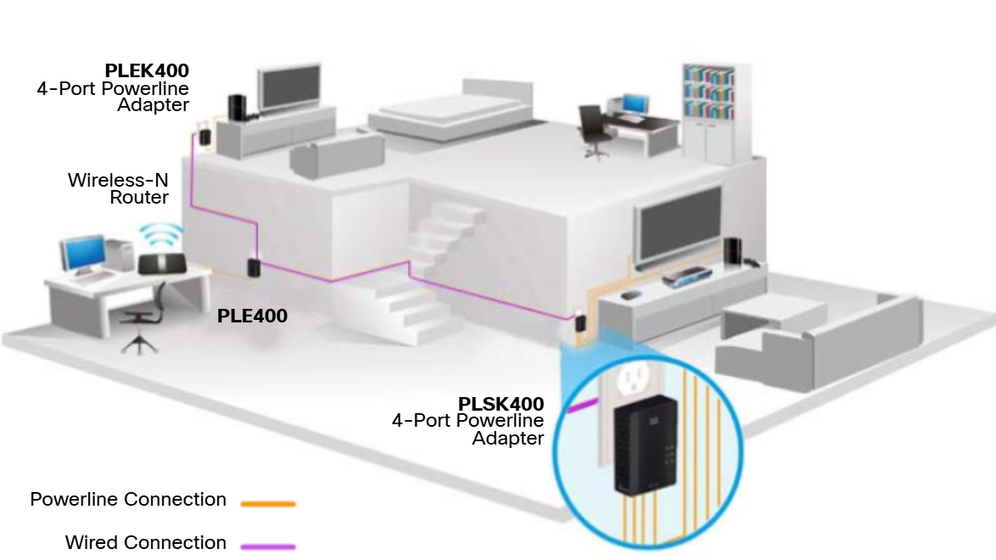
Using a standard powerline adaptor, devices can connect to the LAN wherever there is an electrical outlet. No data cables need to be installed, and there is little to no additional electricity used. Using the same wiring that delivers electricity, powerline networking sends information by sending data on certain frequencies.
Powerline networking is especially useful when wireless access points cannot reach all the devices in the home. Powerline networking is not a substitute for dedicate cabling in data networks. However, it is an alternative when data network cables or wireless communications are not possible or effective.

Wireless Broadband
In many areas where cable an DSL are not available, wireless may be used to connect to the internet.
Wireless Internet Service Provider
A Wireless Internet Service Provider (WISP) is an ISP that connects subscribers to a designated access point or hot spot using similar wireless technologies found in home wireless local area networks (WLANs). WISPs are more commonly found in rural environments where DSL or cable services are not available.
Although a separate transmission tower may be installed for the antenna, typically the antenna is attached to an existing elevated structure, such as a water tower or radio tower. A small dish or antenna is installed on the subscriber’s roof in range of the WISP transmitter. The subscriber’s access unit is connected to the wire network inside the home. From the perspective of the home user, the setup is not much different than DSL or cable service. The main difference is that the connection from the home to the ISP is wireless instead of a physical cable.
Wireless Broadband Service
This solution uses the same cellular technology as a smart phone. An antenna is installed outside the house providing either wireless or wired connectivity for devices in the home. In many areas, home wireless broadband is competing directly with DSL and cable services.

Network Security

Security Threats
You have, no doubt, heard or read news stories about a company network being breached, giving threat actors access to the personal information of thousands of customers. For this reason, network security is always going to be a top priority of administrators.
Network security is an integral part of computer networking, regardless of whether the network is in a home with a single connection to the internet or is a corporation with thousands of users. Network security must consider the environment, as well as the tools and requirements of the network. It must be able to secure data while allowing for the quality of service that users expect o the network.
Securing a network involves protocols, technologies, devices, tools and techniques in order to protect data and mitigate threats. Threat vectors may be external or internal. Many external network security threats today originate from the internet.
There are several common external threats to networks:
  - Viruses, worms, and Trojan horses – These contain malicious software or code running on a user device.
  - Spyware and adware – These are types of software which are installed on a user’s device. The software then secretly collects information about the user.
  - Zero-day attacks – Also called zero-hour attacks, these occur on the first day that a vulnerability become known.
  - Threat actor attacks – A malicious person attacks user devices or network resources.
  - Denial of server attacks – These attacks slow or crash applications and processes on a network device.
  - Data interception and theft – This attack captures private information from an organization’s network.
  - Identity theft – This attack steals the login credentials of a user in order to access private data.

It is equally important to consider internal threats. There have been many studies that show that the most common data breaches happen because of internal users of the network. This can be attributed to lost or stolen devices, accidental misuse by employees, and in the business environment, even malicious employees. With the evolving BYOD strategies, corporate data is much more vulnerable. Therefore, when developing a security policy, it is important to address both external and internal security threats.

Security Solutions
No single solution can protect the network from the variety of threats that exist. For this reason, security should be implemented in multiple layers, using more than one security solution. If one security component fails to identify and protect the network, other may succeed.
A home network security implementation is usually rather basic. Typically, you implement it on the end devices, as well as at the point of connection to the internet, and can even rly on contracted services from the ISP.
These are the basic security components for a home or small office network:
  - Antivirus and antispyware – Hese applications help to protect end devices from becoming infected with malicious software.
  - Firewall filtering - Firewall filtering blocks unauthorized access into and out of the network. This may include a host-based firewall system that prevents unauthorized access to the end device, or a basic filtering service on the home router to prevent unauthorized access from the outside world into the network.

In contrast, the network security implementation for a corporate network usually consists of many components built into the network to monitor and filter traffic. Ideally, al components work together, which minimized maintenance and improves security Larger networks and corporate networks use antivirus, antispyware, and firewall filtering, but they also have other security requirements:
  - Dedicated firewall systems – These provide more advanced firewall capabilities that can filter large amounts of traffic with more granularity.
  - Access control lists (ACL) - These further filter access and traffic forwarding based on IP addresses and application.
  - Intrusion prevention system (IPS) – These identify fast-spreading threats, such as zero-day or zero-hour attacks.
  - Virtual private networks (VPN) – These provide secure access into an organization for remote workers.
Network security requirements must consider the environment, as well as the various application and computing requirements. Both home and business environments must be able to secure their data while still allowing for the quality of service that users expect of each technology. Additionally, the security solution implemented must be adaptable to the growing and changing trends of the network.
The study of network security threats and mitigation techniques starts with a clear understanding of the underlying witching and routing infrastructure used to organize network services.

Basic Switch and End Device Configuration

Cisco IOS Access

Operating Systems
All end devices and network devices require an operating system (OS). The portion of the OS that interacts directly with the computer hardware is known as the kernel. The portion that interfaces with applications and the user is known as the shell. The user can interact with the shell using a command-line interface (CLI) or a graphical user interface (GUI).

- Shell - The user interface that allows users to request specific tasks from the computer. These requests can be made either through CLI or GUI interfaces.
- Kernal – Communicates between the hardware and software of a computer and manages how hardware resources are used to meet software requirements.
- Hardware – The physical part of a computer including underlying electronics.

When using a CLI, the user interacts directly with the system in a text-based environment by entering commands on the keyboard at a command prompt. The system executes the command, often provided textual output. The CLI requires very little overhead to operate. However, it does require that the user have knowledge of the underlying command structure that controls the system.

GUI
A GUI such as Windows, macOS, Linux KDE, Apple iOS, or Android allows the user to interact with the systems using an environment of graphical icons, menus and windows. The GUI is ore user-friendly and requires less knowledge of the underlying command structure that controls the system. For this reason, most users rely on GUI environments.
However, GUIs may not always be able to provide all the features available with the CLI. GUIs can also fail, crash or simply not operate as specified. For these reasons, network devices are typically accessed through CLI. The CLI is less resource intensive and very stable when compared to a GUI.
The family of network operating systems used on many Cisco devices is called the Cisco Internetwork Operating System (IOS). Cisco IOS is used on many Cisco routers and switches regardless of the type or size of the device. Each device router or switch type uses a different version of Cisco IOS. Other Cisco operating systems include IOS XE, IOS XR, and NX-OS.
Note: The operating system on home routers is usually called firmware. The most common method for configuring a home router is by using a web browser-based GUI.

Purpose of an OS
Network operating systems are similar to PC operating systems. Through GUI, a PC operating system enable a user to do the following:
- Use a mouse to make selections and run programs
- Enter text and text-based commands
- View output on a monitor
A CLI-based network operating system (e.g. the Cisco IOS on a switch or router) enables a network technician to do the following:
- Use a keyboard to run CLI-based network programs.
- Use a keyboard to enter text and text-based commands.
- View output on a monitor.

Cisco networking devices run particular versions of the Cisco IOS. The IOS version is dependent on the type of device being used and the required features. While all devices come with a default IOS and feature set, it is possible to upgrade the IOS version or feature set to obtain additional capabilities.

Access Methods
A switch will forward traffic by default and does not need to be explicitly configured to operate. For example, two configured hosts connected to the same new witch would be able to communicate.
Regardless of the default behaviour of a new switch, all switches should be configured and secured.

Console | This is a physical management port that provides out-of-band access to a Cisco device. Out-of-band access refers to access via a dedicated management channel that is use for device maintenance purposes only. The advantage of using a console port is that the device is accessible even if no networking services are configured, such as performing the initial configuration. A computer running terminal emulation software and a special console cable to connect to the device are required for a console connection.
Secure Shell (SSH) | SSH is an in-band and recommended method for remotely establishing a secure CLI connection, through a virtual interface, over a network. Unlike a console connection, SSH connections require active networking services on the device, including an active interface configured with an address. Most versions of Cisco IOS include an SSH server and an SSH client that can be used to establish SSH sessions with other devices.
Telnet | Telnet is an insecure, in-band method of remotely establishing a CLI session, through a virtual interface, over a network. Unlike SSH, Telnet does not provide a secure, encrypted connection and should only be use in a lab environment. User authentication, passwords and the commands are sent over the network in plaintext. The best practice is to use the SSH instead of Telnet. Cisco IOS include both a Telnet server and a Telnet client

Note: Some devices, such as routers, may also support a legacy auxiliary port that was used to establish a CLI session remotely over a telephone connection using a modern. Similar to a console connection, the AUX port is out-of-band and does not require networking services to be configured or available.

Terminal Emulation Program
There are several terminal emulation programs you can use to connect to a networking device either by a serial connection over a console port, or by an SSH/Telnet connection. These program allow you to enhance your productivity by adjusting window sizes, changing font sizes and changing color schemes.

IOS Navigation

Primary Command Modes
In the previous topic, you learned that all network devices require an OS and that they can be configured using the CLI or a GUI. Using the CLI may provide the network administrator with more precise control and flexibility than using the GUI. This topic discuses using CLI to navigate the Cisco IOS
As a security feature, the Cisco IOS software separates management access into the follow two command modes:
- User EXEC Mode – This mode has limited capabilities but is useful for basic operations. It allows only a limited number of basic monitoring commands but does not allow the execution of any commands that might change the configuration of the device. The user EXEC mode is identified by the CLI prompt that ends with the > symbol
- Privileged EXEC Mode – To execute configuration commands, a network administrator must access privileged EXEC mode. Higher configuration modes, like global configuration mode, can only be reached from privilege EXEC mode. The privileged EXEC mode can be identified by the prompt ending with the # symbol.
User ExXEC Mode | - Mode allows access to only a limited umber of basic monitoring commands  - It is often referred to as “view-only” mode. | Switch>  Router>
Privilege EXEC Mode | - Mode allows access to all commands and features.  - The user can use any monitoring commands and execute configuration and management commands. | Switch#  Router#

Configuration Mode and Subconfiguration Modes
To configure the device, the user must enter global configuration mode, which is commonly called global config mode.
From global config mode, CLI configuration changes are made that affect the operation of the device. Global configuration mode is identified by a prompt that ends with (config)# after the device name, such as Switch(config)#.
Global configuration mode is accessed before other specific configuration modes. From global config mode, the user can enter different subconfiguration modes. Each of these modes allows the configuration of a particular part of function of the IOS device. Two common subconfiguration modes include:
- Line Configuration Mode – Used to configure console, SSH, Telnet or AUX access.
- Interface Configuration Mode – Used to configure a switch port or router network interface.

When the CLI is used, the mode is identified by the command-line prompt that is unique to that mode. By default, every prompt begins with the device name. Following the name, the remainder of the prompt indicates the mode. For example, the default prompt for line configuration mode is Switch(config-line)# and the default prompt for interface configuration mode is Switch(config-if)#.

Navigation Between IOS Modes
Various commands are used to move in and out of command prompts. To move from user EXEC mode to privileged EXEC mode, use the enable command. Use the disable privileged EXEC mode command to return to user EXEC mode.
Note: Privilege EXEC mode is sometimes called enable mode.
To move in and out of global configuration mode, use the configure terminal privilege EXEC mode command. To return to the privileged EXEC mode, enter the exit global config mode command.
There are many different subconfiguration modes. For example, to enter line subconfiguration mode, you use the line command followed by the management line type and number you wish to access. Use the exit command to exit the subconfiguration mode and return to global configuration mode.
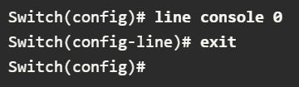
To move from any subconfiguration mode of the global configuration mode to the mode one step above it in the hierarchy of modes, enter the exit command.
To move from any subconfiguration mode to the privilege EXEC mode, enter the end command or enter the key combination Ctrl+Z.
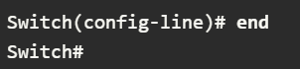
You can also move directly from one subconfiguration mode to another. Notice how after selecting an interface, the command prompt changes from (config-line)# to (config-if)#.
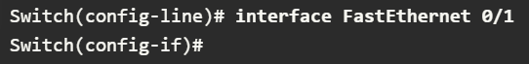

Note About Syntax Checker Activities
When you are learning how to modify device configurations, you might want to start in a safe, non-production environment before trying it on real equipment. NetAcad gives you different simulation tools to help build your configuration and troubleshooting skills. Because these are simulation tools, they typically do not have all the functionality of real equipment. One such tool is the Syntax Checker. In each Syntax Checker, you are given a set of instructions to enter a specific set of commands. You cannot progress in Syntax Checker unless the exact and full command is entered as specified. More advanced simulation tools, such as Packet Tracer, let you enter abbreviated commands, much as you would do on real equipment.

The Command Structure

Basic IOS Command Structure
This topic covers the basic structure of commands of the Cisco IOS. A network administrator must know the basic IOS command structure to be able to use the CLI for devices configuration.
A Cisco IOS device supports many commands. Each IOS command has a specific format, or syntax, and can only be executed in the appropriate mode. The general syntax for a command, shown in the figure, is the command followed by any appropriate keywords and arguments.
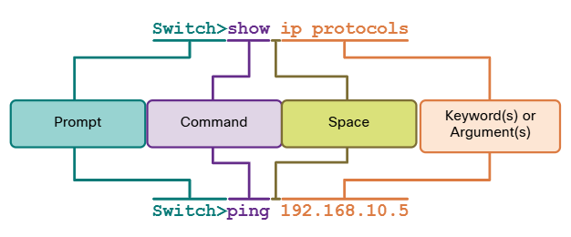
- Keyword – This is a specific parameter defined in the operating system (in the figure, ip protocols).
- Argument – This is not predefined; it is a value or variable defined by the user (in the figure, 192.168.10.5).
After entering each complete command, including any keywords and arguments, press the Enter key to submit the command to the command interpreter.

IOS Command Syntax Check
A command might require one or more arguments. To determine the keywords and arguments required for a command, refer to the command syntax. The syntax provides the pattern, or format, that must be used when entering a command.
As identified in the table, boldface text indicates commands and keywords that are entered as shown. Italic indicates an argument for which the user provides the value.
Boldface | Boldface text indicates commands and keywords that you enter literally as shown.
Italics | Italic text indicates arguments for which you supply values.
[square brackets] | [Square brackets] indicate an optional element (keyword or argument).
{braces} | {braces} indicate a required element (keyword or argument).
[braces { and | vertical } lines ] | Braces and vertical lines within square brackets indicate a required choice within a optional element. Spaces are used to clearly delineate parts of the command.

For instance, the syntax for using the description command is description string. The argument is a string value provided by the user. The description command is typically used to identify the purpose of an interface. For example, entering the command, description Connects to the main headquarters office switch, describes where the other device is at the end of the connection.
The following examples demonstrate conventions used to document and use IOS commands:
- Ping ip-address – The command is ping and the user-defined argument is the ip-address of the destination device. For example, ping 10.10.10.5
- Traceroute ip-adress – The command traceroute and the user-defined argument is the ip-address of the destination device. For example, traceroute 192.168.254.254.
If a command is complex with multiple arguments, you may see it represented like this:
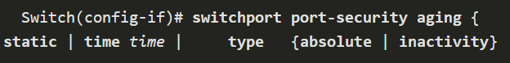
The command will typically be followed with a detailed description of the command and each argument.
The Cisco IOS Command Reference is the ultimate source of information for a particular IOS command.

IOS Help Features
The IOS has two forms of help available: context-sensitive help and command syntax check.
Context-sensitive help enables you to quickly find answers to these questions:
- Which commands are available in each command mode?
- Which command starts with specific characters or group of characters?
- Which arguments and keywords are available to particular commands?

To access context-sensitive help, simply enter a question mark at the CLI.
Command syntax check verifies that a valid command was entered by the user. When a command is entered, the command line interpreter evaluates the command from left to right. If the interpret understands the command, the requested action is executed, and the CLI returns to the appropriate prompt. However, if the interpreter cannot understand the command being entered, it will provide feedback describing what is wrong with the command.

Hot Keys and Shortcuts
The IOS CLI provides hot keys and shortcuts that make configuring, monitoring, and troubleshooting easier.
Commands and keywords can be shortened to the minimum number of characters that identify a unique selection. For example, the configure command can be shortened to conf because configure is the only command that begins with conf. An even shorter version, con, will not work because more than one command begins with con. Keywords can also be shortened.
The table lists keystrokes to enhance command line editing.
TAB | Completes a partial command name entry
BACKSPACE | Erases the character to the left of the cursor
CTRL + D | Erases the character at the cursor
CTRL + K | Erases all character from the cursor to the end of the command line
ESC D | Erases all characters from the cursor to the end of the word
CTRL + U or CTRL + X | Erases all characters from the cursor back to the beginning of the command line
CTRL + W | Erases the word to the left of the cursor
CTRL + A | Moves the cursor to the beginning of the line
LEFT ARROW or CTRL + B | Moves the cursor one character to the left
ESC B | Moves the cursor back one word to the left
ESC F | Moves the cursor forward one character to the right
UP ARROW or CTRL + P | Recalled the previous command in the history buffer, beginning with the most recent command
DOWN ARROW or CTRL + N | Goes to the next line in the history buffer
CTRL + R or CTRL + I or CTRL + L | Redisplays the system prompt and command line after a console message is received

Note: While the DELETE key typically deletes the character to the right of the prompt, the IOS command structure does not recognize the DELETE key.
When a command output produces more text than can be displayed in a terminal window, the IOS will display a “—More—” prompt. The following table describes the keystrokes that can be used when this prompt is displayed.
ENTER Key | Displays the next line
SPACE BAR | Displays the next screen
Any other key * | Ends the display string, returning to previous prompt.  *Except “y”, which answers “yes” to the –More—prompt, and acts like the SPACE BAR

This table lists commands used to exit out of an operation,

CTRL + C | When in any configuration mode, end the configuration mode and returns to privileged EXEC mode. When in setup mode, aborts ack to the command prompt.
CTRL + Z | When in any configuration mode, ends the configuration mode and returns to privileged EXEC mode.
CTRL + SHIFT + 6 | All-purpose break sequence used to abort DNS lookups, traceroutes, pings, etc.

Basic Device Configuration

Device Name
You have learned a great deal about the Cisco IOS, navigating the IOS, and the command structure. Now you’re ready to configure devices! The first configuration command on any device should be to give it a unique device name or hostname. By default, all devices are assigned a factory default name. For example, a Cisco IOS switch is “Switch.”
The problem is, if all switches in a network were let with their default names, it would be difficult to identify a specific device. For instance, how would you know that you are connected to the right device when accessing it remotely using SSH? The hostname provides confirmation that you are connected to the correct device.
The default name should be changed to something more descriptive. By choosing names wisely, it is easier to remember, document and identify network devices. Here are some important naming guidelines for hosts.
  - Start with a letter
  - Contain no spaces
  - End with a letter or digit
  - Use only letter, digits and dashes
  - Be less than 64 characters in length

An organization must choose a naming convention that makes it easy and intuitive to identify a specific device. The hostnames used in the device IOS preserve capitalization and lowercase characters. For example, the figure shows that three switches, spanning three different floors, are interconnected together in a network. The naming convention that was used incorporated the location and the purpose of each device. Network documentation should explain how these name were chosen so additional devices can be named accordingly.
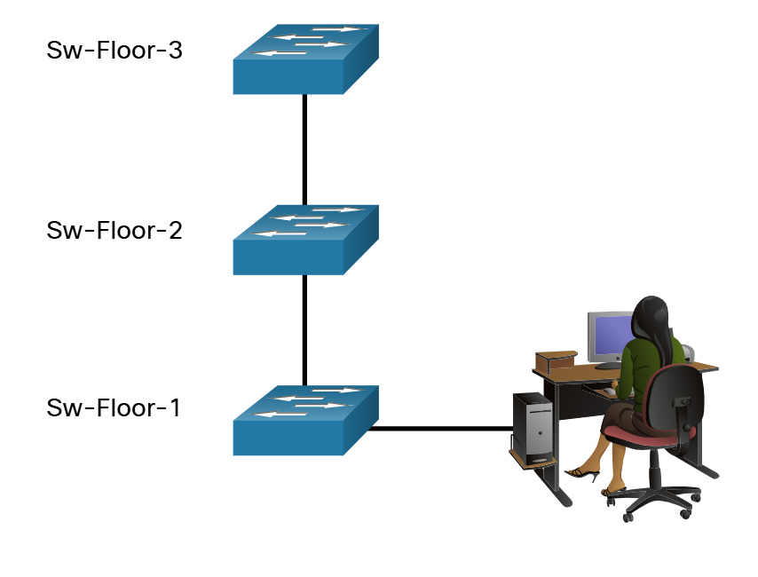
When the naming convention has been identified, the next step is to use the CLI to apply the names to the devices. As shown in the example, from the privileged EXEC mode, access the global configuration mode by entering the configure terminal command.
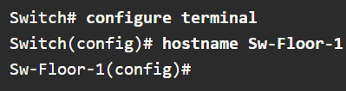

From global configuration mode, enter the command hostname followed by the name of the switch and press Enter.
Note: To return the switch to the default prompt, use the no hostname global config command.
Always make sure the documentation is updated each time a device is added or modified. Identify devices in the documentation by their location, purpose, and address.

Password Guidelines
The use of weak or easily guessed passwords continues to be the biggest security concern of organizations. Network devices, including home wireless routers, should always have passwords configured to limit administrative access.
Cisco IOS can be configured to use hierarchical mode passwords to allow different access privileges to a network device.
All networking devices should limit administrative access by securing privileged EXEC, user EXEC, and remote Telnet access with passwords. In addition, all passwords should be encrypted and legal notifications provided.
When choosing passwords, use strong passwords that are not easily guessed. There are some key points to consider when choosing passwords:
  - Use passwords that are more than eight characters in length
  - Use a combination of upper and lowercase letters, numbers, special characters and/or numeric sequences
  - Avoid using the same password for all devices
  - Do not use common words because they are easily guessed

Use an internet search to find a password generator. Many will allow you to set the length, character set and other parameters.
Note: Most of the labs in this course use simple passwords such as cisco or class. These passwords are considered weak and easily guessable and should be avoided in production environments. We only use these passwords for convenience in a classroom setting, or to illustrate configuration examples.

Configure Passwords
When you initially connect to a device, you are in user EXEC mode. This mode is secured using the console.
To secure user EXEC mode access, enter line console configuration mode using line console 0 global configuration command, as shown in the example. The zero is used to represent the first (and in most cases the only) console interface. Next, specify the user EXEC mode password using the password password command. Finally, enable user EXEC access using the login command.
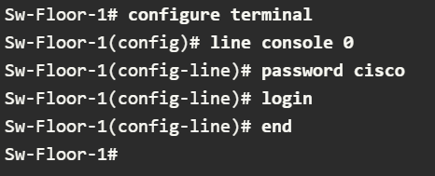
Console access will now require a password before allowing access to the user EXEC mode.
To have administrator access to all IOS commands including configuring a device, you must gain privileged EXEC mode access. It is the most important access method because it provides complete access to the device.
To secure privileged EXEC access, use the enable secret password global config command, as shown in the example.
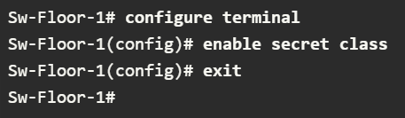
Virtual terminal (VTY) lines enable remote access using Telnet or SSH to the device. Many Cisco witches support up to 16 VTY lines that are numbered 0 to 15.
To secure VTY lines, enter the line VTY mode using the line vty 0 15 global config command. Next, specify the VTY password using the password password command. Lastly, enable VTY access using login command.
An example of securing the VTY lines on a switch is shown.
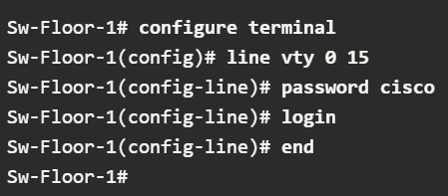

Encrypt Passwords
The startup-config and running-config files display most passwords in plaintext. This is a security threat because anyone can discover the passwords if they have access to these files.
To encrypt all plaintext passwords, use the service password-encryption global config command as shown in the example.
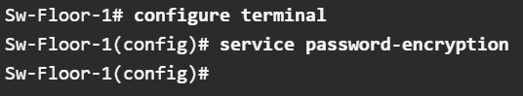

The command applies weak encryption to all unencrypted passwords. This encryption applies only to passwords in the configuration file, not to passwords as they are sent over the network. The purpose of this command is to keep unauthorized individuals from viewing passwords in the configuration file.
Use the show running-config command to verify that passwords are now encrypted.
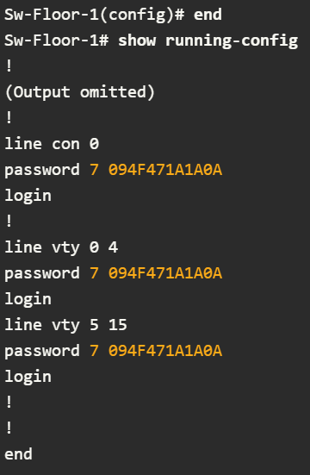

Banner Messages
Although requiring passwords is one way to keep unauthorized personnel out of the network, it is vital to provide a method for declaring that only authorized personnel should attempt to access the device. To do this, add a banner to the device output. Banners can be an important part of the legal process if someone is prosecuted for breaking into a device. Some legal systems do not allow prosecution, or even the monitoring of users, unless a notification is visible.
To create a banner message of the day on a network device, use the banner motd # the message of the day # global config command. The “#” in the command syntax is called the delimiting character. It is entered before and after the message. The delimiting character can be any character as long as it does not occur in the message. For this reason, symbols such as “#” are often used. After the command is executed, the banner will be displayed on all subsequent attempts to access the device until the banner is removed.
The following example shows the steps to configure the banner on Sw-Floor-1.


Save Configurations

Configuration Files
You know how to perform basic configuration on a switch, including passwords and banner messages. This topic will show you how to save your configurations.
There are two system files that store the device configuration:
  - Startup-config – This is the saved configuration file that is stored in NVRAM. It contains all the commands that will be use by the device upon start or reboot. Flash does not lose its contents hen the device is powered off.
  - running-config – This is stored in Random Access Memory (RAM). It reflects the current configuration. Modifying a running configuration affects the operation of a Cisco device immediately. RAM is volatile memory. It loses all of its content when the device is powered off or restarted.

The show running-config privileged EXEC mode command is used to view the running config. As shown in the example, the command will list the complete configuration currently stored in RAM.
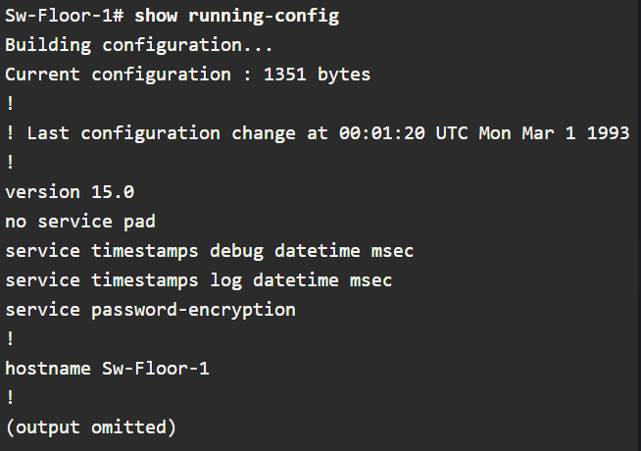
To view the startup configuration file, use the show startup-config privileged EXEC command.
If power to the device is lost, or if the device is restarted, all configuration changes will be lost unless they have been saved. To save changes made to the running configuration to the startup configuration file, use the copy running-config startup-config privileged EXEC mode command.

Alter the Running Configuration
If changes made to the running config do not have the desired effect and the running-config has not yet been saved, you can restore the device to its previous configuration. Remove the changed commands individually or reload the device using the reload privileged EXEC mode command to restore the startup-config.
The downside to using the reload command to remove an unsaved running config is the brief amount of time the device will be offline, causing network downtime.
When a reload is initiated, the IOS will detect that the running config has changed that were not saved to the startup configuration. A prompt will appear to ask whether to save the changes. To discard the changes, enter n or no.
Alternatively, if undesired changes were saved to the startup config, it may be necessary to clear all the configuration. This requires erasing the startup config and restarting the device. The startup config is removed by using the erase startup-config privilege EXEC mode command. After the command is issued, the switch will prompt you for confirmation. Press ENTER to accept.
After removing the startup config from NVRAM, reload the device to remove the current running config file from RAM. On reload, a switch will load the default startup config that originally shipped with the device.

Capture Configuration to a Text File
Configuration files can also be saved and archived to a text document. This sequence of steps ensures that a working copy of the configuration file is available for editing or reuse later
For example, assume that a switch has been configured, and the running config has been saved on the device.
Step 1. Open terminal emulation software, such as PuTTY or Tera Term, that is already connect to a switch.
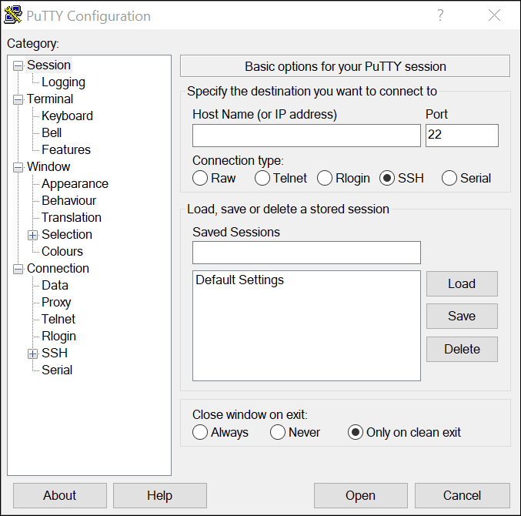
Step 2. Enable logging in the terminal software and assign a name and file location to save the log file. The figure displays that All session output will be captured to the file specified (i.e., MySwitchLogs.)
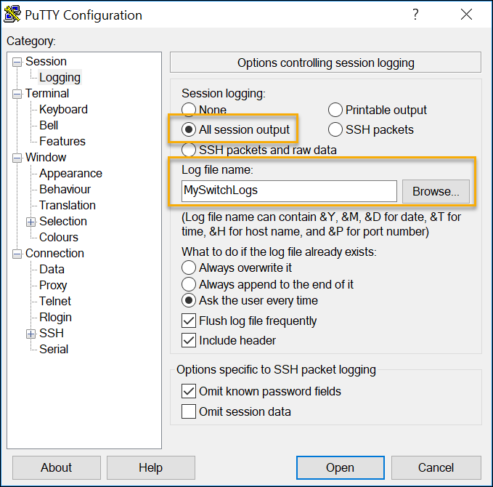

Step 3. Execute the show running-config or show startup-config command at the privileged EXEC prompt. Text displayed in the terminal window will be placed into the chosen file.
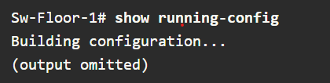
Step 4. Disable logging in the terminal software. The figure shows how to disable logging by choosing None session logging option.
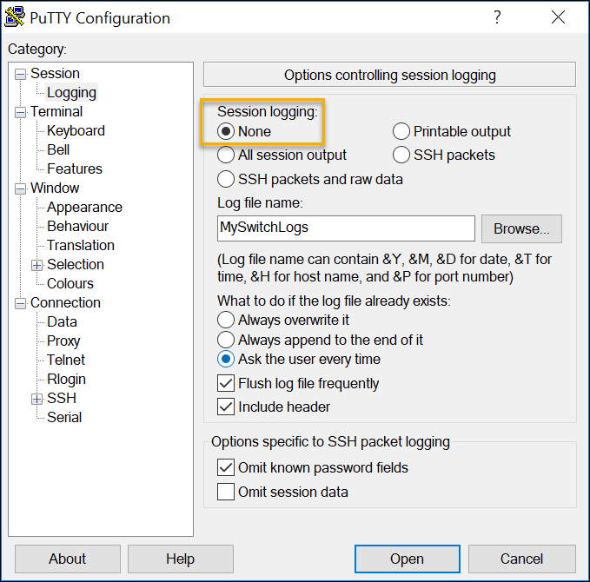

The text file created can be used as a record of how the device is currently implemented. The file could require editing before being used to restore as saved configuration to a device.
To restore a configuration file to a device:
Step 1. Enter global configuration mode on the device.
Step 2. Copy and paste the text file into the terminal window connected to the switch.
The text in the file will be applied as commands in the CLI and become the running configuration on the device. This is a convenient method of manually configurating a device.

Ports and Address

IP Addresses
If you want your end devices to communicate with each other, you must ensure that each of them has an appropriate IP address and is correctly connected. You will learn about IP addresses, device ports and the media used to connect devices in this topic.
The use of IP addresses is the primary means of enabling devices to locate one another and establish end-to-end communication on the internet. Each end device on a network must be configured with an IP address. Examples of end devices include the following:
  - Computers (work stations, laptops, file servers, web servers)
  - Network printers
  - VoIP phones
  - Security cameras
  - Smart phones
  - Mobile handheld devices (such as wireless barcode scanners_

The structure of an IPv4 address is called dotted decimal notation and is represented by four decimal numbers between 0 and 255. IPv4 addresses are assigned to individual devices connected to a network.
Note: IP in this course refers to both IPv4 and IPv6 protocols. IPv6 is the most recent version of IP and is replacing the more common IPv4.
With the IPv4 address, a subnet mask is also necessary. An IPv4 subnet mask is a 32-bit value that differentiates the network portion of the address from the host portion. Coupled with the IPv4 address, the subnet mask determines which subnet the device is a member
The example in the figure displays the IPv4 address (192.168.1.10), subnet mask (255.255.255.0), and default gateway (192.168.1.1) assigned to a host. The default gateway address is the IP address of the router that the host will use to access remote networks, including the internet.
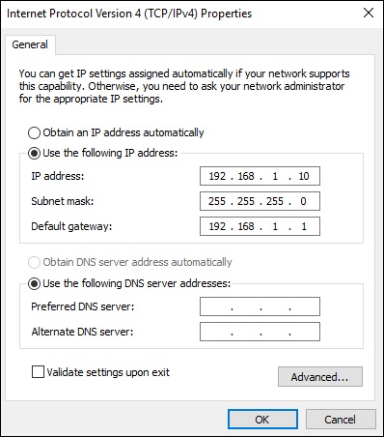
IPv6 addresses are 128 bits in length and written as a string of hexadecimal values. Every four bits is represented by a hexadecimal digit; for a total of 32 hexadecimal values Groups of four hexadecimal digits are separated by a colon. IPv6 addresses are not case-sensitive and can be written in either lowercase or uppercase.

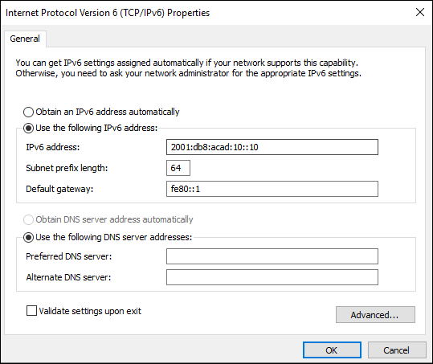

Interfaces and Ports
Network communications depend on end user device interfaces, networking device interfaces, and the cables that connect them. Each physical interface has specifications, or standards, the define it. A cable connecting to the interface must be designed to match the physical standards of the interface. Types of network media include twisted-pair copper, fiber-optic cables, coaxial cables, or wireless.
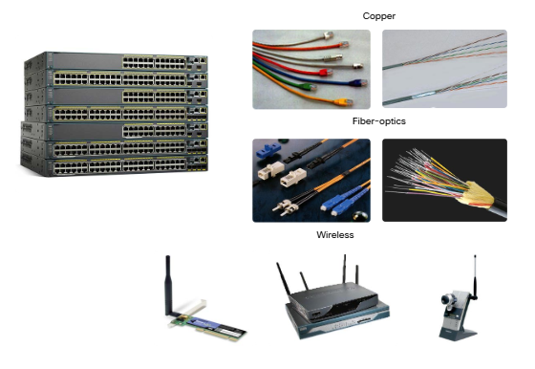
Different types of network media have different features and benefits. Not all network media have the same characteristics. Not all media are appropriate for the same purpose. These are some of the differences between various types of media:
  - Distance the media can successfully carry a signal
  - Environment in which the media is to be installed
  - Amount of data and the speed at which it must be transmitted
  - Cost of the media and installation

Not only does each link on the internet require a specific network media type, but each link also requires a particular network technology. For example, Ethernet is the most common local-area network (LAN) technology used today. Ethernet ports are found on end-user devices, switch devices and other networking devices that can physically connect to the network using a cable.
Cisco IOS Layer 2 switches have physical ports for devices to connect. These ports do not support Layer 3 IP addresses. Therefore, switches have one or more switch virtual interfaces (SVIs). These are virtual interfaces because there is no physical hardware on the device associated with it. An SVI is created in software.
The virtual interface lets you remotely manage a switch over a network using IPv4 and IPv6. Each switch comes with one SVI appearing in the default configuration “out of the box”. The default SVI is interface VLAN1.
Note: A Layer 2 switch does not need an IP address. The IP address assigned to the SVI is use to remotely access the switch. An IP address is not necessary for the switch to perform its operation.

Configure IP Addressing

Manual IP Address Configuration for End Devices
Much like you need your friends’ telephone numbers to text or call them, end devices in your network need an IP address so that they can communicate with other devices on your network. In this topic, you ill implement basic connectivity by configuring IP addressing on switches and PCs.
IPv4 address information can be entered into end devices manually, r automatically using Dynamic Host Configuration Protocol (DHCP).
To manually configure an IPv4 address on a Windows host, open the Control Panel > Network Sharing Center > Change adaptor setting and choose the adaptor. Next, right-click and select Properties to display the Local Area Connection Properties, as shown in the figure.
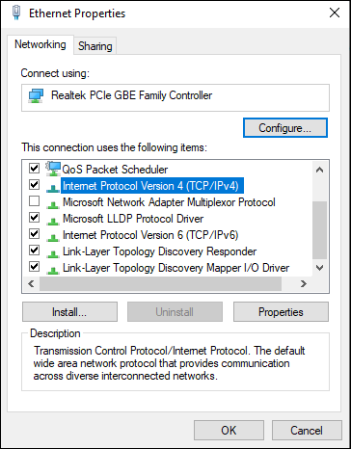
Highlight Internet Protocol Version 4 (TCP/IPv4) and click Properties to open the Internet Protocol Version 4 (TCP/IPv4) Properties window, shown in the figure. Configure the IPv4 address and subnet mask information and default gateway.
Note: IPv6 addressing and configuration are similar to IPv4.
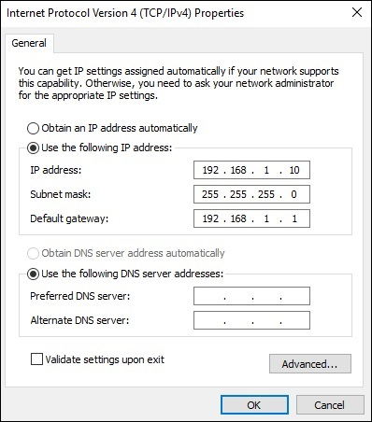
Note: The DNS server addresses are the IPv4 and IPv6 addresses of the Domain Name System (DNS) server, which are use to translate IP addresses to domain names.

Automatic IP address Configuration for End Devices
End devices typically default to using DHCP for automatic IPv4 address configuration. DHCP is a technology that is used in almost every network. The best way to understand why DHCP is so popular is by considering all the extra work that would have to take place without.
In a network, DHCP enable automatic IPv4 address configuration for every end device that is DHCP-enabled. Imagine the amount of time it would take I every time you connected to the network, you had to annually enter the IPv4 address, the subnet mask, the default gateway, and the DNS serv er. Multiple that by every user and every device in an organization and you see the problem. Manual configuration also increases the chance of misconfiguration by duplication another device’s IPv4 address.
As shown in the figure, to configure DHCP on a Windows PC, you only need to select Obtain an IP address automatically and Obtain DNS server address automatically. You PC will search out a DHCP server and be assigned the address settings necessary to communicate on the network.
Note: IPv6 uses DHCPv6 and SLAAC (Stateless Address Autoconfiguraton) for dynamic address allocation.
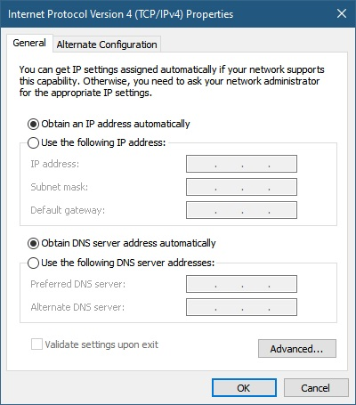

Switch Virtual Interface Configuration
To access the switch remotely, an IP address and a subnet mask must be configured on the SVI. To configure an SVI on a witch, use the interface vlan 1 global configuration command. VLAN 1 is not an actual physical interface but a virtual one. Next assign an IPv4 address using the ip address ip-address subnet mask interface configuration command. Finally, enable the virtual interface using the no shutdown interface configuration command.
After these commands are configured, the switch has all the IPv4 elements ready for communication over the network.
Note: Similar to a Window host, switch configured with IPv4 address will typically also need to have default gateway assigned. This can be done using the ip default-gateway ip-address parameter would be the IPv4 address of the local router on the network, as shown in the example. However, in this module you will only be configuring a network with switches and hosts. Routers will be introduced later.
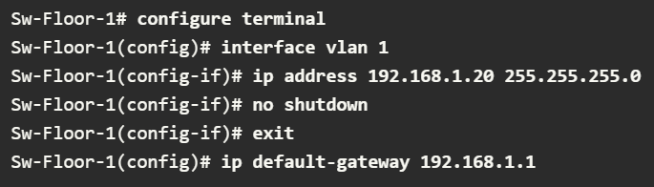

Protocols and Models

The Rules

Communications Fundamentals
Networks vary in size, shape and function. They can be as complex as devices connected across the internet, or as simple as two computers directly connected to one another with a single cable an anything in-between. However, simply having a wired or wireless physical connection between end devices is not enough to enable communication. For communication to occur, devices must know “how” to communicate.
People exchange ideas using many different communication methods. However, all communication methods have the following three elements in common:
  - Message source (sender) – Message sources are people, or electronic devices, that need to send a message to other individuals or devices.
  - Message Destination (receiver) – The destination receives the message interprets it.
  - Channel – This consists of the media that provides the pathway over which the message travels from source to destination.

Communication Protocols
Sending a message, whether by face-to-face communication or over a network, is governed by rules called protocols. These protocols are specific to the type of communication method being used. In our day-to-day personal communing, the rules we use to communicate over one medium, like a telephone call, are not necessarily the same as the rules for using another medium, such as sending a letter.
The process of sending a letter is a like communication that occurs in computer networks.
Imagine two people attempting to communicate, face-to-face.
They must agree on how to communicate. If the communication is to be voice, they must first agree on the language. Next, they will have to format the message they want to communicate in a way that is understandable. If the language is English, but poor sentence structure is used, then the message may be misunderstood.

Rule Establishment
Before communicating with another, individuals must use established rules or agreements to govern the conversation. Consider this message for example
“humans communication between govern rules. It is verydifficult tounderstand messages that are not correctly formatted and donot follow the established rules and protocols. A estrutura da gramatica, da lingua, da pontuacao e do sentence faz a configuracao humana compreensivel por muitos individuos diferentes.”
It is difficult to read the message because it is not formatted properly. It should be written using rules (i.e., protocols) that are necessary for effective communication. The example below shows the message, following proper protocols:

“Rules govern communication between humans. It is very difficult to understand messages that are not correctly formatted and do not follow the established rules and protocols. The structure of the grammar, the language, the punctuation and the sentence make the configuration humanly understandable for many different individuals.”
Protocols must account for the following requirements to successfully deliver a message that is understood by the receiver:
  - An identified sender and receiver
  - Common language and grammar
  - Speed and timing of delivery
  - Confirmation or acknowledgement of requirements.

Network Protocol Requirements
The protocols that are used in network communications share many of these fundamental traits. In addition to identifying the source and destination, computer and network protocols define the details of how a message s transmitted across a network. Common computer protocols include the following requirements:
  - Message encoding
  - Message formatting and encapsulation
  - Message size
  - Message timing
  - Message delivery options

Message Encoding
One of the first steps to sending a message is encoding. Encoding Is the process of converting information into another acceptable form, for transmission. Decoding reverses this process to interpret the information.

Imagine a person calls a friend to discuss the details of a beautiful sunset. To communicate the message, she converts her thoughts into an agreed upon language. She then speeds the words using the sounds and inflections of the spoken language that convey the message. Her friend then listens to the description and decodes the sounds to understand the message he received.

Encoding between hosts must be in an appropriate format for the medium. Messages sent across the network are first converted into bits by the sending host. Each bit is encoded into a pattern of voltages on copper wires, infrared light in optical fibers, or microwaves for wireless systems. The destination host receives an decodes the signals to interpret the message

Message Formatting and Encapsulation
When a message is sent from the source to the destination, it must use a specific format or structure. Message formats depend on the type of message and the channel that is used to deliver the message.
A common example of requiring the correct format in human communication is when sending a letter. An envelope has the address of the sender and receiver; each located at the proper place on the envelope. If it’s destination address and formatting are not correct, the letter is not delivered.
The process of placing one message format (the letter) inside another message format (the envelope) is called encapsulation. De-encapsulation occurs when the process is reversed by the recipient, and the letter is removed from the envelope.
Similar to sending a letter, a message that is sent over a computer network follows specific format rules for it to be delivered and processed.
Internet Protocol (IP) is a protocol with a similar function to the envelope example. In the figure, the fields of the Internet Protocol version 6 (IPv6) packet identify the source of the packet and its destination. IP is responsible for sending a message from the message source to destination over one or more networks.

Message Size
When people communicate with each other, the messages that they send are usually broken into smaller parts or sentences. These sentences are limited in size to what the receiving person can process at one time.
Likewise, when a long message is sent from one host to another over a network, it is necessary to break the message into smaller pieces. The rules that govern the size of the pieces or frames, communicated across the network are very strict. They can also be different, depending on the channel used. Frames that are too long or too short are not delivered.
The size restrictions of frames require the source host to break a long message into individual pieces that meet both the minimum and maximum size requirements. The long message will be sent in separate frames, with each frame containing a piece of the original message. Each frame will also have its own addressing information at the receiving host, the individual pieces of the message are reconstructed into the original message.

Message Timing
Message timing is also very important in network communications. Message timing includes the following:
  - Flow Control – This is the process of managing the rate of data transmission. Flow control defines how much information can be sent and the speed at which it can be delivered. For example, if one person speaks too quickly, it may be difficult for the receiver to hear and understand the message. In network communication, there are network protocols used by the source and destination devices to negotiate and manage the flow of information.
  - Response Timeout – If a person asks a question and does not hear a response within an acceptable amount of time, the person assumes that no answer is coming and reacts accordingly. The person may repeat the question or instead may go on with the conversation. Hosts on the network use network protocols that specify how long to wait for responses and what action to take if a response timeout occurs.
  - Access method – This determines when someone can send a message. When a device wants to transmit on a wireless LAN, it is necessary for the WLAN network interface card (NIC) to determine whether the wireless medium is available.

Message Delivery Options
A message can be delivered in different ways
Sometimes, a person wants to communicate information to a single individual. At other times, the person may need to send information to a group of people at the same time, or even to all people in the same area.
Network communications has similar delivery options to communicate. There are three types of data communication:
  - Unicast – Information is being transmitted to a single end device
  - Multicast – Information is being transmitted to one or more end devices
  - Broadcast – Inormation is being transmitted to all end devices

Note: The multicast animation is indicating the destination devices. By default, a switch will end multicast packets out all ports except the incoming port. However, only the hosts that are part of the multicast group will process the packet.

Protocols

Network Protocols Overview
You know that for end devices to be able to communicate over a network, each device must abide by the same set of rules. These rules are called protocols, and they have many functions in a network. This topic gives you an overview of network protocol.
Network protocols define a common format and set of rules for exchanging messages between devices. Protocols are implemented by end devices and intermediary devices. Protocols are implemented by end devices and intermediary devices in software, hardware or both. Each network protocol has its own function, format, and rules for communications.
The table lists the various types of protocols that are needed to enable communications across one or more networks.
Network Communications Protocols | Protocols enable two or more devices to communicate over one or more networks. The Ethernet family of technologies involves a variety of protocols such as IP, Transmission Control Protocol (TCP), HyperText Transfer Protocol(HTTP) and many more
Network security Protocols | Protocols secure data to provide authentication, data integrity, and data encryptions. Examples of secure protocols include Secure Shell (SSH), Secure Sockets Layers (SSL) and Transport Layer Security (TLS)
Routing Protocols | Protocols enable routers to exchange route information, compare path information and then to select the best ath to the destination network. Examples of routing protocols include Open Shortest Path First (OSPF) and Border Gateway Protocol (BGP)
Service Discovery Protocols | Protocols are use for the automatic detection of devices for services. Examples of service discovery protocols include Dynamic Host Configuration Protocol (DHCP) which discovers services for IP address allocation and Domain Name System (DNS) which is used to perform name-to-IP address translation.

Network Protocol Functions
Network communication protocols are responsible for a variety of functions necessary for network communications between end devices.
Computers and network devices used agreed-upon protocols to communicate. The table lists the functions of these protocols.
Addressing | This identifies the sender and the intended receiver of the message using a defined addressing scheme. Examples of protocols that provide addressing include Ethernet IPv4 and IPv6
Reliability | This function provides guaranteed delivery mechanisms in case messages are lost or corrupted in transit. TCP provides guaranteed delivery.
Flow control | This function provides guaranteed delivery mechanisms in case messages are lost or corrupted in transit TCP provides guarantees delivery
Sequencing | This function uniquely labels each transmitted segment of data/ The receiving device uses the sequencing information to reassemble the information correctly. This is useful if the data segments are lost, delayed or received out-of-order. TCP provides sequencing services.
Error Detection | This function is used to determine if data became corrupted during transmission. Various protocols that provide error detection include Ethernet, IPv4, IPv6 and TCP
Application Interface | This function contains information used for process-to-process communications between network applications. For example, when accessing a web page, HTTP or HTTPS protocols are use to communicate between the client and server web processes.

Protocol Interaction
A message sent over a computer network typically requires the use of several protocols, each one with its own functions and format. The figure shows some common network protocols that are used when a device sends a request to a web server for its web page.
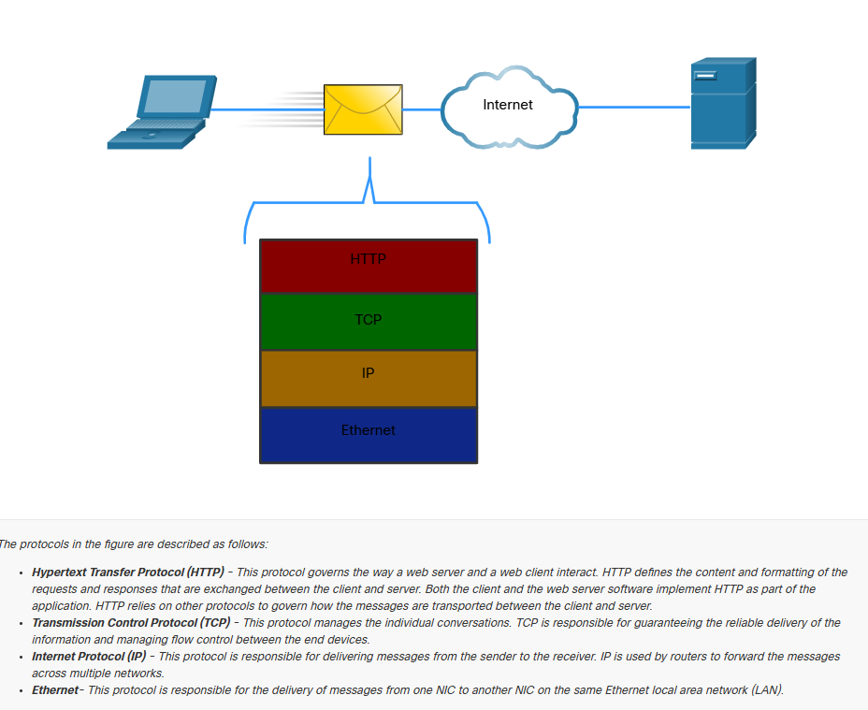

Protocol Suites

Network Protocol Suites
In many cases, protocols must be able to work with other protocols so that your online experience gives you everything you need for network communication. Protocols suites are designed to work with each other seamlessly.
A protocol suite is a group of inter-related protocols necessary to perform a communication function.
One of the best ways to visualize the protocols within a suite interact is to view the interaction as a stack. A protocol stack shows how the individual protocols within a suite are implemented. The protocols are viewed in terms of layers, with each higher-level service depending on the functionality defined by the protocol shown in the lower levels. The lower layer of the stack are concerned with moving data over the network and providing services to the upper layers, which are focused on the content of the message being sent.
As illustrated in the figure, we can use layers to describe the activity occurring in face-to-face communication. At the bottom is the physical layer where we have two people with voices saying words out loud. In the middle is the rules layer that stipulates the requirements of communication including that a common language must be chosen. At the top is the content layer and this is where the content of the communication is spoken.
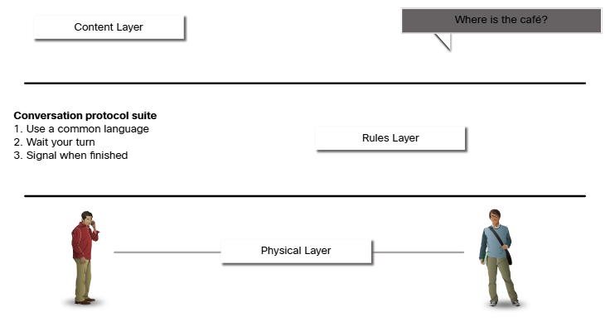

Evolution of Protocol Suites
A protocol suite is a set of protocols that work together to provide comprehensive network communication services. Since the 1970s there have been several different protocol suites, some developed by a standards organization and other developed by various venders.
During the evolution of network communications and the internet there were several competing protocol suites, as shown in the figure.
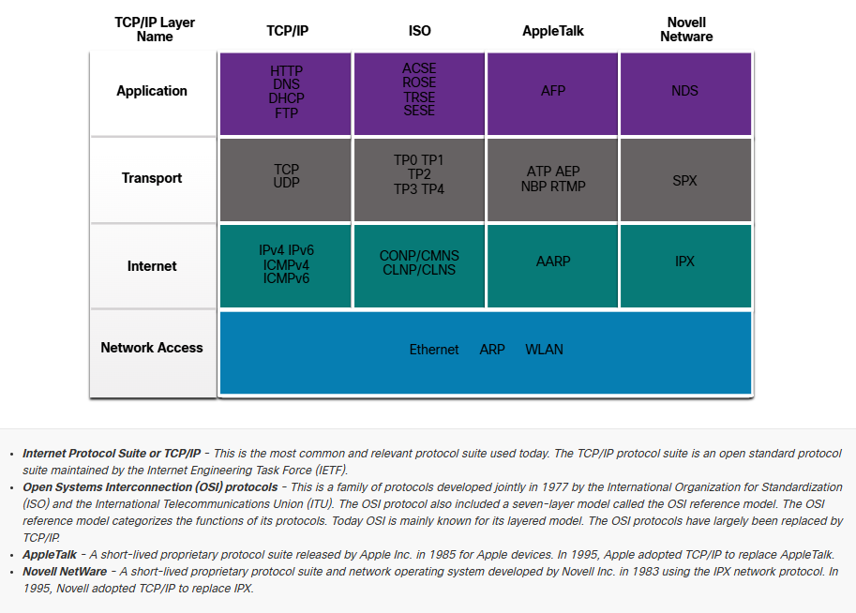

TCP/IP Protocol Example
TCP/IP Protocols are available for the application, transport and internet layers. There are no TCP/IP protocols in the network access layer. The most common network access layer LAN protocols are Ethernet and WLAN (wireless LAN) protocols. Network access layer protocols are responsible for delivering the IP packet over the physical medium.
The figure shows an example of the three TCP/IP protocols used to send packets between the web browser of a host and the web server. HTTP, TCP and IP are the TCP/IP protocols used. At the network access layer, Ethernet is used in the example. However, this could also be a wireless standard such as a WLAN or cellular service.
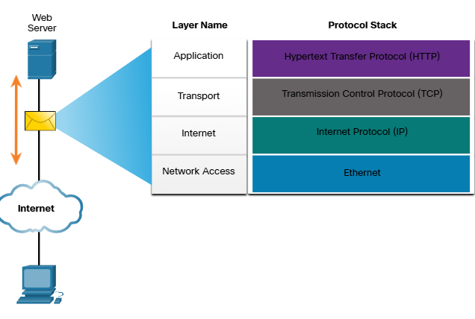

TCP/IP Protocol Suite
Today, the TCP/IP protocol suite includes many protocols and continues to evolve to support new service. Some of the more popular ones are shown in the figure.
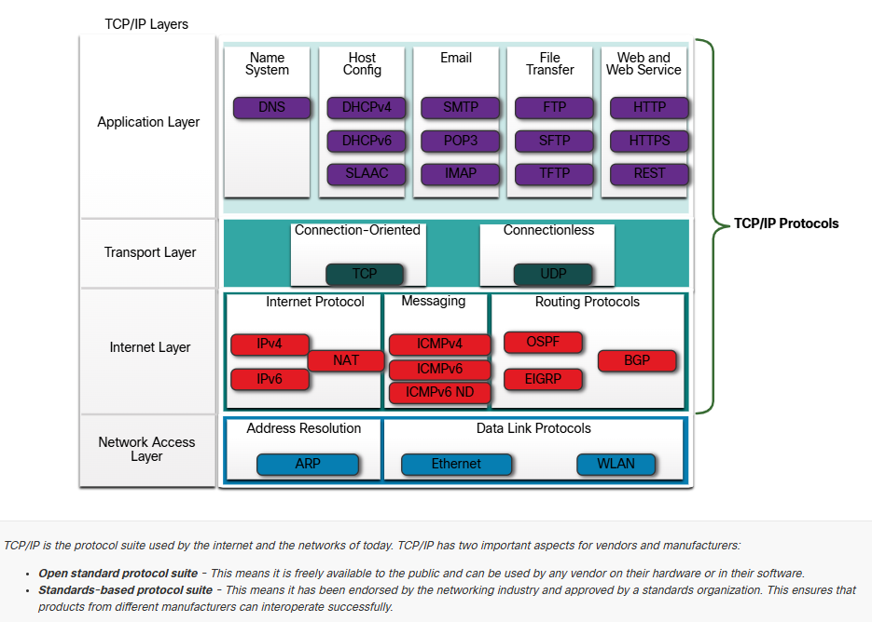
The following is a brief description of protocols at each layer.
Application Layer
Name System
    - DNS – Domain Name System. Translates domain names such as cisco.com, into IP addresses
Host Configuration
    - DHCPv4 – Dynamic Host Configuration Protocol for IPv4. A DHCPv4 server dynamically assigns IP4 addressing information to DHCP4 clients at start-up and allows the addresses to be re-use when no longer needed
    - DHCPv6 – Dynamic Host Configuration Protocol for IPv6. DHCPv6 is similar to DHCPv4. A DHCPv6 server dynamically assigns IPv6 address information to DHCPv6 clients at start-up.
    - SLAAC – Stateles Adress Autoconfiguration. A method that allows a device to obtain its IPv6 addressing information without using a DHCPv6 server
Email
    - SMTP – Simple Mail Transfer Protocol. Enables clients to send email to a mail server and enables servers to send emails to other servers.
    - POP3 – Post Office Protocol version 3. Enables clients to retrieve email from a mail server and download the email to the client’s local mail application
    - IMAP – Internet Message Access Protocol. Enables clients to access email stored on a mail server as well as maintaining email on the server.
File Transfer
    - FTP – File Transfer Protocol. Sets the rules that enable as user on one host to access and transfer files to and from another host over a network. FTP is a reliable, connection-oriented, and acknowledged file delivery protocol.
    - SFTP – SSH File Transfer Protocol. As an extension to Secure Shell (SSH) protocol, SFTP can be used to establish a secure file transfer session in which the file transfer is encrypted. SSH is a method for secure remote login that is typically used for accessing the command line of a device.
    - TFTP – Trivial File Transfer Protocol. A simple, connectionless file transfer protocol with best-effort, unacknowledged file delivery. IT uses less overhead than FTP.
Web and Web Service
    - HTTP – Hypertext transfer Protocol. A set of rules for exchanging text, graphic images, sound, video and other multimedia files on the World Wide Web.
    - HTTPS – HTTP Secure. A secure form of HTTP that encrypts the data that is exchanged over the World Wide Web.
    - REST – Representational State Transfer. A web service that uses application programming interfaces (APIs) and HTTP requests to create web applications.
Transport Layer
Connection-Oriented
    - TCP – Transmission Control Protocol. Enables reliable communication between processes running on separate hosts and provides reliable, acknowledged transmissions that confirm successful delivery

Connectionless
    - UDP – User Datagram Protocol. Enables a process running on one host to send packets to a process running on another host. However, UDP does not confirm successful datagram transmission.
Internet Layer
Internet Protocol
    - IPv4 – Internet Protocol version 4. Receives message segments from the transport layer, packages messages into packets, and addresses packets for end-to-end delivery over a network. IPv4 uses a 32-bit address
    - IPv6 – Internet Protocol version 6. Similar to IPv4 but uses a 128-bit address
    - NAT – Network Address Translation. Translate IPv4 addresses from a private network into globally unique public IPv4 addresses
Messaging
    - ICMPv4 – Internet Control Message Protocol for IPv4. Provide feedback from a destination host to a source host about errors in packet delivery.
    - ICMPv6 – ICMP for Pv6. Similar functionality to ICMPv4 but is use for IPv6 packets.
    - ICMPv6 ND – ICMPv6 Neighbour Discovery. Includes four protocol messages that are used for address resolution and duplicate address detection.
Routing Protocol
    - OSPF – Open Shortest Path First. Link-state routing protocol that uses a hierarchical design based on areas. OSPF is an open standard interior routing protocol.
    - EIGRP – Enhanced Interior Gateway Routing Protocol. An open standard routing protocol developed by cisco that uses a composite metric based on bandwidth, delay, load and reliability.
    - BGP – Border Gateway Protocol. An open standard exterior gateway routing protocol used between Internet Service Providers (ISPs). BGP is also commonly used between ISPs and their large private clients to exchange routing information.

Network Access Layer
Address Resolution
    - ARP – Address Resolution Protocol. Provides dynamic address mapping between an IPv4 address and a hardware address
Note: You may see other documentation state that ARP operates at the Internet Layer (OSI Layer 3). However, in this course we state that ARP operates at the Network Access Layer (OSI Layer 2) because it’s primary purpose is to discover the MAC address of the destination. A MAC address is a Layer 2 operation.
Data Link Protocols
    - Ethernet – Defines the rules for wiring nd signaling standards of the network access layer.
    - WLAN – Wireless Local Are Network. Defines the rules for wireless signaling across the 2.4 GHz and 5 GHz radio frequencies.

Standard Organizations

Open Standards
When buying new tires for a car, there are many manufacturers you might choose. Each of them will have at least one type of tire that fits your car. This is because the automotive industry uses standards when they make cars. It is the same with protocols. Because there are many different manufacturers of network components, they must all use the same standards. In networking, standards are developed by international standard organizations.
Open standards encourage interoperability, competition and innovation. They also guarantee that the product of no single company can monopolize the market or have an unfair advantage over its competition.
A good example of this is when purchasing a wireless router for the home. There are many different choices available from a variety of vendor, all of which incorporate standard protocols such as IPv4, IPv6, DHCP, SLAAC Ethernet and 801.11 Wireless LAN. These open standards also allow a client running the Apple OS X operating system to download a web page from a web server running the Linux operating system. This is because both operating systems implement the open standard protocols, such as those in the TCP/IP protocol suite.
Standards organizations are usually vendor-neutral, non-profit organizations established to develop and promote the concept of open standards. These organization are important in maintaining an open internet with freely accessible specifications and protocols that can be implemented by any vendor
A standards organization may draft a set of rules entirely on its own or, in other cases, may select a proprietary protocol as the basis for the standard. If a proprietary protocol is used, it usually involves the vendor ho created the protocol.

Internet Standards
Various organizations have different responsibilities for promoting and creating standards for the internet and TCP/IP protocol

- Internet Society (ISOC) – Responsible for promoting the open development and evolution of internet use throughout the world.
- Internet Architecture Board (IAB) - Responsible for the overall management and development of internet standards
- Internet Engineering Task Force (IETF) – Develops, updates and maintains internet and TCP/IP technologies. This includes the process and documents for developing new protocols and updating existing protocols, which are know as Request for Comments (RfC) documents.
- Internet Research Task Force (IRTF) – Focused on long-term research related to internet and TCP/IP protocols such as Anti-Spam Research Group (ASRG), Cypto Forum Research Group (CFRG) and Peer-to-peer Research Group (P2PRG).

The following are standard organizations involved with the development and support of TCP/IP and include IANA and ICANN.

- Internet Corporation for Assigned Names and Numbers (CANN) – Based in the United States, ICANN coordinates IP address allocation, the management of domain names and assignment of the other information used in TCP/IP protocols
- Internet Assigned Numbers Authority (IANA) – Responsible for overseeing and managing IP address allocation, domain name management, and protocol identifiers for ICANN

Electronic And Communications Standards
Other standards organizations have responsibilities for promoting and creating the electronic and communication standards used to deliver the IP packets as electronic signals over a wired or wireless medium
These standard organizations include the following:
  - Institute of Electrical and Electronics Engineers (IEEE, pronounced “I-triple-E”) – Organization of electrical engineering and electronic dedicated to advancing technological innovation and creating standards in a wide area of industries including power and energy, healthcare, telecommunication, and networking. Important IEEE networking standards included 802.3 Ethernet and 802.11 WLAN standard. Search the internet for other IEEE network standards.
  - Electronic Industries Alliance (EIA) – Organization is best known for its standard relating to electrical wiring, connectors and the 19-inch racks used to mount networking equipment.
  - Telecommunications Industry Association (TIA) – Organization responsible for developing communication standards in a variety of areas including radio equipment, cellular towers, Voice over IP (VoIP) devices, satellite communication and more
  - International Telecommunications Union-Telecommunication Standard Sector (ITU-T) – One of the largest and oldest communication standards organization. The ITU-T defines standards for video compression, Internet Protocols Television (IPTV), and broadband communications, such as a digital subscriber line (DSL)

Reference Model

The Benefits of Using a Layered Model
You cannot actually watch real packets travel across a real network, the way you can watch the components of a car being put together on an assembly line. So, it helps to have a way of thinking about a network so that you can imagine what is happening. A model is useful in these situations.
Complex concepts such as how a network operates can be difficult to explain and understand. For this reason, a layered model is used to modularize the operations of a network into manageable layers
These are the benefits of using a layered model to describe network protocols and operations:
  - Assisting in protocol design because protocols that operate at a specific layer have defined information that they act upon and a defined interface to the layers above and below
  - Fostering competition because products from different vendors can work together
  - Preventing technology or capability changes in one layer from affecting other layers above and below
  - Providing a common language to describe networking functions and capabilities.

As shown I the figure, there are to layered models that are used to describe network operations:
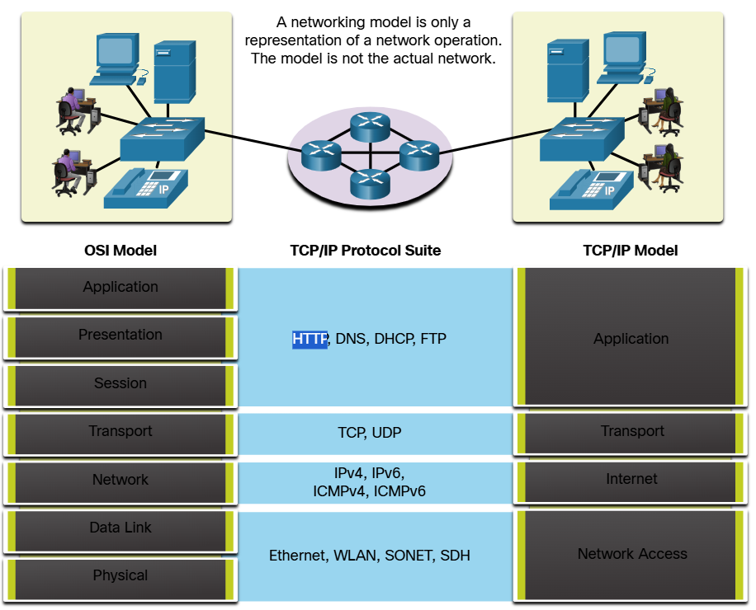

The OSI Reference Model
The OSI Reference Model provides an extensive list of functions and services that can occur at each layer. This type of model provides consistency within all types of network protocols and services by describing what must be done at a particular layer, but not prescribing how it should be accomplished.
It also describes the interaction of each layer with the layers directly above and below. The TCP/IP protocols discussed in this course are structured around both the OSI and TCP/IP models. The table shows details about each layer of the OSI model. The functionality of each layer and the relationship between layers will become more evident throughout this course as the protocols are discussed in more detail:
7 – Application | The application layer contains protocols used for process-to-process communications
6 – Presentation | The presentation layer provides for common representation of the data transferred between application layer services
5 – Session | The session layer provides services to the presentation layer to organize its dialogue and to manage data exchange
4 – Transport | The transport layer defines services to segment, transfer and reassemble the data for individual communications between the end devices.
3 – Network | The network layer provides services to exchange the individual pieces of data over the network between identified end devices
2 – Data Link | The data link layer protocol describe methods for exchanging data frames between devices over a common media
1 – Physical | The physical layer protocols describe the mechanical, electrical, functional and procedural means to activate, maintain and de-activate physical connections for a bit transmission to and from a network device
Note: Whereas the TCP/IP model layers are referred to only by name, the seven OSI model layers are more often referred to by number rather than by name. For instance, the physical layer is referred to as Layer 1 of the OSI model, data link layer is Layer 2 and so on.

The TCP/IP Protocol Model
The TCP/IP protocol model for internetwork communications was created in the early 1970s and is sometimes referred to as the internet model. This type of model closely matches this structure of particular protocol suite. The TCP/IP model is a protocol model because it describes the functions that occur at each layer of protocol within the TCP/IP suite.
4 – Application | Represents data to the user, plus encoding and dialog control
3 – Transport | Supports communication between various devices across diverse networks
2 – Internet | Determines the best path through the network
1 – Network Access | Controls the hardware devices and media that make up the network

The definitions of the standard and the TCP/IP protocols are discussed in a public forum and defined in a publicly available set if IETF RFCs. An RFC is authored by networking engineers and sent to other IETF members for comments.

OSI and TCP/IP Comparison
The protocols that made up the TCP/IP protocol suite can also be described in terms of the OSI reference model. In the OSI model, the network access layer and the application layer of the TCP/IP model are further divided to describe discrete functions that must occur at these layers.
At the network access layer, the TCP/IP protocol suite does not specify which protocols to use when transmitting over a physical medium; it only describes the handoff from the internet layer to the physical network protocols. OSI layers 1 and 2 discuss the necessary procedures to access the media and the physical means to send data over a network.
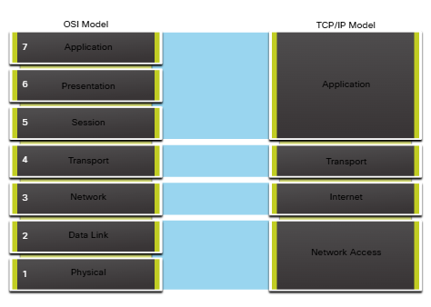
The key similarities are in the transport and network layers; however, the two models differ in how they relate to the layers above and below each layer
  - OSI Layer 3, the network layer, maps directly to the TCP/IP internet layer. This layer is used to describe protocols that address and route messages through an internetwork.
  - OSI Layer 4, the transport layer, maps directly to the TCP/IP transport layer. This layer describes general services and functions that provide ordered and reliable delivery of data between source and destination hosts.
  - The TCP/IP application layer includes several protocols that provide specific functionality to a variety of end user applications. The OSI model Layers 5, 6 and 7 are used as references for application software developers and vendor to produce applications that operate on networks.
  - Both the TCP/IP and OSI models are commonly used when referring to protocols at various layers. Because the OSI model separates the data link layer from the physical layer, it is commonly use when referring to these lower layers.

Data Encapsulation

Segmenting Messages
Knowing the OSI reference model and the TCP/IP protocol model will come in handy when you learn about how data is encapsulated as it moves across a network. It is not as simple as physical letter being sent through the mail system.
In theory, a single communication, such as a video or an email message with many large attachments, could be sent across a network from a source to a destination as one massive, uninterrupted stream of bits. However, this would create problems for other devices needing to use the same communication channels or links. These large streams of data would result in significant delays. Further, if any link in the interconnected network infrastructure failed during the transmission, the complete message would be lost and would have to be retransmitted in full.
A better approach is to divide the data into smaller, more manageable pieces to send over the network. Segmentation is a process of dividing a stream of data into smaller units for transmissions over the network. Segmentation is necessary because data networks use the TCP/IP protocol suite send data in individual IP packets. Each packet is sent separately, similar to sending a long letter as a series of individual postcards. Packets containing segments for the same destination can be sent over different paths.
This leads to segmenting messages having two primary benefits:
  - Increases speed – Because a large data stream is segmented into packets, large amounts of data can be sent over the network without typing up a communications link. This allows many different conversations to be interleaved on the network called multiplexing.
  - Increase efficiency - If a single segment fails to reach its destination due to failure in the network or network congestion, only that segment needs to be retransmitted instead of resending the entire data stream.

Sequencing
The challenge to using segmentation and multiplexing to transmit messages across a network is the level of complexity that is added to the process. Imagine if you had to send a 100-page letter, but each envelope could only hold one page. Therefore, 100 envelopes would be required and each envelope would need to be addressed individually. It is possible that the 100-page letter in 100 different envelopes arrives out-of-order. Consequently, the information in the envelope would need to include a sequence number to ensure that the receiver could reassemble the pages in the proper order.
In network communications, each segment of the message must go through a similar process to ensure that it gets to the correct destination and can be reassembled into the content of the original message.

Protocol Data Unites
As application data is passed down the protocol stack on its way to be transmitted across the network media, various protocol information is added at each level. This is known as the encapsulation process.
Note: Although the UDP PDU is called datagram, IP packets are sometimes also referred to as IP datagrams.
The form that a piece of data takes at a layer is called a protocol data unit (PDU). During encapsulation, each succeeding layer encapsulates the PDU that it receives from the layer above in accordance with the protocol being used. At each stage of the process, a PDU has a different name to reflect its new functions. Although there is no universal naming convention for PDUs, in this course, the PDUs are named according to the protocols of the TCP/IP suite. The PDUs for each form of data are shown in the figure.
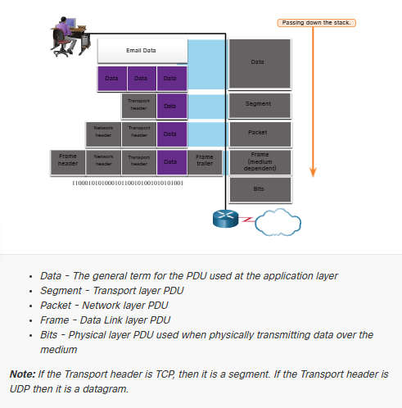

Encapsulation Example
When messages are being sent on a network, the encapsulation process works for top to bottom. At each layer, the upper layer information is considered data within the encapsulated protocol. For example, the TCP segment is considered data within the IP packet.

De-encapsulation Example
This process is reversed at the receiving host ad is known as de-encapsulation. De-encapsulation is the processed used by receiving device to remove one or more of the protocol headers. The data is de-encapsulated as it moves up the stack toward the end-user application.

Data Access

Addresses
As you just learned, it is necessary to segment messages in a network. But those segmented messages will not go anywhere if they are not addressed properly. This topic gives an overview of network addresses. You will also get the chance to use the Wireshark Tool, which ill help you to “view” network traffic.
The network and data link layers are responsible for delivering the data from the source device to the destination device. As shown in the figure, protocols at both layers contain a source and destination address, but their addresses have different purposes:
- Network layer source and destination addresses – Responsible for delivering the IP packet from the original source to the final destination, which may be on the same network or a remote network.
- Data link layer source and the destination addresses - Responsible for delivering the data link frame from one Network Interface Card (NIC) to another NIC on the same network.
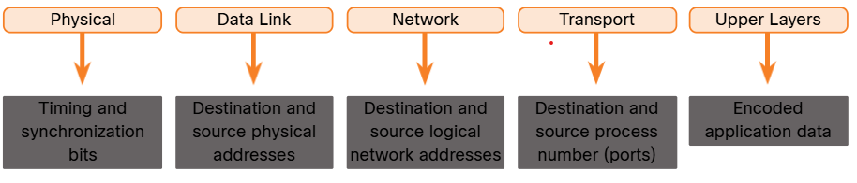

Layer 3 Logical Address
An IP address is the network layer, or Layer 3, logical address used to deliver the IP packet from the original source to the final destination, as shown in the figure.
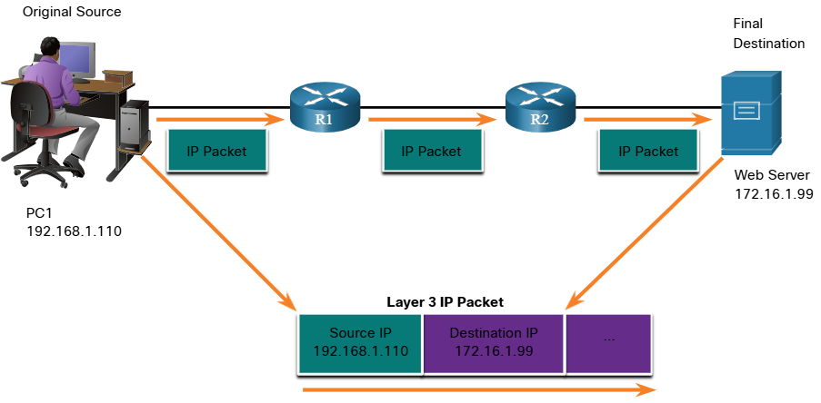
The IP packet contains to IP addresses:
  - Source IP Address – The IP address of the sending device, which is the original source of the packet.
  - Destination IP Address – The IP address of the receiving device, which is the final destination of the packet.
The IP addresses indicate the original source IP address and final destination IP address. This is true whether the source and destination are on the same IP networks or different IP networks.
An IP address contains two parts:
  - Network Porton (IPv4) or Prefix (IPv6) – The left-most part of the address that indicates the network in which the IP address is a member. All devices on the same network will have the same network portion of the address.
  - Host Portion (IPv4) or Interface ID (IPv6) – The remaining part of the address that identifies a specific device on the network. This portion is unique for each device or interface on the network.
Note: The subnet mask (IPv4) or prefix-length (IPv6) is used to identify the network portion of an IP address from the host portion.

Devices on the Same Network
In this example, we have a client computer, PC1, communicating with an FTP server on the same IP network.
  - Source IPv4 Address – The IPv4 address of the sending device, the client computer PC1: 192.168.1.110
  - Destination IPv4 Address – The IPv4 address of the receiving device, FTP server. 192.168.1.9
Notice in the figure that the network portion of the source IPv4 address and the network portion of the destination IPv4 address are the same and therefore; the source and destination are on the same network.
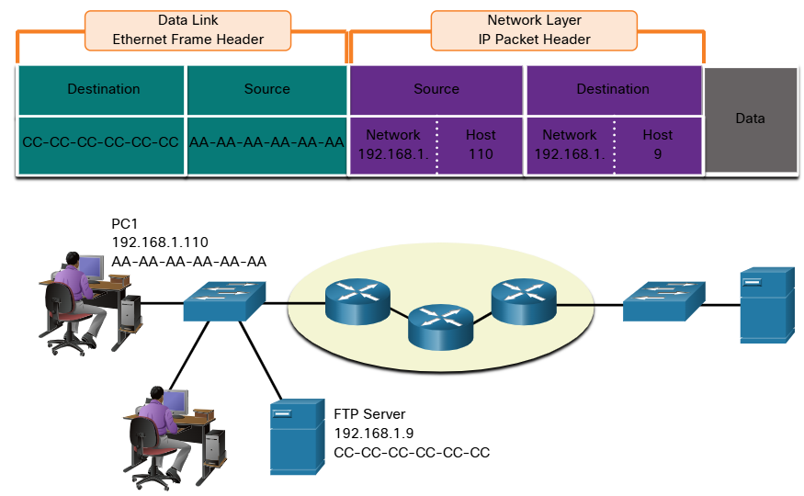

Role of the Data Link Layer Adress – Same IP Network
When the sender and receiver of the IP packet are on the same network, the data link frame is sent directly to the receiving device. On an Ethernet network, the data link addresses are known as Ethernet Media Access Control (MAC) addresses, as highlight in the figure.
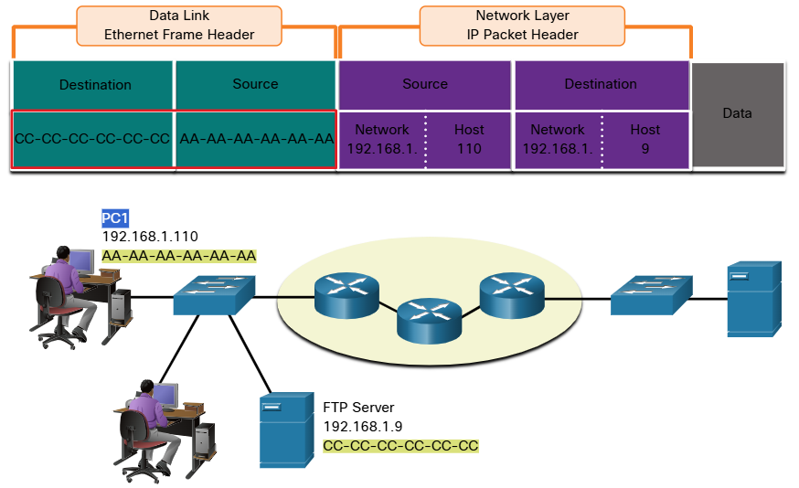

MAC addresses are physically embedded on the Ethernet NIC
  - Source MAC address – This is the data link address, or the Ethernet MAC address, of the device that sends the data link frame with the encapsulated IP packet. The MAC address of the Ethernet NIC of PC1 is AA:AA:AA:AA:AA:AA, written in hexadecimal notation.
  - Destination MAC address - When the receiving device is on the same network as the sending device, this is the data link address of the receiving device. In this example, the destination MAC address is the MAC address of the TP server. CC:CC:CC:CC:CC:CC, written in hexadecimal notation.
The frame with the encapsulated IP packet can now be transmitted from PC1 directly to the FTP server

Role of the Network Layer Addresses
When the sender of the packet is on a different network from the receiver, the source and destination IP addresses will represent hosts on different networks. This will be indicated by the network portion of the IP address of the destination host.
  - Source IPv4 address – The IPv4 address of the sending device, the client computer PC1: 192.1.110
  - Destination IPv4 address – The IPv4 address of the receiving device, the server, Web Server. 172.16.1.99.
Notice in the figure that the network portion of the source IPv4 address and destination IPv4 address are on different networks.
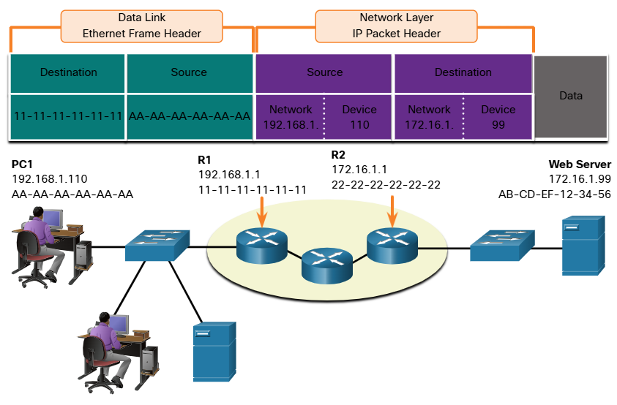

Role of the Data Link Layer Addresses – Different IP Networks
When the sender and receiver of the IP address are on different networks, the Ethernet data ink frame cannot be sent directly to the destination host because the hose is not directly reachable in the network of the sender The Ethernet frame must be sent to another device known as the router or default gateway. In our example, the default gateway is R1. R1 has an Ethernet data link address that is on the same network a PC1. Tis allows PC1 to reach the router directly.
  - Source MAC address – The Ethernet MAC address of the sending device, PC1. The MAC address of the Ethernet interface of PC1 is AA-AA-AA-AA-AA-AA
  - Destination MAC address – When the receiving device, the destination IP address, is on a different network from the sending device uses the Ether MAC address of the default gateway or router. In this example, the destination MAC address is the MAC address of the R1 Ethernet interface, 11-11-11-11-11-11. This is the interface that is attached to the same network as PC1, as shown in the figure.
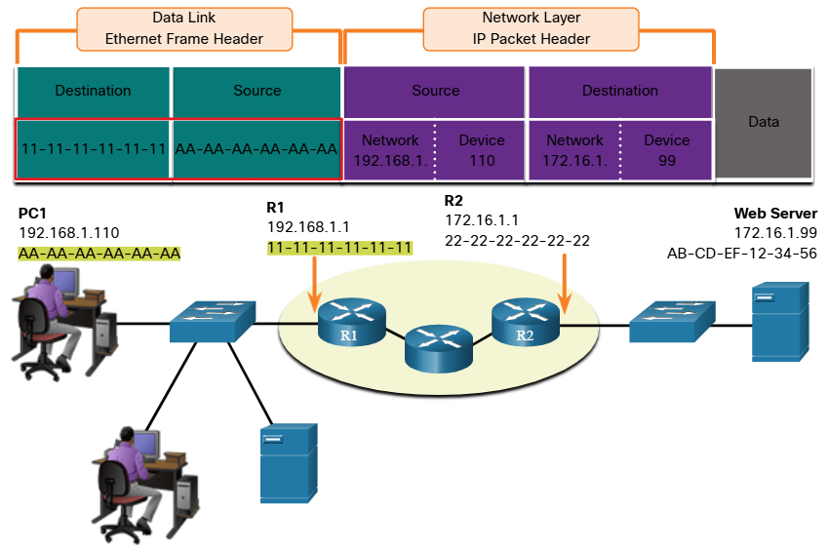
The Ethernet frame with the encapsulated IP packet can now be transmitted to R1. R1 forwards the packet to the destination, Web Server. This may mean that R1 forwards the packet to another router or directly to Web Server if the destination is on a network connected to R1.
It is important that the IP address of the default gateway be configured on each host on the local network. All packets to a destination on remote networks are sent to the default gateway. Ethernet MAC addresses and the default gateway are discussed in more detail in ore modules.

Data Link Addresses
The data link Layer 2 physical address has a different role. The purpose of the data link address is to deliver the data link frame from one network interface to another network interface on the same network.
Before an IP packet can be sent over a wired or wireless network, it must be encapsulated in a data link frame, so it can be transmitted over the physical medium.
Host to Router
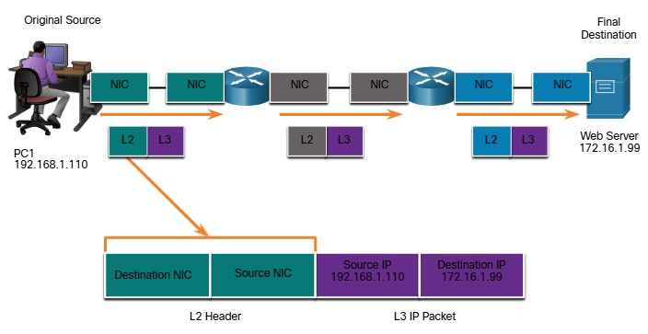
Router to Router
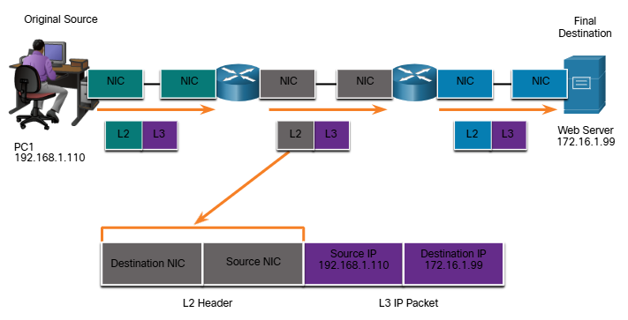

Router to Server
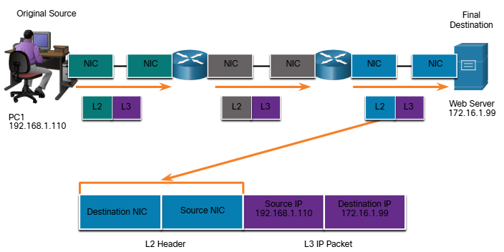
As the IP packet travels from host-to-router, router-to-router and finally router-to-host, at each point along the way, the IP packet is encapsulated in a new data link frame. Each data link frame contains the source data link address of the NIC card sending the frame, and the destination data link address of the NIC card receiving the frame.
The Layer 2, data link protocol is only used to deliver the packet from NIC-to-NIC on the same network. The router removes the Layer 2 information as it is received on one NIC and adds new data link information before forwarding out the exit NIC on its ways towards the final destination.
The IP packet is encapsulated in a data link frame that contains the following data link information:
  - Source data link address – The physical address of the NIC that is sending the data link frame
  - Destination data link address – The physical address of the NIC that is receiving the data link frame The address s either the next hop router of the address of the final destination device.

Purpose of the Physical Layer

The Physical Connection
Whether connecting to a local printer in the home or a website in another country, before any network communication can occur, a physical connection to a local network must be established. A physical connection can be a wired connection using a cable or wireless communication using radio waves.
The type of physical connection used depends upon the setup of the network. For example, in many corporate offices, employees have desktop or laptop computers that are physically connect, via cable, to a shared switch. This type of setup is wired network. Dat is transmitted through a physical cable.
In addition to wired connections, many businesses also offer wireless connections for laptops, tablets and smartphones. With wireless devices, data is transmitted using radio waves. Wireless connectivity is common as individuals and businesses alike discover its advantages. Devices on a wireless network must be connected to a wireless access point (AP) or wireless router like the one shown in the figure.
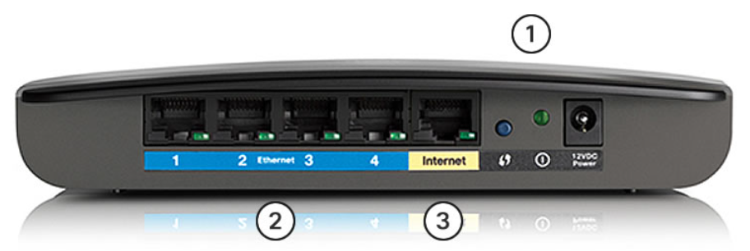
These are the components of an access point:
- The wireless antennas (These are embedded inside the router version shown in the figure)
- Several ethernet switchports
- An internet port
Similar to a corporate office, most homes offer both wired and wireless connectivity to the network. This figure shows a home router and a laptop connecting to the local area network (LAN)
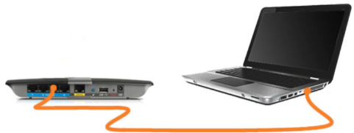
Network Interface Cards
Network Interface Cards (NICs) connect a device to a network. Ethernet NICs are used for a wired connection, as shown in the figure, whereas wireless local area network (WLAN) NICs are used for wireless. An end-user may include one or both types of NICs. A network printer, for example, may only have an Ethernet NIC and therefore, must connect to a network using an Ethernet cable. Other devices, such as tablets and smartphones, might only contain a WLAN NIC and must use a wireless connection.

The Physical Layer
The OSI physical layer provides the means to transport the bits that make up a data link layer frame across the network media. This layer accepts a complete frame from the data link layer and encodes it as a series of signals that are transmitted to the local media. The encoded bits that comprise a frame are received by either an end device or an intermediate device.
The physical layer encodes the frames and creates the electrical, optical or radio wave signals that represent the bits in each frame These signals are then sent over the media, one at a time.
The destination node physical layer retrieves these individual signals from the media, restores them to their bit representation and passes the bits up to the data link layer as complete frame.

Physical Layer Characteristics

Physical Layer Standards
In the previous topic, you gained a high-level overview of the physical layer and its place in a network. This topic dives a bit deeper into the specifics of the physical layer. This includes the components ad the media used to build a network, as well as the standards that are required so that everything works together.
The protocols and operations of the upper OSI layers are performed using software designed by software engineers and computer scientists. The services and protocols in the TCP/IP suite are defined by the Internet Engineering Task Forces (IETF).
The physical layer consists of electronic circuitry, media and connectors developed by engineers. Therefore, it is appropriate that the standards governing this hardware are defined b the relevant electrical and communications engineering organizations.
There are many different international and national organization, regulatory government organization, and private companies involved in establishing and maintaining physical layer standards. For instance, the physical layer hardware, media, encoding an signaling standards are defined and government by these standard organizations:
- International Organization for Standardization (ISO)
- Telecommunications Industry Association/Electronic Industries Association (TIA/EIA)
- International Telecommunications Union (ITU)
- American National Standards Institute (ANSI)
- Institute of Electrical And Electronics Engineers (IEEE)
- National Telecommunication Regulatory Authorities including the Federal Communication Commission (FOC) in the USA and the European Telecommunication Standards Institute (ETSI)
In addition to these, there are often regional cabling standard groups such as CSA (Canadian Standards Association), CENELEC (European Committee for Electronical Standardization), and JSA/JIS (Japanese Standards Association), which develop local specifications.
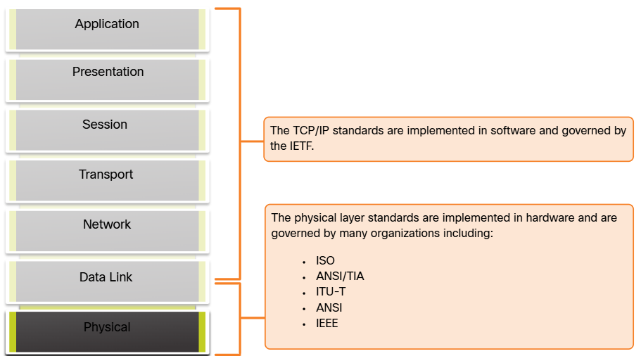

Physical Components
The physical layer standards address three functional areas:
  - Physical Components
  - Encoding
  - Signaling

The physical components are the electronic hardware devices, media and other connectors that transmit the signals that represent the bits. Hardware components such as NICs, interface and connectors, cable designs are all specified in standards associate with the physical layer. The various ports and interfaces on a Cisco 1941 router are also examples of physical components with specific connectors and pinouts resulting from standard

Encoding
Encoding or line encoding is a method of converting a stream of data bits into a predefined “code”. Codes are groupings of bits used to provide a predictable pattern that can be recognized by both the sender and the receiver. In other words, encoding is the method or pattern used to represent digital information. This is similar to how Mores code encodes a message using series of dots and dashes.
For example, Manchester encoding represents a 0 bit by a high to ow voltage transition, and a 1 bit is represented as a low to high voltage transition. An example of Manchester encoding I illustrated in the figure. The transition occurs at the middle of each bit period. This type of encoding is used in 10 Mbps Ethernet. Fater data rates require more complex encoding. Manchester encoding is used in older Ethernet standards such as 10BASE-T. Ethernet 100BASE-TX use 4B/5B encoding and 1000BASE-T uses 8B/10B encoding.
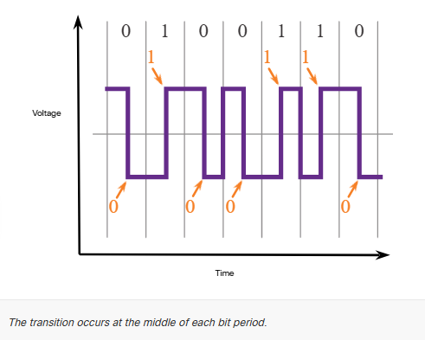

Signaling
The physical layer must generate the electrical, optical or wireless signals the represent the “1” and the “0” on the media. The way that bits are represented is called the signaling method. The physical layer standards must define what type of signal represents a “1” and what type of signal represents a “0”. This can be as simple as change in the level of the electrical or optical pulse. For example, a long pulse might represent a 1 whereas a short pulse might represent a 0.
This is similar to the signaling method used in Morse code, which may use a series of on-off tones, lights or clicks to send text over telephone wires or between ships at sea.

Encoding
Different physical media support the transfer of bits at different rates. Data transfer is usually discussed in terms of bandwidth. Bandwidth is the capacity at which a medium can carry data Digital bandwidth measures the amount of data that can flow from one place to another in a given amount of time. Bandwidth is typically measured in kilobits per second (kbps), megabits per second (Mbps) or gigabits per second (Gbps). Bandwidth is sometimes thought of as a speed that bits travel, however this is not accurate For example, in both 10Mbps and 100Mbps Ethernet, the bits are sent at the speed of electricity. The difference is the number of bits that are transmitted per second.
A combination of factors determines the practical bandwidth of a network:
- The properties of the physical media
- The technologies chosen for signaling and detecting network signals.
Physical media properties, current technologies and the laws of physics all play a tole in determining the available bandwidth.
The table shows the commonly used units of measure for bandwidth
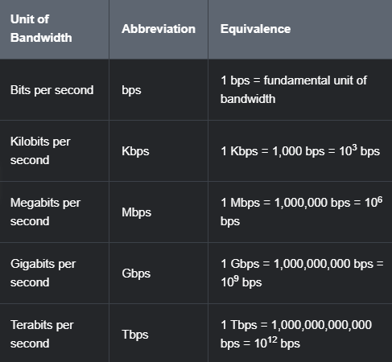

Bandwidth Terminology
Terms used to measure the quality of bandwidth include:
  - Latency
  - Throughput
  - Goodput
Latency refers to the amount of time, including delays, for data to travel from one given point to another.
In an internetwork, or a network with multiple segments, throughput cannot be faster than the slowest link in the path from source to destination. Even if all, or most, of the segments have high bandwidth, it will only take one segment in the path with a low throughput to create a bottleneck in the throughput of the entire network.
Throughput is the measure of the transfer of bits across the media over a given period of time.
Due to a number of factors, throughput usually does not match the specified bandwidth in physical layer implementations. Throughput is usually lower than the bandwidth There are many factors that influence throughput:
  - The amount of traffic
  - The type of traffic
  - The latency created by the number of network devices encountered between source and destination

There are many only speed tests that can reveal the throughput of an internet connection.
There is a third measurement to assess the transfer of usable data; it is known as goodput. Goodput is the measure of usable data transferred over a given period of time. Goodput is throughput minus traffic overhead for establishing sessions, acknowledgments, encapsulations and retransmitted bits. Goodput is always lower than throughput, which is generally lower than bandwidth

Copper Cabling

Characteristics of Copper Cabling
Copper cabling is the most common type of cabling used in networks today. In fact, copper cabling is not just one type of cable. There are three different types of copper cabling that are each used in specific situations.
Networks use copper media because it is inexpensive, easy to install, and has lower resistance to electrical current. However, copper media is limited by distance and signal interference.
Data is transmitted on copper cables as electrical pulses. A detector in the network interface of a destination device must receive a signal that can be successfully decoded to match the signal sent. However, the farther the signal travels, the more it deteriorates. This is referred to as signal attenuation. For this reason, all copper media mut follow strict distance limitations as specified by the guiding standards.
The timing and voltage values of the electrical pulses are also susceptible to interference from to sources:
- Electromagnetic Interference (EMI) or radio frequency interference (RFI) – EMI and RFI signals can distort and corrupt the fata signals being carried by copper media. Potential sources of EMI and RFI include radio wave and electromagnetic devices, such as fluorescent lights or electric motors
- Crosstalk – Crosstalk is disturbance caused by the electric or magnetic fields of a signal on one wire to the signal in an adjacent wire. In telephone circuits, crosstalk can result in hearing part of another voice conversation from an adjacent circuit. Specifically, when an electrical current flows through a wire, it creates a small, circular magnetic field around the wire, which can be picked up by an adjacent wire.
The figure shows how data transmission can be affected by interference.
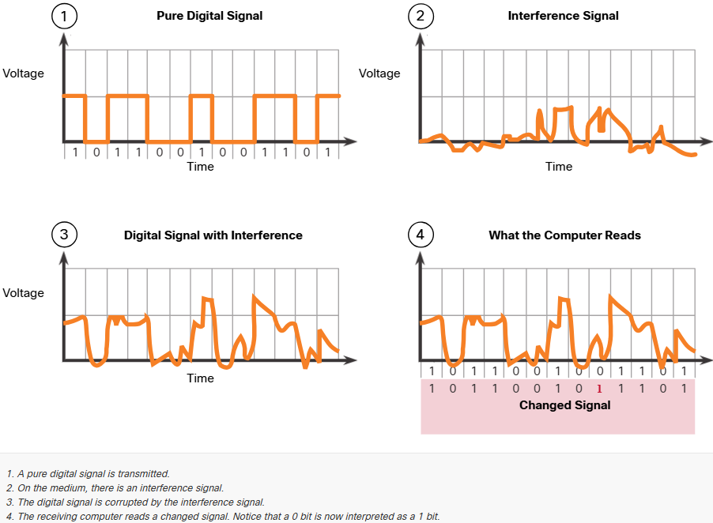
To counter the negative effect of EMI and RFI, some types of copper cables are wrapped in metallic shielding and require proper grounding connections.
To counter the negative effects of crosstalk, some types of copper cables have opposing circuit wire pairs twisted together, which effectively cancels the crosstalk.
The susceptibility of copper cables to electronic noise can also be limited using these recommendations:
- Selecting the cable type or category most suited to a given networking environment
- Designing a cable infrastructure to avoid known and potential sources of interference in the building structure
- Using cabling techniques that include the proper handling and termination of the cables.

Types of Copper Cabling
There are three main types of copper media used in networking
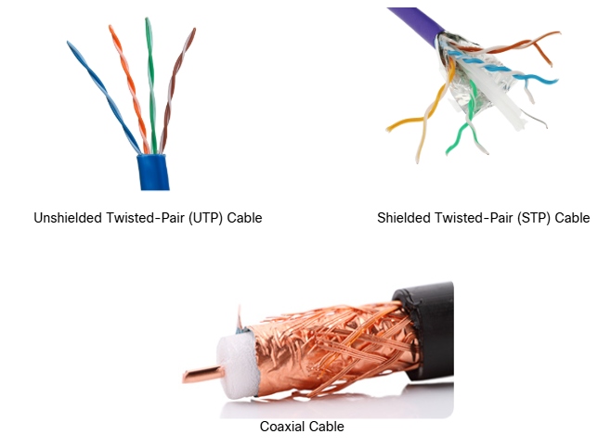

Unshielded Twisted-pair (UTP)
Unshielded twisted pair (UT) cabling is the most common networking media. UTP cabling, terminated with RJ-45 connectors, is used for interconnecting network hosts with intermediary networking devices, such as switches and routers.
In LANs, UTP cable consists of four pairs of color-coded wires that have been twisted together and then encased in a flexible plastic sheath that protects from minor physical damage. The twisting of wires helps protect against interference from other wires.
As seen in the figure, the color codes identify the individual pair and wires and aid in cable termination.
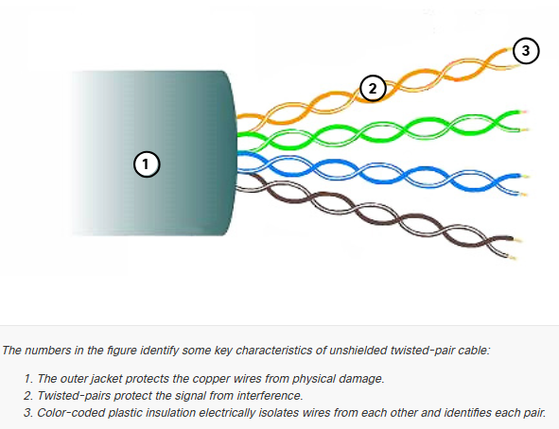

Shielded Twisted-pair (STP)
Shielded twisted-pair (STP) provides better noise protection than UTP cabling. However, compared to UTP cable STP cable is significantly more expensive and difficult to install. Like UTP cable, STP uses an RJ-45 connector.
STP cables combine the techniques of shielding to counter EMI and RFI, and wire twisting to counter crosstalk. To gain the full benefit of the shielding, STP cables are terminated with special shielded STP data connectors. If the cable is improperly grounded, the shield may act as an antenna and pick up unwanted signals.
The STP cable shown uses four main pairs of wires, each wrapped in a foil shield, which are then wrapped in an overall metallic braid or foil
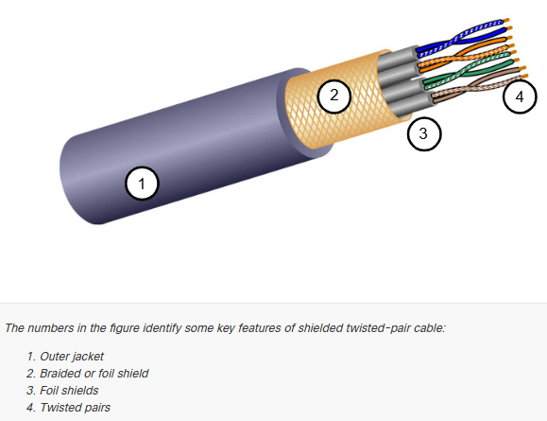

Coaxial Cable
Coaxial Cable, or “co-ax” for short, gets its name from the fact that there are two conductors that share the same axis. As shown in the figure, coaxial cable consists of the following:
  - A copper conductor is used to transmit the electronic signals.
  - A layer of flexible plastic insulation surrounds a copper conductor
  - The insulating material is surrounded in a woven copper braid, or metallic foil, that acts as the second wire on the circuit and as a shield for the inner conductor This second layer, or shield, also reduces the amount of outside electromagnetic interference.
  - The entire cable is covered with a cable jacket to prevent minor physical damage.
There are different types of connectors used with coax cable. The Bayonet Neill-Concelman (BNC), N type, and F type connectors are shown in the figure.
Although UTP cable has essentially replaced coaxial cable in modern Ethernet installations, the coaxial cable design is used in the following situations:
  - Wireless installations – Coaxial cables attach antennas to wireless devices. The coaxial cable carries radio frequency (RF) energy between the antennas and the radio equipment.
  - Cable internet installations – Cable service provide internet connectivity to their customers by replacing portions of the coaxial cable and supporting amplification elements with fiber-optic cable. However, the wiring inside the customer’s premises is still coax cable.
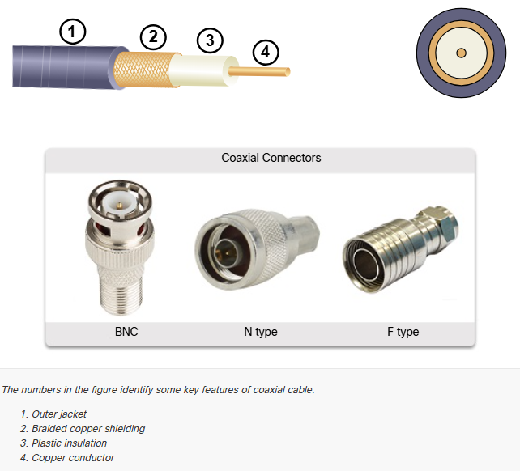

UTP Cabling

Properties of UTP Cabling
In the previous topic, you learned a bit about unshielded twisted-pair (UTP) copper cabling. Because UTP cabling is the standard for use in LANs, this topic goes into detail about its advantages and limitations, and what can be done to avoid problems.
When used as a networking medium, UTP cabling consists of four pairs of color-coded copper wires that have been twisted together and then encased in a flexible plastic sheath. Its small size can be advantageous during installation.
UTP cable does not use shielding to counter the effects of EMI and RFI. Instead, cable designers have discovered other ways that they can limit the negative effect of crosstalk:
  - Cancellation – Designers now pair wires in a circuit. When two wires in an electrical circuit are placed closed together, their magnetic fields are the exact opposite of each other. Therefore, the two magnetic fields cancel each other and also cancel out any outside EMI and RFI signals.
  - Varying the number of twists per wire pair – To further enhance the cancellation effect of paired circuit wires, designers vary the number of twists of each wire pair in a cable. UTP cable must follow precise specifications governing how many twists or braids are permitted per meter (3.28 feet) of cable. Notice in the figure that the orange/orange white pair is twisted less than the blue/blue white pair. Each coloured pair is twisted a different number of times.
UTP cable relies solely on the cancellation effect produced by the twisted wire pairs to limit signa degradation and effectively provide self-shielding for wire pairs within the network media.
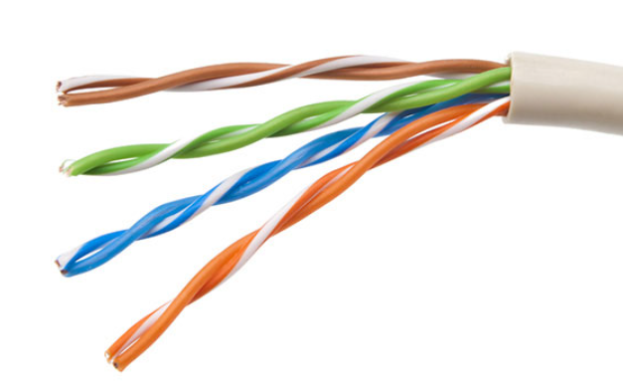

UTP Cabling Standards and Connectors
UTP cabling conforms to the standards established jointly by the TIA/EIA. Specifically, TIA/EIA-568 stipulates the commercial cabling standards for LAN installations and is the standard most commonly used in LAN cabling environments. Some of the elements defined are as follows:
  - Cable types
  - Cable lengths
  - Connectors
  - Cable termination
  - Methods of testing cable
The electrical characteristics of copper cabling are defined by the Institute of Electrical and Electronics Engineers (IEEE). IEEE rates UTP cabling according to its performance. Cables are placed into categories based on their ability to carry higher bandwidth rates. For example, Category 5 cable is used commonly in 100BASE-TX Fast Ethernet installations. Other categories included Enhanced Category 5 cable, Category 6 and Category 6a.
Cables in higher categories are designed and constructed to support higher data rates. As new gigabit speed Ethernet technologies are being developed and adopted, Category 5e is now the minimally acceptable cable type, with Category 6 being the recommended type for new building installations.
The figure shows three categories of UTP cable:
  - Category 3 was originally used for voice communications over voice lines but later use for data transmission.
  - Category 5 and 5e is used for data transmission. Category 5 supports 100Mbps and Category 5e supports 1000Mbps
  - Category 6 has an added separator between each wire pair to support higher speeds. Category 6 supports up to 10Gbps
  - Category 7 also supports 10Gbps
  - Category 8 supports 40Gbps
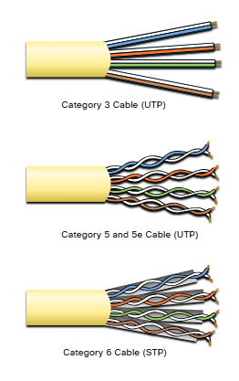

UTP cable is usually terminated with an RJ-45 connector. The TIA/EIA-568 standard describes the wire color codes to pin assignments (pinouts) for Ethernet cables.
As shown in the figure, the RJ-45 connector is the male component, crimped at the end of the cable.
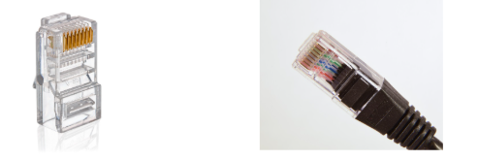

The socket, shown in the figure, is the female component of a network device, wall, cubicle partition outlet, or patch panel. When terminated improperly, each cable is a potential source of physical layer performance degradation.
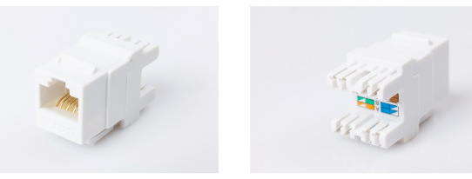
This figure shows an example of a badly terminated UTP cable. This bad connector has wires that are exposed, untwisted and not entirely covered by the sheath.
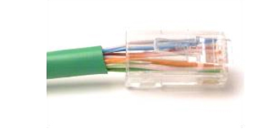
The next figure shows a properly terminated UTP cable. It is a good connector with wires that are untwisted only to the extent necessary to attach the connector
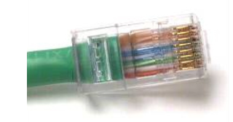

Straight-through and Crossover UTP
Different situations may require UTP cables to be wired according to different wiring conventions. This means that the individual wires in he cable have to be connected in different orders to different set of pins in the RJ-45 connectors.
The following are the main cable types that are obtained by using specific wiring conventions:
  - Ethernet Straight-through – The most common type of networking cable. It is commonly used to interconnect a host to a witch and a switch to a router.
  - Ethernet Crossover – A cable used to interconnect similar devices. For example, to connect a switch to a switch, a host to a host, or a router to a router. However, crossover cables are now considered legacy as NICs use medium-dependent interface crossover (auto-MDIX) to automatically detect the cable type and make the internal connection.
Note: Another type of cable is a rollover cable, which is Cisco proprietary. It is used to connect a workstation to a router or switch console port.

Using a crossover or straight-through cable incorrectly between devices may not damage the device, but connectivity and communication between the devices will not take place. This is a common error and checking that the device connections are correct should be the first troubleshooting action if connectivity is not achieved.
The figure identifies the individual wire pairs for the T658A and T568B standards.
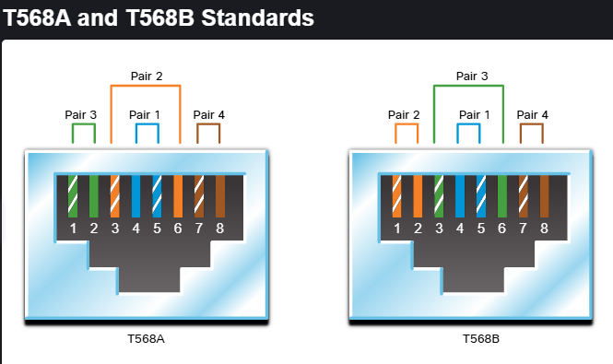

The table shows the UTP cable type, relate standards and the typical application of these cables.
Ethernet Straight-through | Both ends T568A or both ends T568B | Connects a network host to a network device such as a switch or hub
Ethernet Crossover | One end T568A, other end T568B | Connects two network hosts. Connects two network intermediary devices (switch to switch or router to router)
Rollover | Cisco proprietary | Connects a workstation serial port to a router console port, using an adapter

Fiber-Optic Cabling

Properties of Fiber-Optic Cabling
As you have learned, fiber-optic cabling is the other type o cabling used in networks. Because it is expensive, it is not as commonly used at the various types of copper cabling. But fiber-optic cabling has certain properties that make it the best option in certain situations, which you will discover in this topic.
Optical fiber cable transmits data over longer distances and at higher bandwidths than any other networking media. Unlike copper wires, fiber-optic cable can transmit signals with less attenuation and is complete immune to EMI and RFI. Optical fiber is commonly used to interconnect network devices.
Optical fiber is a flexible, but extremely thin, transparent strand of very pure glass, not much bigger than a human hair. Bits are encoded on the fiber as light impulses. The fiber-optic cable acts as a waveguide or “light-pipe” to transmit light between the two ends with minimal loss of signal.
As an analogy, consider an empty paper towel roll with the inside coated like a mirror. It is a thousand meters in length, and a small laser pointer is used to send Morse code signals at the speed o light. Essentially, that is how a fiber-optic cable operates, except that it is smaller in diameter and uses sophisticated light technologies.

Types of Fiber Media
Fiber-optic cables are broadly classified into two types:
  - Single-mode fiber (SMF)
  - Multimode fiber (MMF)
Single-Mode Fiber
SMF consists of a very small core and uses expensive laser technology to send a single ray of light, as shown in the figure. SMF is popular in long-distance situations spanning hundreds of kilometers, such as those required in long haul telephony and cable TV applications.
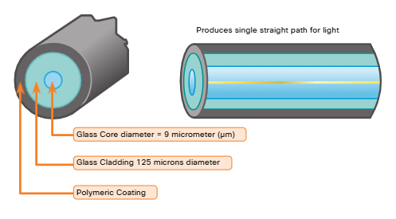
Multimode Fiber
MMF consists of a larger core and uses LED emitters to send light pulses. Specifically, light from an LED enters the multimode fiber at different angles, as shown in the figure. MMFs are popular in LANs because they can be powered by low-cost LEDs. It provides bandwidth up to 10Gbps over link lengths o up to 550 meters.
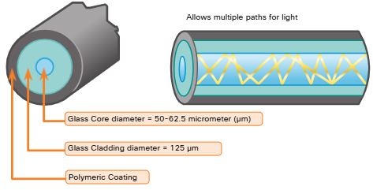

One of the highlighted differences between MMF and SMF is the amount of dispersion. Dispersion refers to the spreading out of a light pulse over time. Increased dispersion means increased loss of signal strength. MMF has a greater dispersion than SMF. That is why MMF can only travel up to 500 meters before signal loss

Fiber-Optic Cabling Usage
Fiber-optic cabling is now being used in four types of industry:
  - Enterprise Networks – Used for backbone cabling applications and interconnecting infrastructure devices
  - Fiber-to-the-home (FTTH) – Used to provide always-on broadband services to homes and small businesses
  - Long-Haul Networks – Used by service providers to connect countries and cities
  - Submarine Cable Networks – Used to provide reliable high speed, high-capacity solutions capable of surviving in harsh undersea environments at up to transoceanic distances. Search the internet for “submarine cables telegeography map” to view various maps online.
Our focus in this course is the use of fiber within the enterprise.

Fiber-Optic Connectors
An optical-fiber connector terminates the end of an optical fiber. A variety of optical-fiber connectors are available. The main differences among the types of connectors are dimensions and methods of coupling. Businesses decide on the type of connectors that will be used, based on their equipment.
Note: Some switches and routers have ports that support fiber-optic connectors through a small form-factor pluggable (SFP) transceiver. Search the internet for various types of SFPs

Straight Tip (ST) Connectors were one of the first connector types used. The connector locks securely with a “twist-on/twist-off” bayonet-style mechanism.
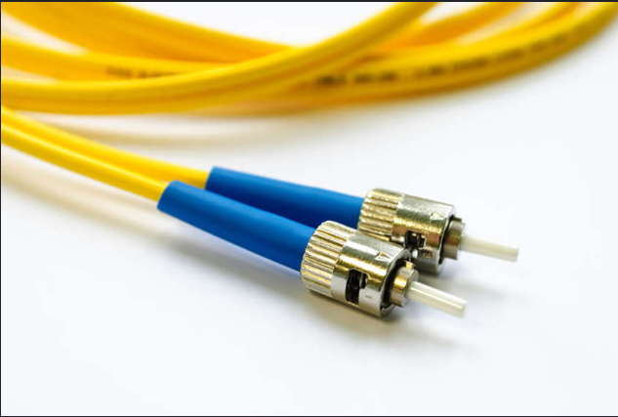

Subscriber Connector (SC) connectors are sometimes referred to as “square connectors” or “standard connectors.” They are widely adopted LAN and WAN connector that uses a push-pull mechanism to ensure positive insertion. This connector type is used with multimode and single-mode fiber.
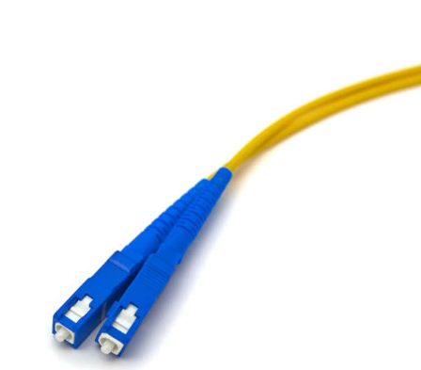

Lucent Connector (LC) Simplex Connectors are a smaller version of the SC connector. These are sometimes called little or local connector and are quickly growing in popularity due to their smaller size.
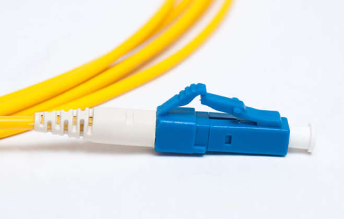
Duplex Multimode LC Connectors are similar to an LC simplex connector but uses a duplex connector.
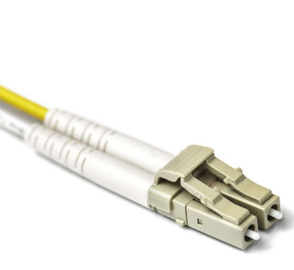
Until recently, light could only travel in one direction over optical fiber. Two different fibers were required to support the full duplex operation. Therefore, fiber-optic patch cables bundle together two optical fiber cables and terminate them with a pair of standard, single-fiber connectors. Some fiber connectors accept both the transmitting and receiving fibers in a single connector known as a duplex connector, as shown in the Duplex Multimode LC Connector figure. BX standards such as 100BASE-BX use different wavelengths for sending and receiving over a single fiber.

Fiber Patch Cords
Fiber patch cords are required for interconnecting infrastructure devices. The use of color distinguishes between single-mode and multimode cords. A yellow jacket is for single-mode fiber cables and orange (or aqua) for multimode fiber cables.

Fiber versus Copper
There are many advantages to using fiber-optic cable compared to copper cables. The table highlights some of these differences.
At present, in most enterprise environments, optical fiber is primarily used as backbone cabling for high-traffic, point-to-point connections between data distribution facilities. It is also use for the interconnection of buildings in multi-building campuses. Because fiber-optic cables do not conduct electricity and have a low signal loss, they are will suited for those uses.
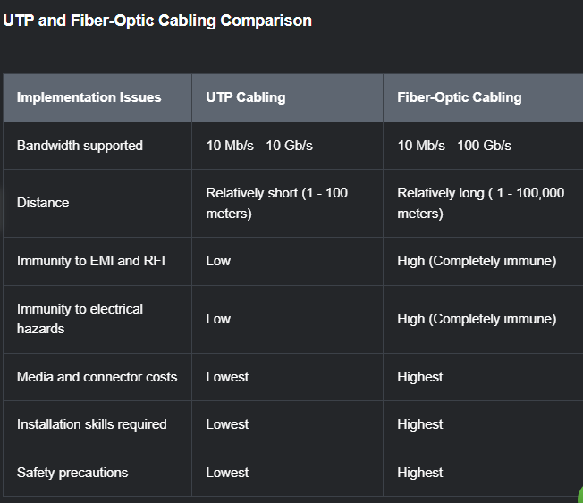

Wireless Media

Properties of Wireless Media
You may be taking this course using a tablet or a smart phone. This is only possible due to wireless media, which is the third way to connect to the physical layer of a network.
Wireless media carry electromagnetic signals that represent the binary digits of data communications using radio or microwave frequencies.
Wireless media provide the greatest mobility options of all media, and the number of wireless-enabled devices continues to increase. Wireless is now the primary way users connect to home and enterprise networks.
These are some of the imitations of wireless:
  - Coverage Area – Wireless data communication technologies work well in open environments. However, certain construction materials used in buildings and structures, and the local terrain, will limit effective coverage.
  - Interference – Wireless is susceptible to interference and can be disrupted by such common devices as household cordless phones, some types of fluorescent lights, microwave ovens and other wireless communications.
  - Security – Wireless communications coverage requires no access to a physical strand of media. Therefore, devices and users, not authorized for access to the network, con gain access to the transmission. Network security is a major component of wireless network administration.
  - Shared Medium – WLANs operate in half-duplex, which means only one device can send or receive at a time. The wireless medium is shared amongst all wireless users. Many users accessing the WLAN simultaneously results in reduced bandwidth for each user

Although wireless is increasing in popularity for desktop connectivity, copper and fiber are the most popular physical layer media for deployment of intermediary network devices such as routers and switches.

Types of Wireless Media
The IEEE and telecommunications industry standards for wireless data communications cover both the data link and physical layers. In each of these standards, physical layer specifications are applied to area that include the following:
  - Data to radio signal encoding
  - Frequency and power of transmission
  - Signal reception and decoding requirements
  - Antenna design and construction
These are the wireless standards:
  - Wi-Fi (IEEE 802.11) – Wireless LAN (WLAN) technology, commonly referred to as Wi-Fi. WLAN uses a contention-base protocol known as carrier sense multiple access/collision avoidance (CSMA/CA). The wireless NIC must first listen before transmitting to determine if the radio channel is clear. If another wireless device is transmitting, then the NIC must wait until the channel is clear. Wi-Fi is a trademark of the Wi-Fi Alliance. Wi-Fi is used with certified WLAN devices based on the IEEE 802.11 standards.
  - Bluetooth (IEEE 802.15) – This is a wireless personal area network (WPAN) standard, commonly known as “Bluetooth.” It uses a device pairing process to communicate over distances from 1 – 100 meters.
  - WiMAX (IEEE 802.16) – Commonly known as Worldwide Interoperability for Microwave Access (WiMAX), this wireless standard uses a point-to-multipoint topology to provide wireless broadband access.
  - Zigbee (IEEE 802.15.14) – Zigbee is a specification used for low-data rate, low-power communications. It is intended for application that require short-range, low data-rates and long battery life. Zigbee is typically use for industrial and Internet of Things (IoT) environments such as wireless light switches and medical device data collection

Note: Other wireless technologies such as cellular satellite communications can also provide data network connectivity. However, these wireless technologies are out of scope for this module.

Wireless LAN
A common wireless data implementation is enabling devices to connect wirelessly via a LAN. In general, a WLAN requires the following network devices:
  - Wireless Access Point (AP) – These concentrate the wireless signals from users and connect to the existing copper-based network infrastructure, such as Ethernet. Home and small business wireless routers integrate the functions of a router, switch and access point into one device, as shown in the figure.
  - Wireless NIC adaptors – These provide wireless communication capability to network hosts
As the technology has developed, a number of WLAN Ethernet-based standards have emerged. When purchasing wireless devices, ensure compatibility and interoperability.
The benefits of a wireless data communications technologies are evident, especially the saving on costly premises wiring and the convenience of host mobility. Network administrators must develop and apply stringent security policies and processes to protect WLANs from unauthorized access and damage.

Binary Number Systems

Binary and IPv4 Addresses
IPv4 addresses begin as binary, a series of only 1s and 0s. These are difficult to manage, so network administrators must convert them to decimal. This topic shows you a few ways to do this.
Binary is a numbering system that consists of the digits 0 and 1 called bits. In contrast, the decimal numbering system consists of 10 digits consisting of the digits 0 -9.
Binary is important for us to understand because hosts, servers and network devices use binary addressing. Specifically, they use binary IPv4 addresses as shown in the figure, to identify each other.
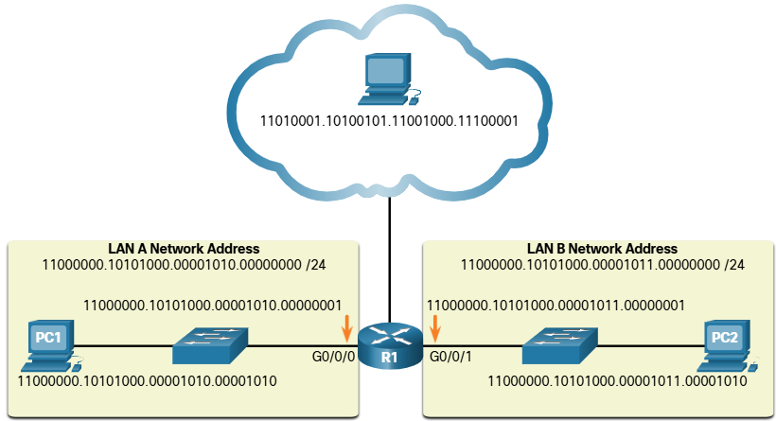

Each address consists of a string of 32 bits, divided into four sections called octets. Each octet contains 8 bits ( or 1 byte) separated with a dot. For example, PC1 in the figured is assigned IPv4 address 11000000.10101000.00001010.00000001. Its default gateway address would be that of R! Gigabit Ethernet interface 11000000.10101000.00001010.00000001.
Binary works well with hosts and network devices. However, it is very challenging for humans to work with.
For each of use by people, IPv4 addresses are commonly expressed in dotted decimal notation. PC1 is assigned the IPv4 address 192.168.10.10 and its default gateway address is 192.168.10.1, a shown in the figure.
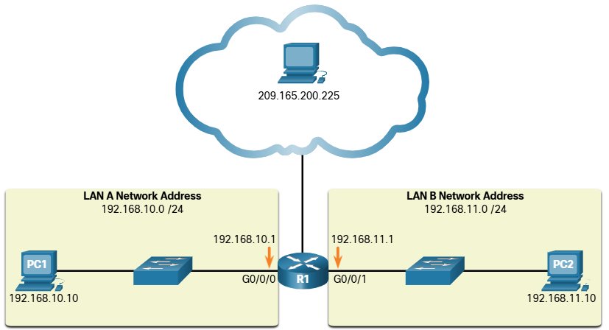
For a solid understanding of networking addressing, it is necessary to know binary addressing and gain practical skills converting between binary and dotted decimal IPv4 addresses. This section will cover how to convert between base two (binary) and base 10 (decimal) numbering systems.

Binary Positional Notation
Learning to convert binary to decimal requires an understanding of positional notation. Positional notation means that a digit represents different values depending on the “position” the digit occupies in the sequence of numbers. You already know the most common numbering system; the decimal (base 10) notation system.
The decimal positional notation system operates as described in the table.
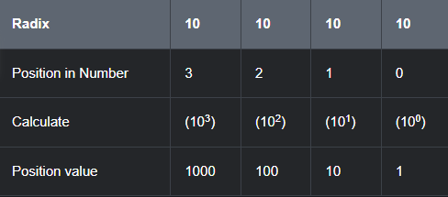
The following bullets describe each row on the table
  - Row 1 – Radix is the number base. Decimal notation is based on 10, therefore the radix is 10
  - Row 2 – Position in number considers the position of the decimal number starting with, from right to let, 0 (1st position), 1 (2nd position), 2 (3rd position), 3 (4th position). These numbers also represent the exponential value used to calculate the positional value in the 4th row.
  - Row 3 – Calculates the positional value y taking the radix and raising it by the exponential value of its position in Row 2
  - Row 4 – Positional value represents units of thousands, hundreds, tens and ones.

The use the positional system, match a given number to its positional value. The example in the table illustrates how positional notation is used with the decimal number 1234.
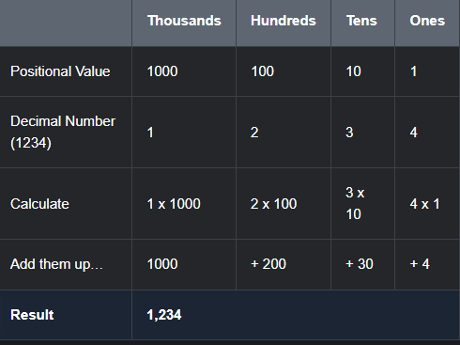
In contrast, the binary positional notation operates as described in the table:
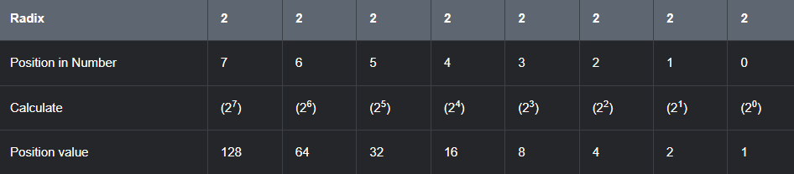
The following bullets describe each row of the table
  - Row 1 = Radix is the number base Binary notation is based on 2, therefore the radix is 2.
  - Row 2 – Position in number considers the position of the binary number starting with, from right to left, 0 (1st position), 1 (2nd position), 2 (3rd position), 3 (4th position). These numbers also represent the exponential value used to calculate the positional value in the 4th row.
  - Row 3 – Calculates the positional value by taking the radix and raising it by the exponential value of it’s position in Row 2
  - Row 4 – Positional value represents units of ones, twos, fours, eights, etc.

The example in the table illustrates how a binary number 11000000 corresponds to the number 192. If the binary number had been 10101000, then the corresponding decimal number would be 168.
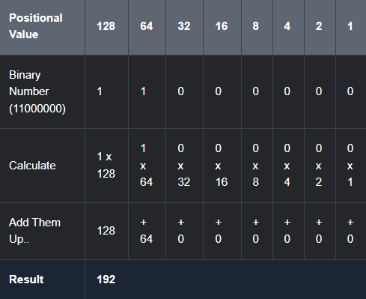

Convert Binary to Decimal
To convert a binary IPv4 address to its dotted decimal equivalent, divide the IPv4 address into four 8-bit octets. Next apply the binary positional value to the first octet binary number are calculate accordingly.
For example, consider that 11000000.10101000.00001011.00001010 is the binary IPv4 address of a host. To convert the binary address to decimal, start with the first octet, as shown in the table. Enter the 8bit binary number under the positional value of row 1 and then calculate to produce the decimal umber 192. This number goes into the first octet of the dotted decimal notation.
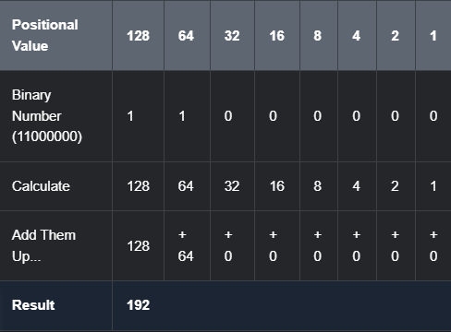
Next, convert the second octet of 10101000 as shown in the table. The resulting decimal value is 168, and it goes into the second octet.
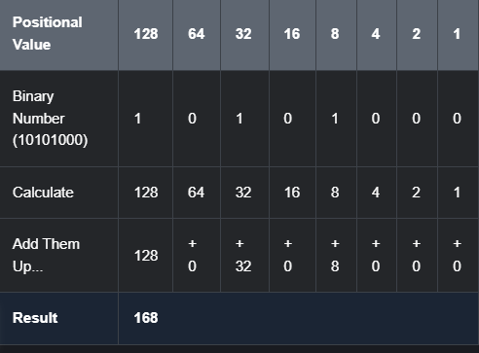
Convert the third octet of 00001011 as shown in the table.
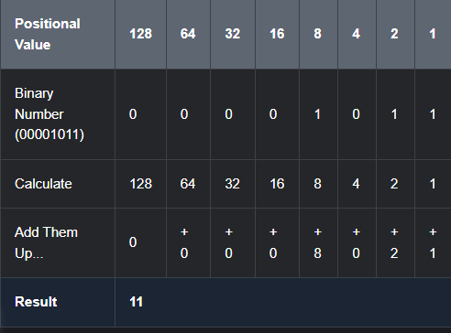
Convert the fourth octet of 00001010 as shown in the table. This completes the IP address and produces 192.168.11.10
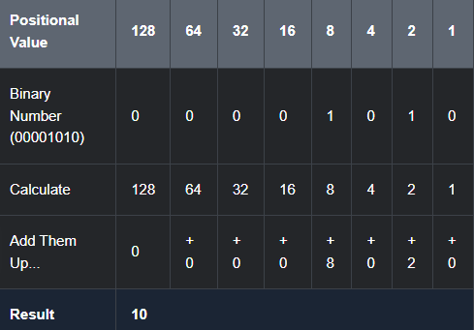

Decimal to Binary Conversion
It is also necessary to understand how to convert dotted decimal IPv4 address to binary. A useful tool in the binary positional value table.
Imagine our IPv4 address is 192.168.10.11
Break 192 down into an octet:
128 | 64 | 32 | 16 | 8 | 4 | 2 | 1

Check each position starting at 128 and work left to right, to the 1 position.
Starting from 128, is the decimal number of the octet is <= or > than 128?
If it is > (greater than) , then enter a 0 in the 128 positional value.
If is <= (Less than or equal to), then enter a 1 in the 128 positional value and then subtract 128 from the decimal value.
Since 128 is less than 192, we can place a 1 in the 128 positional value, like so
128 | 64 | 32 | 16 | 8 | 4 | 2 | 1
1

We then subtract 128 from 192 to get us 64.
Then we check if the new decimal number of 64 (192 – 128 ) is <= or > than 64.
Since it is, we will place a “1” under the 64 positional value. Like so:
128 | 64 | 32 | 16 | 8 | 4 | 2 | 1
1 | 1

Then we repeat the steps of subtracting 64 from our decimal number. 64 – 64. This leaves us with 0. AS we have no longer anything left in our decimal, we will place 0s in the remaining positional values. Like so
128 | 64 | 32 | 16 | 8 | 4 | 2 | 1
1 | 1 | 0 | 0 | 0 | 0 | 0 | 0

This means the binary value of our first octet, 192 is 11000000.
We repeat the above until we have converted all 4 octets.

IPv4 Addresses
As mentioned in the beginning of this topic, routers and computers only understand binary, while humans work in decimal. It is important for you to gain a thorough understanding of these two numbering systems and how they are used in networking.
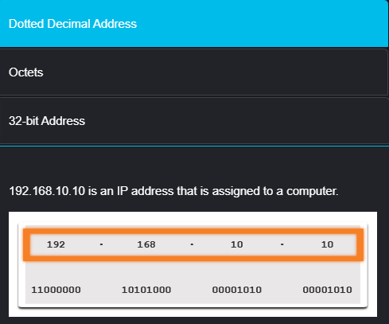
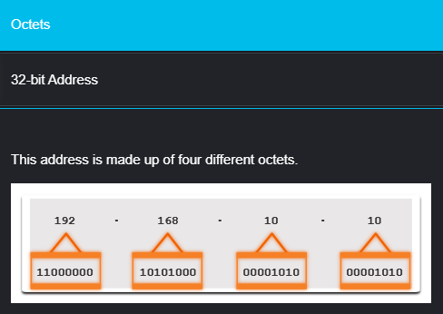
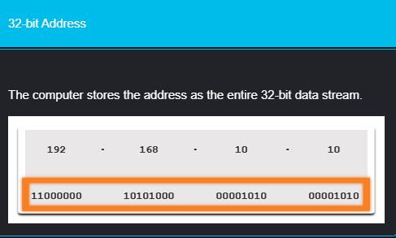

Hexadecimal Number Systems

Hexadecimal and IPv6 Addresses
Now you know how to convert binary to decimal and decimal to binary. You need that skill to understand IPv4 addressing in your network. But you are just as likely to be using IPv6 addresses in your network. To understand IPv6 addresses, you must be able to convert hexadecimal to decimal and vice versa
Just as decimal is a base ten number system, hexadecimal is a base sixteen system. The base sixteen number system uses the digits 0 – 9 and the letters A to F. The figure shows the equivalent decimal and hexadecimal values for binary 0000 to 1111
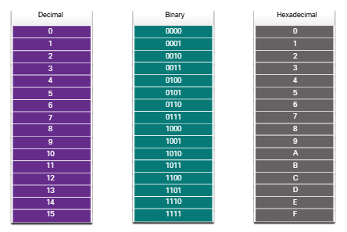

Binary and hexadecimal work well together because it is easier to express a value as a single hexadecimal digit that as four binary bits.
The hexadecimal numbering system is used in networking to represent IP Version 6 addresses and Ethernet MAC addresses.
IPv6 addresses are 128 bits in length and every 4 bits is represented by a single hexadecimal digit, for a total of 32 hexadecimal values. IPv6 addresses are not case-sensitive and can be written either in lowercase or uppercase.
As shown in the figure, the preferred format for writing IPv6 address is x:x:x:x:x:x:x:x, with each “x” consisting of four hexadecimal values. When referring to 8 bits of an IPv4 address we use the term octet. In IPv6, a hextet is the unofficial term used to refer to a segment o 16 bits or our hexadecimal value. Each “x” is a single hextet, 16 its or four hexadecimal digits.
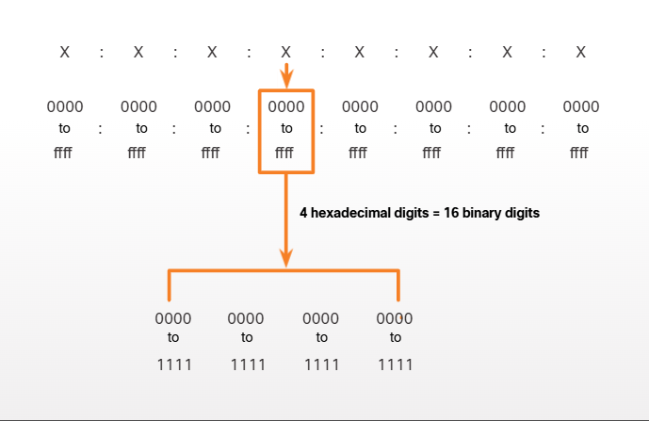The sample topology in the figure displays IPv6 hexadecimal addresses
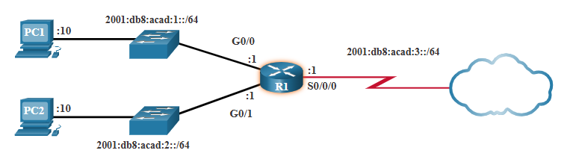

Decimal to Hexadecimal Conversions
Converting decimal numbers to hexadecimal values is straightforward. Follow the steps listed:
- Convert the decimal number to 8-bit binary strings
- Divide the binary strings in groups of four, starting from the rightmost position
- Convert each binary number into the equivalent hexadecimal digit.
The example provides the steps for converting 168 to a hexadecimal.
- 168 is binary 10101000
- 10101000 in two groups of 4 binary digits is 1010 and 1000
- 1010 is hex A and 1000 is hex B
Answer: 168 is AB in hexadecimal.

Hexadecimal to Decimal Conversions
Converting hexadecimal numbers to decimal values is also straightforward. Follow the steps listed:
- Convert the hexadecimal number to 4-bit binary strings
- Create 80bit binary grouping starting from the rightmost position
- Convert each 80bit binary grouping into the equivalent decimal digit.
This example provides the steps for converting D2 to decimal
- D2 in 4-bit binary strings is 1101 and 0010
- 1101 and 0010 is 11010010 in an 8-bit grouping.
- 11010010 in binary is equivalent to 210 in decimal
Answer: D2 in hexadecimal is 210 in decimal.

Data Link Layer

Purpose of the Data Link Layer
The Data Link Layer is responsible for communications between end-device network interface cards (NICs). It allows upper layer protocols to access the physical layer media and encapsulates Layer 3 packets (Iv4 and IPv6) into Layer 2 Frames. It also performs error detection and rejects corrupted frames.
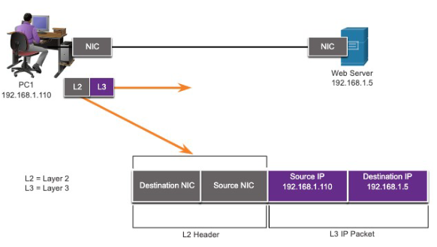
IEEE 802 LAN/MAN standards are specific to the type of network (Ethernet, WLAN, WPAN, etc.)
The Data Link Layer consists of two sublayers; the Logical Control (LLC) and the Media Access Control (MAC).
  - The LLC sublayer communicates between the networking software at the upper layers and the device hardware at the lower layers.
  - The MAC sublayer is responsible for data encapsulation and media access control.
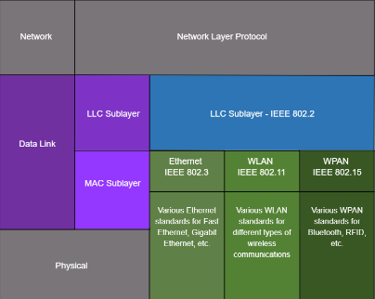

Packets exchanged between nodes may experience numerous data link layers and media transitions. At each “hop along he path,” a router performs our basic Layer 2 functions:
  - Accepts a frame from the network medium
  - De-encapsulates the frame to expose encapsulated packet.
  - Re-encapsulates the packet into a new frame.
  - Forwards the new frame on the medium of the net network segment.

Topologies
The topology of a network is the arrangement and relationship of the network devices and the interconnections between them. There are two types of topologies when describing networks:
  - Physical topology – Shows physical connections and how devices are interconnected.
  - Logical topology – Identifies the virtual connections between devices using device interfaces and IP addressing schemes.
There are three types of common physical WAN topologies:
  - Point-to-point – The simplest and most common WAN topology. Consists of a permanent link between two endpoints.
    - Physical point-to-point topologies directly connect two nodes.
    - The nodes may not share the media with other hosts.
    - Because all frames on the media can only travel to or from the two nodes, point-to-point WAN protocols can be very simple.
  - Hub and spoke – Similar to a “star” topology, where a central site interconnects branch sites through point-to-point links.
  - Mesh – Provides high availability but requires every end system to be connected to every other end system.
End devices on LANs are typically interconnected using a “star” or “extended star” topology. Star and extended star topologies are easy to install, very scalable and easy to troubleshoot.
Early Ethernet and Legacy Token Ring technologies provide two additional topologies:
  - Bus – All end systems chained together and terminated at each end.
  - Ring – Each end system s connection to its respective neighbors to form a ring.

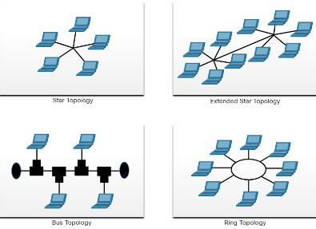

Half-duplex Communications
- Only allows one device to send or receive at a time on a shared medium.
- Used on WLAN and legacy bus topologies with Ethernet hubs
  - Contention-based Access – All nodes operating in half-duplex, competing for use of the medium.
    - Carrier sense multiple access with collision detection (CSMA/CD) as used on legacy bus-topology Ethernet
    - CSMA/CD
      - Used by legacy Ethernet LANs
      - Operates in half-duplex mode where only one device sends or receives at a time.
      - Uses a collision detection process to govern when a device can send and what happens if multiple devices send at the same time.
      - CSMA/CD collision detection process
        - Devices transmitting simultaneously will result in a signal collision on the shared media.
        - Devices detect the collision.
        - Devices wait a random period of time and retransmits data
    - Carrier sense multiple access with collision avoidance (CSMA/CA) as used on Wireless LANs.
    - CSMA/CA
      - Used by IEEE 802.11 WLANs
      - Operates in half-duplex mode where only one device sends or receives at a time.
      - Uses a collision avoidance process to govern when a device can send and what happens if multiple devices send at the same time.
      - CSMA/CA collision avoidance process:
        - When transmitting, devices also include the time duration needed for the transmission.
        - Other devices on the shared medium receive the time duration information and know how long the medium will be unavailable.

Full-duplex Communications
- Allows both devices to simultaneously transmit and receive on a shared medium.
- Ethernet switches operate in full-duplex mode.

Controlled access
- Deterministic access where each node has its own time on the medium.
- Used in legacy networks such as Token Ring and ARCNET.

Data Link Frame
Data is encapsulated by the data link layer with a header and a trailer to form a frame. A data link frame has three parts:
    - Header
    - Data
    - Trailer
The fields of the header and trailer vary according to data link layer protocol.
The amount of control information carried with in the frame varies according to access control information and logical topology.

Frame Field
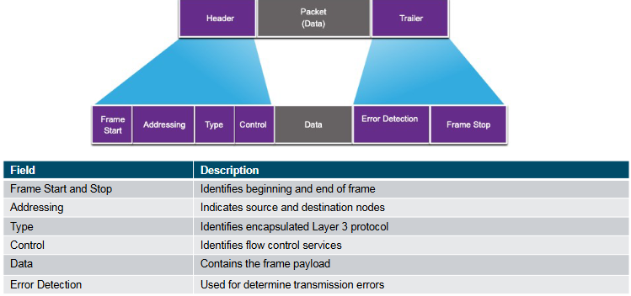

Layer 2 Addresses
The Layer 2 Address is also referred to as a physical address. It is contained in the frame header and is used only for local delivery of a frame on the link. It is updated by each device that forwards the frame.

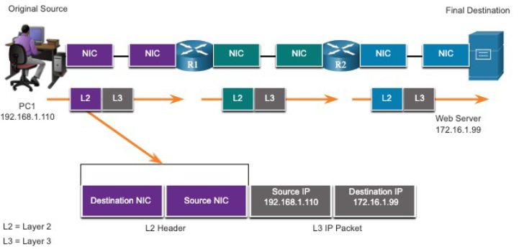

The logical topology and physical media determine the data link protocol used:
- Ethernet
- 802.11 Wireless
- Point-to-Point (PPP)
- High0Level Data Link Control (HDLC)
- Frame-Relay

Each protocol performs media access control for specified logical topologies.

Ethernet Switching

Ethernet Frames

Ethernet Encapsulation
Ethernet is one of two LAN technologies used today, with the other being wireless LANs (WLANs). Ethernet uses wired communications, including twisted pair, fiber-optic links and coaxial cables.
Ethernet operates in the data link layer and the physical layer. It is a family of networking technologies defined in the IEEE 802.2 and 802.3 standards. Ethernet supports data bandwidth of the following:
- 10 Mbps
- 100 Mbps
- 1000 Mbps (1 Gbps)
- 10 000 Mbps (10 Gbps)
- 40 000 Mbps (40 Gbps)
- 100 000 Mbps (100 Gbps)

As shown in the figure, Ethernet standards define both the Layer 2 protocols and the layer 1 technologies.
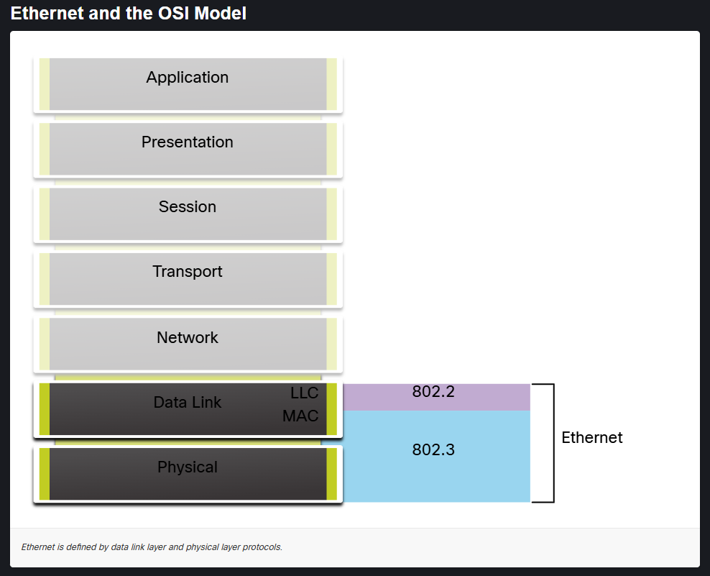

Data Link Sublayers
IEEE 802 LAN/MAN protocols, including Ethernet, use the following two separate sublayers of the data link layer to operate. They are the Logical Link Control (LLC) and the Media Access Control (MAC), as shown in the figure below.
Recall that LLC and MAC have the following roles in the Data Link Layer:
  - LLC Sublayer – This IEEE 802.2 sublayer communicates between the networking software at the upper layers and the device hardware at the lower layers. It places information in the frame that identifies which network layer protocol is being used for the frame. This information allows multiple Layer 3 protocols, such as IPv4 and IPv6 to use the same network interface and media.
  - MAC Sublayer – This sublayer (IEEE 802.3, 802.11, or 802.15, for example) is implemented in hardware and is responsible for data encapsulation and media access control. It provides data link layer addressing and is integrated with various physical layer technologies.

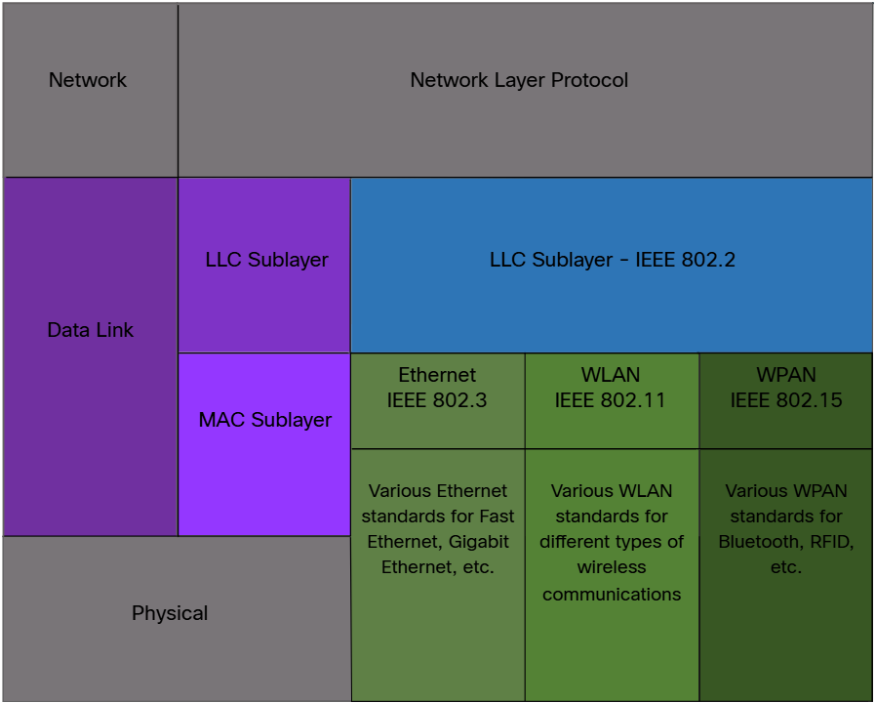

MAC Sublayer
The MAC sublayer is responsible for data encapsulation and access the media.
IEEE 802.3 data encapsulation includes the following:
  - Ethernet frame - This is the internal structure of the Ethernet frame
  - Ethernet Addressing – The Ethernet frame includes both a source and destination MAC address to deliver the Ethernet frame from Ethernet NIC to Ethernet NIC on the same LAN
  - Ethernet Error detection – The Ethernet frame includes a frame check sequence (FCS) trailer used for error detection.

As shown in the figure, the IEEE 802.3 MAC sublayer includes the specifications for different Ethernet communications standards over various types of media including copper and fiber.

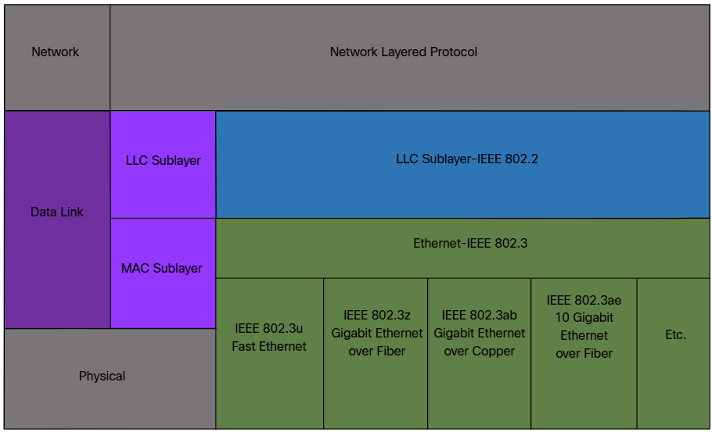

Recall that legacy Ethernet using a bus topology or hubs, is a shared, half-duplex medium. Ethernet over a half-duplex medium uses a contention-based access method, carrier sense multiple access/collision detection (CSMA/CS). This ensures that only one device is transmitting at a time. CSMA/CD allows multiple devices to share the same half-duplex medium, detecting a collision when more than one device attempts to transmit simultaneously. It also provides a back-off algorithm for retransmission.
Ethernet LANs of today use switches that operate in full-duplex. Full-duplex communications with Ethernet switches do not require access control through CSMA/CD.

Ethernet Frame Fields
The minimum Ethernet frame size is 64 bytes, with an expected maximum of 1518 bytes. This includes all bytes from the destination MAC address field through the frame check sequence (FCS) field. The preamble field is not included when describing the size of the frame.
Note: The frame size may be larger if additional requirements are included, such as VLAN tagging. VLAN tagging is beyond the scope of this course.
Any frame less than 64 bytes in length is considered a “collision fragment” or “runt frame” and is automatically discarded by receiving stations. Frames more than 1500 bytes of data are considered “jumbo” or “baby giant frames”.
If the size of a transmitted frame is less than the minimum, or greater than the maximum, the receiving device drops the frame. Dropped frames are likely to be the result of collisions or other unwanted signals. They are considered invalid. Jumbo frames are usually supported by most Fast Ethernet and Gigabit Ethernet switches and NICs.
The figure shows each field in the Ethernet frame. Refer to the table for more information about the function of each field.
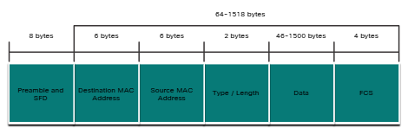

Preamble and Start Frame Delimiter Fields | The Preamble (7 bytes) and Start Frame Delimiter (SFD), also called the Start of Frame (1 byte), fields are used for synchronization between the sending and receiving devices. These first eight bytes of the frame are used to get the attention of the receiving nodes. Essentially, the first few bytes tell the receivers to get ready to receive a new frame.
Destination MAC Address Field | This 6-byte field is the identifier for the intended recipient. As you will recall, this address is used by Layer 2 to assist devices in determining if a frame is addressed to them. The address in the frame is compared to the MAC address in the device. If there is a match, the device accepts the frame. Can be a unicast, multicast or broadcast address.
Source MAC Address Field | This 6-byte field identifies the originating NIC or interface of the frame.
Type / Length | This 2-byte field identifies the upper layer protocol encapsulated in the Ethernet frame Common values are, in hexadecimal, 0x800 for IPv4, 0x86DD for IPv6 and 0x806 or ARP. Note: You may also see this field referred to as EtherType, Type or Length
Data Field | This field (46-1500 bytes ) contains the encapsulated data from a higher layer, which is a generic Layer 3 PDU, or more commonly, an IPv4 packet. All frames must be at least 64 bytes long. IF a small packet is encapsulated, additional bits called a pad are used to increase the size of the frame to this minimum size.
Frame Check Sequence Field | The Frame Check Sequence (FCS) field (4 bytes) is used to detect errors in a frame. It uses a cyclic redundancy check (CRC). The sending device includes the results of a CRC in the DCS field of the frame. The receiving device receives the frame and generates a CRC to look for errors. If the calculations match, no error occurred. Calculations that do not match and in indication that the data has changed; therefore, the frame is dropped. A change in the data could be the result of disruption of the electrical signals that represent the bits.

Ethernet MAC Address

MAC Address and Hexadecimal
To reiterate, IPv4 addresses are represented using the decimal base 10 number system and the binary base 2 number system. IPv6 addresses and Ethernet addresses are represented using the hexadecimal base 16 number system.
An Ethernet MAC address consists of a 46-bit binary value. Hexadecimal is used to identify an Ethernet address because a single hexadecimal digit represents 4 binary bits. Therefore, a 48-bit Ethernet MAC address can be expressed using only 12 hexadecimal values.
The figure compares the equivalent decimal and hexadecimal values for binary 0000 to 1111
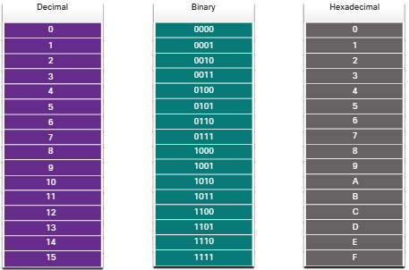
Given that 8 bites (1 byte) is a common binary grouping, binary 00000000 to 11111111 can be represented in hexadecimal as the range 00 to FF. As shown below:
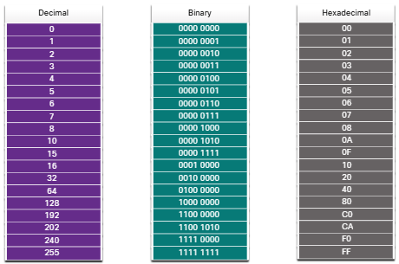
When using hexadecimal, leading zeros are always displayed to complete the 8-bit representation. For example, in the table, the binary value 000 1010 is shown in hexadecimal as 0A
Hexadecimal numbers are often represented by the value preceded by 0x (e.g., 0x73) to distinguish between decimal and hexadecimal values in documentation.
Hexadecimal may also be represented by a subscript 16, or the hex number followed by an H (e.g., 73H).
You may have to convert between decimal and hexadecimal values. If such conversions are require, convert the decimal or hexadecimal value to binary, and then to convert the binary value to either decimal or hexadecimal as appropriate.

Ethernet MAC Address
In an Ethernet LAN, every network device is connected to the same, shared media. The MAC address is used to identify the physical source and destination device (NICs) on the local network segment. MAC addressing provides a method for device identification at the data link layer of the OSI model.
An Ethernet MAC address is a 48-bit address expressed using 12 hexadecimal digits, as shown in the figure. Because a byte equals 8 bits, we can also say that a MAC address is 6 bytes in length.
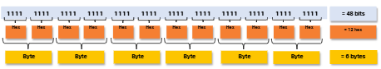

All MAC addresses must be unique to the Ethernet device or Ethernet interface. To ensure this, all vendors that sell Ethernet devices must register with the IEEEE to obtain a unique 6 hexadecimal (i.e., 24-bit or 3-byte) code called the organizationally unique identifier (OUI).
When a vendor assigns a MAC address to a device or Ethernet interface, the vendor must do as follows:
- Use its assigned OUI as the first hexadecimal digits.
- Assign a unique value in the last 6 hexadecimal digits.

Therefore, an Ethernet MAC address consists of a 6-hexadecimal vendor OUI code followed by a 6-hexadecimal vender-assigned value, as shown in the figure.
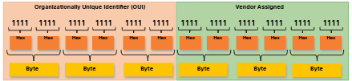
For example, assume that Cisco needs to assign a unique MAC address to a new device. The IEEE has assigned the Cisco a OUI of 00-60-2f. Cisco would then configure the device with a unique vendor code such as 3A-07-BC. Therefore, the Ethernet MAC address of that device would be 00-60-sF-3A-07-BC.
It is the responsibility of the vendor to ensure that none of its devices be assigned the same MAC address. However, it is possible for supplicate MAC addresses to exist because of mistakes made during manufacturing, mistakes made in some virtual machine implementation methods, or modifications made using one of several software tools. In any case, it will be necessary to modify the MAC address with a new NIC or make modifications via software.

Frame Processing
Sometimes the MAC address is referred to as a burned is address (BIA) because the address is hardcoded into the read-only memory (ROM) on the NIC. This means that the address is encode into the ROM chip permanently.
Note: On modern PC operating systems and NICs, it is possible to change the MAC address in software. This is useful when attempting to gain access to a network that filters based on BIA. Consequently, filtering or controlling traffic base on the MAC address is no longer as secure.
When the computer boots up, the NIC copies its MAC address from ROM into RAM. When a device is forwarding a message to an Ethernet network, the Ethernet header includes these:
- Source MAC address – This is the MAC address of the source device NIC
- Destination MAC address – This is the MAC address of the destination device NIC

When a NIC received an Ethernet frame, it examines the destination MAC address to see if it matches the physical MAC address that is stores in RAM If there is no match, the device discards the frame. IF there is a match, it passes the frame up to the OSI layers, where the de-encapsulation process takes place.
Note: Ethernet NICs will also accept frames if the destination MAC address isa broadcast or multicast group o which the host is a member.

Any device that is the source or destination of the Ethernet frame, will have an Ethernet NIC and there, a MAC address. This includes workstations, servers, printers, mobile devices and routers.

Unicast MAC address
In Ethernet, different MAC addresses are use for Layer 2 unicast, broadcast and multicast communications.
A unicast MAC address is the unique address that is use when a frame is sent from a single transmitting device to a single destination device.

As an example, a host with IPv4 address 192.168.1.5 (source) requests a web page from the server at IPv4 unicast address 192.168.1.200. For a unicast packet to be sent and received, a destination IP address must be n the IP packet header. A corresponding destination MAC address must also be present in the Ethernet frame header. He IP address and the MAC address combine to deliver data to one specific destination host.
Note: The source MAC address must always be unicast.

Broadcast MAC Address
An Ethernet broadcast frame is received and processed by every device on the Ethernet LAN. The features of the Ethernet broadcast are as follows:
- It has a destination MAC address of FF-FF-FF-FF-FF-FF in hexadecimal (48 ones in binary).
- It is flooded out to all Ethernet switch ports except the incoming port.
- It is not forwarded by a router.
If the encapsulated data is in IPv4 broadcast packet, this means the packet contains a destination IPv4 address that has all ones (1s) in the host portion. This numbering in the address means that all hosts on that local network (broadcast domain) will receive and process the packet.
As an example, the source host sends an IPv4 broadcast packet to all devices on its network. The IPv4 destination address is a broadcast address, 192.168.1.255. When the IPv4 broadcast packet is encapsulated in the Ethernet frame, the destination MAC address is the broadcast MAC address of FF-FF-FF-FF-FF-FF in hexadecimal (48 ones in binary).
DHCP for IPv4 is an example of protocol that uses Ethernet and IPv4 broadcast addresses.
However, not all Ethernet broadcasts carry an IPv4 broadcast packet. For example, ARP Requests do not use IPv4, but the ARP message is sent as an Ethernet broadcast.

Multicast MAC address
AN Ethernet multicast frame is received and processed by a group of devices on the Ethernet LAN that belong to the same multicast group. The features of an Ethernet multicast are as follows:
- There is a destination MAC address of 01-00-5E when the encapsulated data is an IPv4 multicast packet and a destination MAC address of 33-33 when the encapsulated data is an IPv6 multicast packet.
- There are other reserved multicast destination MAC address for when the encapsulated data is not an IP, such as Spanning Tree Protocol (STP) and Link Layer Discovery Protocol (LLDP).
- It is flooded out all Ethernet witch port except the incoming port, unless the switch is configured for multicast snooping.
- It is not forwarded by a router, unless the router is configured to route multicast packets.

If the encapsulated data is an IP multicast packet, the devices that belong to a multicast group are assigned a multicast group IP address. The range of IPv4 multicast address is 144.0.0.0 to 239.255.255.255. The range of IPv6 multicast addresses begins with ff00::/8. Because multicast addresses represent a group of addresses (sometimes called a host group), they can only be use as the destination of a packet. The source will always be a unicast address.
As with the unicast and broadcast addresses, the multicast IP address requires a corresponding multicast MAC address to deliver frames on a local network. The multicast MAC address is associate with, and uses addressing information from, the IPv4 or IPv6 multicast address.

The MAC Address Table

Switch Fundamentals
Now that we know about Ethernet MAC addresses, it is time to talk about how a switch uses these addresses to forward (or discard) frames to other devices on a network. If a switch just forwarded every frame it received out to all ports, your network would be so congested that it would likely just stop working.
At Layer 2 Ethernet switch uses Layer 2 MAC addresses to make forwarding decisions. It is completely unaware of the data (protocol) being cared in the data portion of the frame, such as an IPv4 packet, an ARP message, or an IPv6 ND packet. The switch makes its forwarding decisions based solely on the Layer 2 Ethernet MAC addresses.
An Ethernet switch examines its MAC address table to make a forwarding decision for each frame, unlike legacy Ethernet hubs that repeat bits out all ports except the incoming port. In the figure, the four-port switch was just powered on. The table shows the MAC address Table which has not yet learned the MAC addresses for the four attached PCs.
Note: MAC addresses are shortened throughout this topic for demonstration purposes.
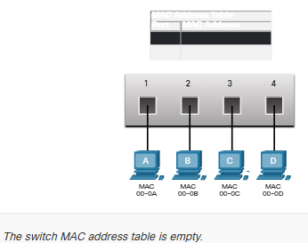
Note: The MAC address table is sometimes referred to as a content addressable memory (CAM) table. While the term CAM table is common, for the purposes of tis course, we will refer to it as a MAC address table.

Switch Learning and Forwarding
The switch dynamically builds the MAC address table by examining the source MAC address of the frames received on a port. The switch forwards frames by searching for a match between the destination MAC address in the frame and an entry in the MAC address table.
Examine the Source MAC Address
Every frame that enters a switch is checked for new information to learn. It does this by examining the source MAC address of the frame and the port number where the frame entered the switch. If the source MAC address does not exist, it is added to the table along with the incoming port number. If the source MAC address does exist, the switch updates the refresh timer for that entry in the table. By default, most Ethernet switches keep an entry n the table for 5 minutes.
In the figure, for example, PC-A is sending an Ethernet frame to PC-D. The table show he switch adds the MAC address for PC-A to the MAC Address table.
Note: If the Source MAC address does exist in the table but on a different port, the switch treats this as a new entry. The entry is replace using the same MAC address but with the more current port number.
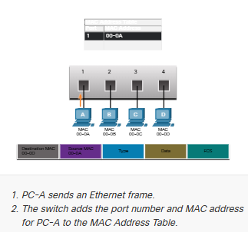

Find the Destination MAC Address
If the destination MAC address is a unicast address, the witch will look for a match between the destination MAC address of the frame and an entry in its MAC address table If the destination MAC address is in the table, it will forward the frame out the specified port. If the destination MAC address is not in the able, the switch will forward the frame out all ports except the incoming port. This is called an unknown unicast.
As shown in the figure, the switch does not have the destination MAC address in its table for PC-D so it sends the frame out all ports except for port 1
Note: If the destination MAC address is a broadcast or a multicast, the frame is also flooded out all ports except the incoming port.

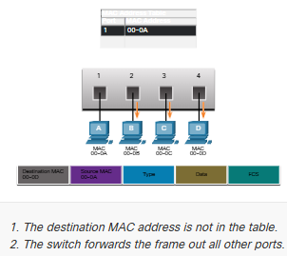

Filtering Frames
As a switch received frames from different devices, it can populate its MAC address table by examining the source MAC address of every frame. When the MAC address table of the switch contains the destination MAC address, it can filter the frame and forward out a single port.
PC-D to Switch
In the figure, PC-D is replying to PC-A. The switch sees the MAC address of PC-D in the incoming frame on port 4. The switch then puts the MAC address of PC-D into the MAC address Table associated with port 4
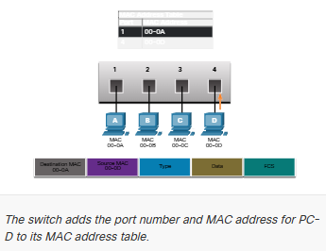

Switch to PC-A
Next, because the switch has destination MAC address for PC-A in the MAC Address Table, it wills end the frame only out port 1, as shown in the figure.
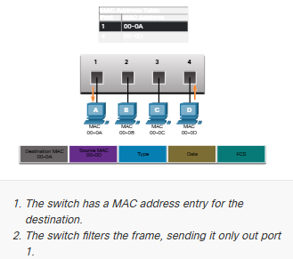
PC-A to Switch to PC-D
Next, PC-A sends another frame to PC-D, as shown in the figure. The MAC address table already contains the MAC address for PC-A; therefore, the five-minute refresh timer for that entry is reset. Next, because the switch table contains the destination MAC address for PC-D, it sends the frame only out port 4.
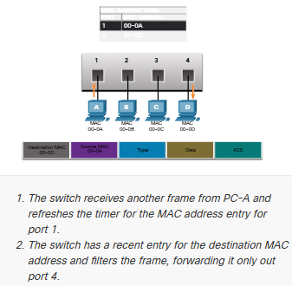

Switch Speeds and Forwarding

Frame Forwarding Methods on Cisco Switches
As you learned in the previous topic, switches use their MAC address tables to determine which port to use to forward frames. With Cisco switches, there are two frame forwarding methods and there are good reasons to use one instead of the other, depending on the situation
Switches use one of the following forwarding methods for switching data between network ports:
- Store-and-forward switching – This frame forwarding method receives the entire frame and computes the CRC. CRC uses a mathematical formula, base on the number of bits (1s) in the frame, to determine whether the receive frame has an error. If the CRC is valid, the switch looks up the destination address, which determines the outgoing interface. Then the frame is forwarded out to the correct port.
- Cut-through switching – This frame forwarding method forwards the frame before it is entirely received. At a minimum, the destination address of the frame must be rea before the frame can be forwarded.

A big advantage of store-and-forward switching is that it determines if a frame has errors before propagating the frame. When an error is detected in a frame, the switch discards the frame. Discarding frames with errors reduces the amount o bandwidth consumed by corrupt data. Store-and-forward witching is required for quality of service (QoS) analysis on converged networks where frame classification for traffic prioritization is necessary. For example, voice over IP (VoIP) data streams nee to have priority over web-browsing traffic.

Cut-Through Switching
In cut-through switching, the switch acts upon the data as soon as it is received, even if the transmission is not complete. The switch buffers just enough of the frame to read the destination MAC address so that it can determine to which port it should forward out the data. The destination MAC address is located in the first 6 bytes of the frame following the preamble. The switch looks up the destination MAC address in its switching table, determines the outgoing interface port, and forwards the frame onto its destination through the designate switch port. The switch does not perform any error checking on the frame.

There are two variants of cut-through switching:
- Fast-forward switching – Fast-forward switching offers the lowest level of latency. Fast-forward switching immediately forwards a packet after reading the destination address. Because fast-forward switching starts forwarding before the entire packet has been receive, there ma be times when packets are relayed with errors. This occurs infrequently, and the destination NIC discards the faulty packet upon receipt. In fast-forward mode, latency is measured from the first bit receive to the first bit transmitted. Fast-forward switching is the typical cut-through method of switching.
- Fragment-free switching – In fragment-free switching, the switch stores the first 64 bytes of the frame before forwarding. Fragment-free switching can be viewed as a compromise between store-and-forward switching and fast-forward switching. The reason fragment-free switching stores only the first 64 bytes of the frame is that most network errors and collisions occur in the first 64 bytes. Fragment free switching tries to enhance fast-forward switching by performing a small error check on the first 64 bytes of the frame to ensure that a collision has not occurred before forwarding the frame. Fragment-free switching is a compromise between the high latency and high integrity of store-and-forward switching, and the low latency and reduced integrity of fast-forward switching.
Some switches are configured to perform cut-through switching on a per-port basis util a user-define error threshold is reached, and then they automatically change to store-and-forward. When the error rate falls below the threshold, the port automatically changes back to cut-through switching.

Memory Buffering on Switches
An Ethernet switch may use a buffering technique to store frames before forwarding them. Buffering may also be use when the destination port is busy because of congestion. The switch stores the frame until it can be transmitted.
As shown in the table, there are two methods of memory buffering:

Memory Buffering Methods

Method | Description
Port-based memory | - Frames are stored in queues that are linked to specific incoming and outgoing ports.  - A frame is transmitted to the outgoing port only when all the frames ahead in the queue have been successfully transmitted  - It is possible for a single frame to delay the transmission of all the frames in memory.  - This delay occurs even if the other frames could be transmitted to open destination ports.
Shared memory | - Deposits all frames into a common memory buffer shared by all switch ports and the amount of buffer memory required b a port is dynamically allocated.  - The frames in the buffer are dynamically linked o the destination port enabling a packet to be receive on one port and then transmitted on another port, without moving it to a different queue.
Shared memory buffering also results in the ability to store larger frames with potentially fewer dropped frames. This is important with asymmetric switching which allows for different data rates on different ports sch as when connecting a server to a 10 Gbps switch port and PCs to 1 Gbps ports.

Duplex and Speed Settings
Two of the most basic settings on a switch are the bandwidth (sometimes referred to as “speed”) ad duplex settings for each individual switch port. It is critical that the duplex and bandwidth setting match between the switch port and the connected devices, such as a computer or another switch.
There are to types of duplex settings sued for communications on an Ethernet network:
- Full-duplex – Both ends of the connection can send and receive simultaneously.
- Half-duplex – Only one end o the connection can send at a time.

Autonegotiation is an optional function found on most Ethernet switches and NICs. It enables two devices to automatically negotiate the best speed and duplex capabilities. Full duplex is chosen if both devices have the capability along with their highest common bandwidth.
In the figure, the Ethernet NIC for PC-A can operate in full-duplex of half-duplex and in 10 Mbps or 100 Mbps.
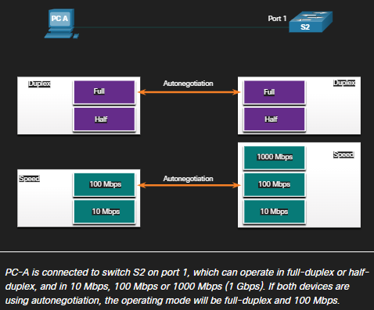

Note: Most Cisco switches and Ethernet NICs default to autonegotiation for speed and duplex. Gigabit Ethernet ports only operate in full-duplex.
Duplex mismatch is one of the most common causes of performance issues on 10/100 Mbps Ethernet links. It occurs when one port on the link operates at half duplex while the other port operates at full-duplex, as shown in the figure.
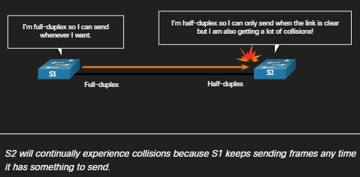

Duplex mismatch occurs when one or both ports on a link are reset, and the autonegotiation process does not result in both link partners having the same configuration. It also can occur when users reconfigure one side of a link and forget to reconfigure the other. Both sides of a link should have autonegotiation on, or both sides should have it off. Best practice is to configure both Ethernet switch ports as full-duplex.

Auto-MDIX
Connections between devices once required the use of either a crossover or straight-through cable. The type of cable required depended on the type of interconnecting devices.
For example, the figure identifies the correct cable type required to interconnect witch-to-switch, switch-to-router, switch-to-host or router-to-host devices. A crossover cable is used when connecting like devices, and a straight-through cable is use for connecting unlike devices.
Note: A direct connection between a router and a host requires a cross-over connection.

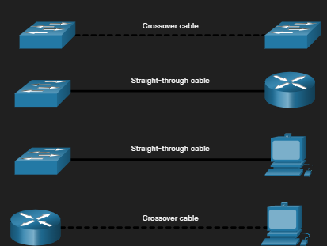

Most switch devices now support the automatic medium-dependant interface crossover (auto-MDIX) feature. When enabled, the switch automatically detects the type of cable attached to the port and configures the interfaces accordingly. Therefore, you can use either a crossover or a straight0through cable for connections to a copper 10/100/1000 port on the switch, regardless of the type of device on the other end of the connection.
The auto-MDIX feature is enabled by default on switching running Cisco IOS release 12.2(18)SE or later. However, the feature could be disable. For this reason, you should always use correct cable type and not rely on the auto-MDIX feature. Auto-MDIX can be re-enable using the mdix auto interface configuration command.

Network Layer

Network Layer Characteristics

The Network Layer
The network layer or OSI Layer 3, provides services to allow end devices to exchange data across networks. As show in the figure, IP version 4 (IPv4) and IP version 6 (IPv6) are the principle network layer communication protocols. Other network layer protocols include routing protocols such as Open Shortest Path First (OSPF) and messaging protocols such as Internet Control Message Protocol (ICMP).
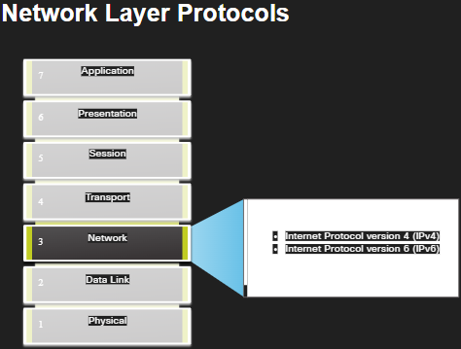
To accomplish end-to-end communications across network boundaries, network layer protocols perform four basic operations:
- Addressing end devices – End devices must be configured with a unique IP adder for identification on the network.
- Encapsulation – The network layer encapsulates the protocol data unit (PDU) from the transport layer into a packet. The encapsulation process adds IP header information, such as the IP address of the source (sending) and the destination (receiving) hosts. The encapsulation process is performed by the source of the IP packet.
- Routing – The network layer provides services to direct the packets to a destination host on another network. To travel to other networks, the packet must be processed by a router. The role of the router is to select the best path and direct packets toward the destination host in the process known as routing. A packet may cross many routers before reaching the destination host. Each router a packet crosses to reach the destination hos is called a hop.
- De-encapsulation – When the packet arrives at the network layer of the destination host, the host checks the IP header of the packet. If the destination IP address within the header matches its own IP address, the IP header is removed rom the packet. After the packet is de-encapsulated by the network layer, the resulting Layer 4 PDU is passed up to the appropriate service at the transport layer. The de-encapsulation process is performed by the destination host of the IP packet.

Unlike the transport layer (OSI Layer 4), which manages the data transport between the processes running on each host, network layer communication protocols (i.e, IPv4 and IPv6) specify the packet structure and processing used to carry the data from one host to another host. Operating without regard to the data carried in each packet allows the network layer to carry packets for multiple types of communications between multiple hosts.
The Network layer:
- Provides services to allow end devices to exchange data
- IP version 4 (IPv4) and IP version 6 (IPv6) are the principle network layer communication protocols.
- The network layer performs four basic operations:
  - Addressing end devices
  - Encapsulation
  - Routing
  - De-encapsulation

IP Encapsulation
IP encapsulates the transport layer (the layer just above the network layer) segment or other data by adding an IP header. The IP header is used to deliver the packet to the destination host.
The figure illustrates how the transport layer PFU is encapsulated by the network layer PDU to create an IP packet.
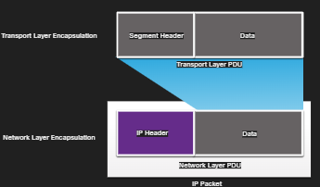

The process of encapsulating data layer by layer enables the services at the different layers to develop a scale without affecting the other layers. This means the transport layer segments can be readily packages by IPv4 or IPv6 or by any new protocol that might be developed in the future.
The IP header is examined by Layer 3 devices (i.e., routers and Layer 3 switches) as it travels across a network to its destination. It is important to note, that the IP addressing information remains the same from the time the packet leaves the source host until it arrives at the destination host, except when translated by the device performing Network Address Translations (NAT) for IPv6.
Note: NAT is discussed in later modules
Routers implement routing protocols to route packets between networks. The routing performed by these intermediary devices examines the network layer addressing in the packet header. In all cases, the data portion of the packet, that is, the encapsulated transport layer PDU or other data, remained unchanged during the network layer processes.
IP encapsulation:
- IP encapsulates the transport layer segment.
- IP can use either an IPv4 or IPv6 packet and not impact the Layer 4 segment
- IP packet will be examined by all Layer 3 devices as it traverses the network.
- The IP addressing does not change from source to destination
- NAT will change addressing.

Characteristics of IP
IP was designed as a protocol with low overhead. It provides only the functions that are necessary to deliver a packet from a source to a destination over an interconnected system of networks The protocol was not designed to track and manage the flow of packets. These functions, if requires, are performed by other protocols at other layers, primarily TCP at Layer 4.
These are the basic characteristics of IP:
- Connectionless – There is no connection with the destination established before sending data packets.
- Best efforts – IP is inherently unreliable because packet delivery is not guaranteed.
- Media Independent – Operation is independent of the medium (i.e., copper, fiber-optic, or wireless) carrying the data.

Connectionless
IP is connectionless, meaning that no dedicated end-to-end connection is created by IP before data is sent. Connectionless communication is conceptually similar to sending a letter to someone without notifying the recipient in advance.
Connectionless data communications work on the same principle. As shown in the figure, IP requires o initial exchange of control information to establish an end-to-end connection before packets are forwarded.
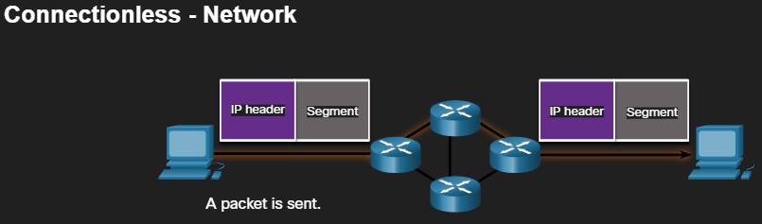
IP is connectionless
- IP does not establish a connection with the destination before sending the packet.
- There Is no control information needed (synchronizations, acknowledgements, etc)
- The destination will receive the packet when it arrives, but no pre-notifications are sent by IP
- If there is a need or connection-oriented traffic, then another protocol will handle this (typically TCP at the transport layer)

Best Effort
IP also does not require additional fields in the header to maintain an established connection. This process greatly reduces the overhead of IP. However, with no pre-established end-to-end connection, senders are unaware whether destination devices are present and functional when sending packets, or are they aware if the destination receives the packet, or if the destination deice is able to access and read the packet.
The IP protocol does not guarantee that all packets that are delivered are, in fact, received. The figure illustrates the unreliable or best-effort delivery characteristics of the IP protocol.
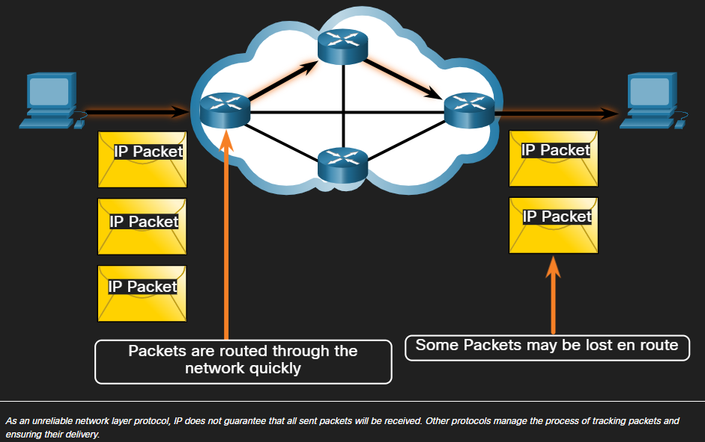
IP is Best Effort:
- IP will not guarantee delivery of the packet.
- IP has reduced overhead since there is no mechanism to resend data that is not received.
- IP does not expect acknowledgments.
- IP does not know I the other device is operational or if it received the packet.

Media Independent
Unreliable means that IP does not have the capability to manage and recover from undelivered or corrupt packets. This is because while IP packets are sent with information about the location of delivery, they do not contain information that can be processed to inform the send whether delivery was successful. Packets may arrive at the destination corrupted, out of sequence, or not at all. IP provides no capability for packet retransmissions if errors occur.
If out-of-order packets are delivered, or packers are missing then applications using the data, or upper layer services, must resolve these issues. This allows IP to function very efficiently. In the TCP/IP protocol suite, reliability is the role o the TCP protocol at the transport layer.
IP operates independently of the media that carry the data at lower layers of the protocol stack.
The OSI data link layer is responsible for taking an IP packet and preparing it for the transmission over the communications medium. This means that the delivery of IP packets is not limited to any particular medium.
There is, however, one major characteristic of the media that the network layer considers: the maximum size of the PDU that each medium can transport. This characteristic is referred to as the maximum transmission unit (MTU). Part of the control communication between the data link layer and the network layer is the establishment of a maximum size for the packet. The data link layer passes the MTU value up to the network layer. The network layer then determines how large packets can be.
In some cases, an intermediate device, usually a router, must split up an IPv4 packet when forwarding it from one medium to another medium with a smaller MTU. This process is called fragmenting the packet, or fragmentation. Fragmentation causes latency. IPv6 packets cannot be fragmented by the router.
IP is unreliable:
- It cannot manage or fix undelivered or corrupt packets.
- IP cannot retransmit after an error
- IP cannot realign out of sequence packets.
- IP must rely on other protocols for these functions

IP is media independent:
- IP does not concern itself with the type of frame required at the data link layer or the media type at the physical layer.
- IP can be sent over any media type: Copper fiber, or wireless.

The network layer will establish the Maximum Transmission Unit (MTU):
- Network layer receives this from control information sent by the data link layer.
- The network then establishes the MTU size.

Fragmentation is when Layer 3 splits the IPv4 packet into small units.
- Fragmenting causes latency
- IPv6 does not fragment packets.
- Example: Router goes from Ethernet to a slow WAN with a smaller MTU

IPv4 Packet

IPv4 Packet Header
IPv4 is one of the primary network layer communication protocols. The IPv4 packet header is used to ensure that this packet is delivered to its next stop on the way to its destination end device.
An IPv4 packet header consists of fields containing important information about the packet. These fields contain binary numbers which are examined by the Layer 3 Process
IPv4 Packet Header
  - It ensures the packet is sent in the correct direction (to the destination)
  - It contains information for network layer processing in various fields
  - The information in the header is used by all Layer 3 devices the handle the packet.

IPv4 Packet Header Fields
The binary values of each field identify various settings of the IP packet. Protocol header diagrams, which are read left to right, and top down, provide a visual to refer to when discussing protocol fields. The IP protocol header diagram in the figure identifies the fields of an IPv4.
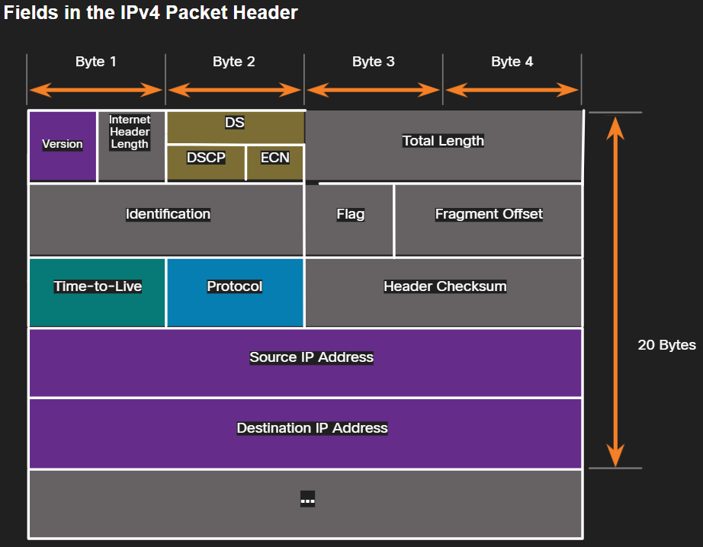

Significant fields in the IPv4 header include the following:
- Version – Contains a 4-bit binary value set to 0100 that identifies this as in IPv4 packet.
- Differentiated Services of DiffServ (DS) – Formerly called the type of service (ToS) field, the DS field is an 8-bit field used to determine the priority of each packet The six most significant bits of the DiffServ field are the differentiated services code point (DSCP) bits and the last two bits are the explicit congestion notification (ECN) bits
- Time to Live (TTL) – TTL contains an 8-bit binary value that is used to limit the lifetime of a packet. The source device of the IPv4 packet sets the initial TTL value. It is decreased by one each time the packet is processed by a router. If the TTL field decrements to zero, the router discards the packet and sends and Internet Control Messed Protocol (ICMP) Time Exceeded message to the source IP address. Because the router decrements the TTL of each packet, the router must also recalculate the Header Checksum.
- Protocol – This field is used to identify the next level protocol. This 8bt binary value indicates the data payload type that the packet is carrying, which enables the network layer to pass the data to the appropriate upper-layer protocol. Common values include ICMP (1), TCP (6), and UDP (17).
- Header Checksum – This is used to detect corruption in the IPv4 header.
- Source IPv4 Address – This contains a 32-bit binary value that represents the source IPv4 address of the packet The source IPv4 address is always a unicast address.
- Destination IPv4 Address – This contains a 32-bit binary value that represents the destination Pv4 address of the packet The destination IPv4 address is a unicast, multicast or broadcast address.

The two most referenced fields are the source and destination IP addresses. These fields identify where the packet is coming from and where it is going. Typically, these addresses do not change while travelling from the source to the destination.
The Internet Header Length (IHL), Total Length, and Header Checksum fields re used to identify and validate the packet.
Ither fields are used to reorder a fragmented packet. Specifically, the IPv4 packet uses Identification, Flags, and Fragment Offset fields to keep trac of the fragments. A router may have to fragment an IPv4 packet when forwarding it from one medium to another with a smaller MTU.
The Options and Padding fields are rarely used and are beyond the scope of this module.
The IPv4 network header characteristics:
  - It is in binary.
  - Contains several fields of information
  - Diagram is rea from left to right, 4 bytes per line
  - The two most important fields are the source and destination

IPv6 Packet

Limitations of IPv4
IPv4 is still in use today. This topic is about IPv6, which will eventually replace IPv4. TO better understand why you need to know the IPv6 protocol, it helps to know the limitations of IPv4 and the advantages of IPv6.
Through the years, additional protocols and processes have been developed to address new challenges. However, even with changes, IPv4 still has three major issues:
- IPv4 Address Depletion – IPv4 has a limited number of unique public addresses available. Although there are approximately 4 billion IPv4 addresses, the increasing number of new ip-enabled devices, always-on connections and the potential growth of less-developed regions have increased the nee for more addresses.
- Lack of end-to-end connectivity – Network Address Translation (NAT) is a technology commonly implemented within IPv4 networks. NAT provides a way for multiple devices to share a single public IPv4 address. However, because the public IPv4 address is shared, the IPv4 address of an internal network host is hidden. This can be problematic for technologies that require end-to-end connectivity.
- Increased network complexity – While AT has extended the lifespan if IPv4, it was only meant as a transition mechanism to IPv6. NAT in its various implementation create additional complexity in the network, creating latency and making troubleshooting more difficult.

IPv6 Overview
In the early 1990s, the Internet Engineering Task Force (IETF) grew concerned about the issues with IPv4 and began to look for a replacement. This activity le to the development of IP versions 6 (IPv6). IPv6 overcomes the limitations of IPv4 and is a powerful enhancement with features that better suit current and foreseeable network demands.
Improvements that IPv6 provides include the following:
- Increased address space – IPv6 addresses are based on 128.bit hierarchical addressing as opposed to IPv4 with 32 bits
- Improved packet handling – The IPv6 header has been simplified with fewer fields.
- Eliminates the need for NAT – With such a large number of public IPv6 addresses, NAT between a private IPv4 address and a public IPv4 is not needed. This avoids some of the NAT-induced problems experienced by applications that require end-to-end connectivity.
The 32-bit IPv4 address space provides approximately 4 294 967 296 unique addresses. IPv6 address space provides 340 282 366 920 938 463 463 374 607 431 768 211 456, or 340 undecillion addresses. This is roughly equivalent to every grain of sand on Earth.

IPv4 Packet Header Fields in the IPv6 Packet Header
One of the major design improvements of IPv6 over IPv4 is the simplified IPv6 header.
For example, the IPv4 header consists of a variable length header of 20 octets (up to 60 bytes if the Options field is used) and 12 basic header fields, not including the Options field and Padding field.
For IPv6, some fields have remained the same, some fields have changed names and positions, and some IPv4 fields are no longer required, as highlighted in the figure.
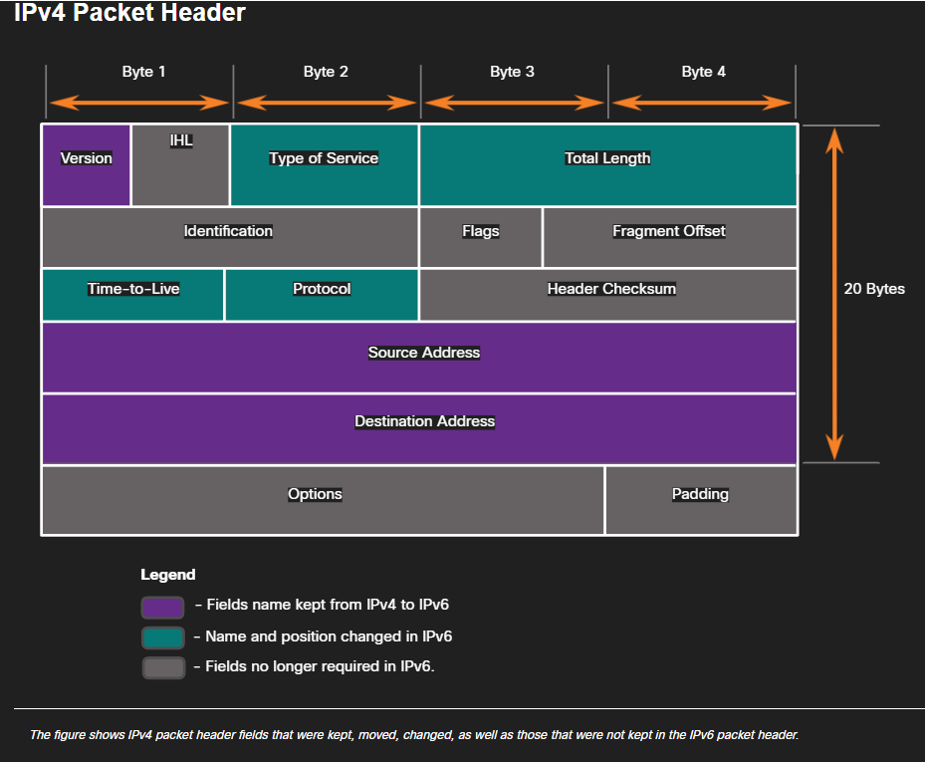
In contrast, the simplified IPv6 header shown the next figure consists of a fixed length header for 40 octets (largely due to length of the source and destination IPv6 addresses).
The IPv6 simplified header allows for more efficient processing of IPv6 headers.
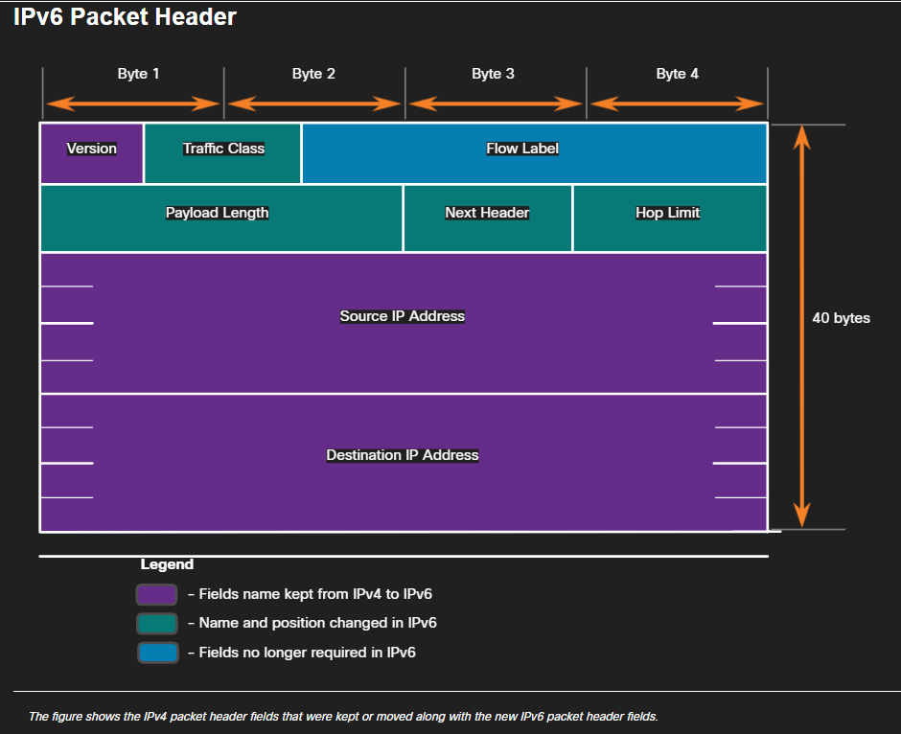

IPv6 Packet Header
The IP protocol header diagram identifies the fields of an IPv6 packet.

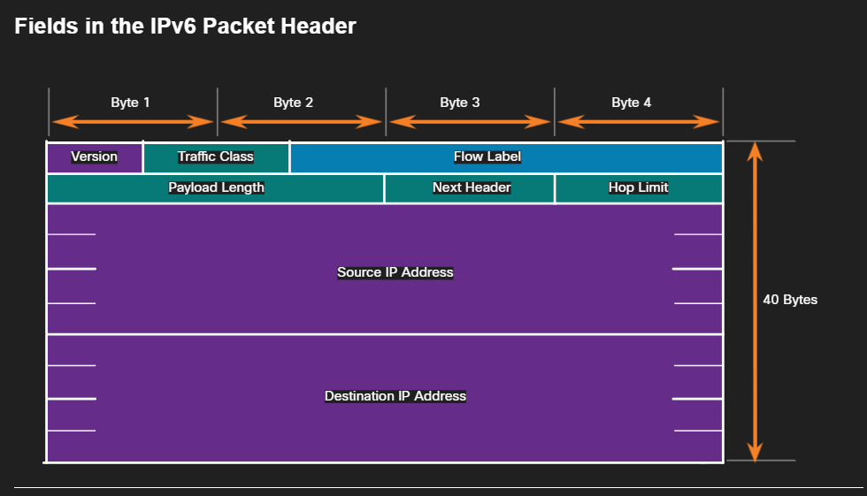
- Version – The field contains a 4-bit binary value set to 0110 that identifies this as an IP version 6 packet.
- Traffic Class – This 8-bit field is equivalent to the IPv4 Differentiated Services (DS) field.
- Flow Label – This 20-bit field suggests that all packets with the same flow label receive the same type of handling by routers.
- Payload Length – This 16-bit field indicates the length of the data portion or payload of the IPv6 packet. This does not include the length of the IPv6 header, which is a fixed 40-byte header.
- Next Header – This 8-bit field is equivalent to the IPv4 Protocol field. It indicates the data payload type that the packet is carrying, enabling the network layer to pass the data to the appropriate upper-layer protocol.
- Hop Limit – This 8-bit field replaces the IPv4 TTL field. This value is decremented by a value of 1 by each router that forwards the packet When the counter reaches 0, the packet is discarded, and an ICMPv6 Time Exceeded message is forward to the sending host. This indicates that the packet did not reach its destination because the hop limit as exceeded Unlike IPv4, IPv6 does not include an IPv6 Header Checksum, because this function is performed at both the lower and upper layer. This means the checksum does not need to be recalculated by each router when it decrements the Hop Limit field, which also improves network performance.
- Source IPv6 Address – This is 128-bit field identifies the IPv6 address of the sending host.
- Destination IPv6 Address – This 128.bit field identifies the IPv6 address of the receiving host.

An IPv6 packet may also contain headers (EH), which provide optional network layer information. Extension headers are optional and are placed between the IPv6 header and the payload. EHs are used for fragmentation, security, to support mobility and more.
Unlike IPv4, routers do not fragment routed IPv6 packets.

How a Host Routes

Host Forwarding Decision
With both IPv4 and IPv6, packets are always created at the source host. The source host must be able to direct the packet to the destination host. To do this, host end devices create their own routing table. This topic discusses how end devices use routing tables.
Another role of the network layer is to direct packets between hosts. A host can send a packet to the following:
- Itself – A host can ping itself by sending a packet t a special IPv4 address of 127.0.0.1 or an IPv6 address ::1, which is referred to as the loopback interface. Pinging the loopback interface tests the TCP/IP protocol stack on the host.
- Local host – This is destination host that is on the same local network as the sending host. The source and destination hosts share the same network address.
- Remote host – This is a destination host on a remote network. The source and destination hosts do not share the same network address.

In a home or business network, you may have several wired and wireless devices interconnected together using an intermediary device, such as a LAN witch or a wireless access point (WAP). This intermediary device provides interconnections between local hosts on a local network. Local hosts can reach each other and share information without the need for any additional devices. If a host is sending a packet to a device that is configured with the same IP network as the host device, the packet it simply forwarded out of the host interface, through the intermediary device, and to the destination device directly.
Of course, in most situations we want our devices to be able to connect beyond the local network segment, such as out to other homes, businesses, and the internet. Devices that are beyond the local network segment are known as remote hosts. When a source device sends a packet to a remote destination device, then the help of routers and routing is needed. Routing is the process of identifying the best path to a destination. The router connected to the local network segment is referring to as the default gateway.

Default Gateway
The default gateway is the network device (i.e., router or Layer 3 switch) that can route traffic to other networks If you use the analogy that a network is like a room, then the default gateway is like a doorway. If you want to get to another room or network, you need to find the doorway.
On a network, a default gateway is usually a router with these features:
- It has a local IP address in the same address range as other hosts on the local network.
- It can accept data into the local network and forward data out o the local network.
- It routes traffic to other networks.

A default gateway is required to send traffic outside of the local network. Traffic connect be forwarded outside the local network if there is no default gateway, the default gateway address is not configured, or the default gateway is down.

A Host Routes to the Default Gateway
A host routing table will typically include a default gateway. In IPv4, the host receives the IPv4 address of the default gateway either dynamically from Dynamic Host Configuration Protocol (DHCP) or configured manually. In IPV6, the router advertises the default gateway address or the host can be configured manually.

Having a default gateway configure creates a default route in a routing table of the PC. A default route is the route or pathway your computer ill take when it tries to contact a remote network.
Both PC1 and PC2 will have a default route to send all traffic destine to remote networks R1.

Host Routing Tables
On a Windows host, the route print or netstat -4 command can be used to display the host routing table. Both commands generate the same output. The output may seem overwhelming at first but is fairly simple to understand.
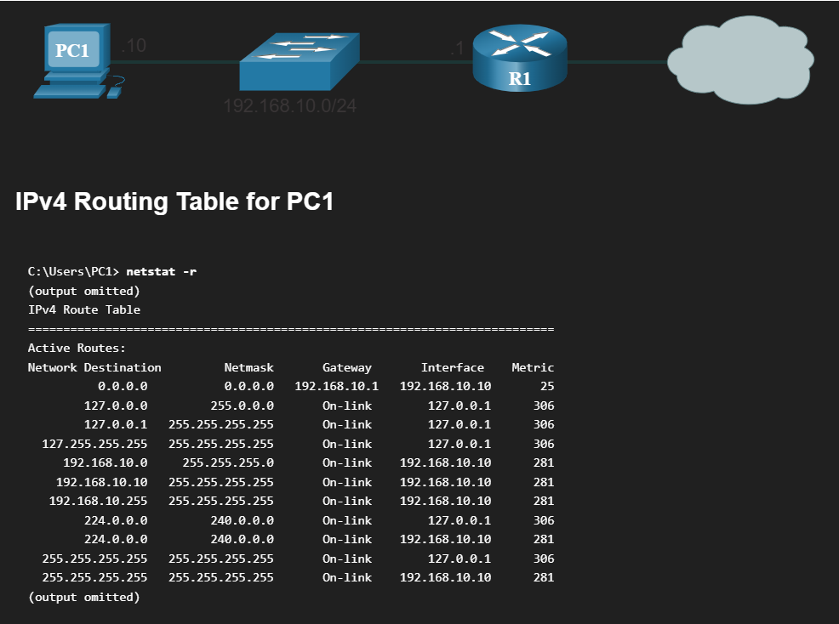
Entering the netstat -r command or the equivalent route print command displays here section relate the current TCP/IP network connections:
- Interface List – Lists the Media Access Control (MAC) address and assigned interface number of every network-capable interface on the host, including Ethernet, Wi-Fi and Bluetooth adapters.
- IPv4 Route Table – Lists all known IPv4 routes, including direct connections, local network, and local default routes.
- IP6 Route Table – Lists all known IPv6 routes, including direct connections, local network, and local default routes.

Introduction to Routing

Router Packet Forwarding Decision
The previous topic discussed host routing tables. Most networks also contain routers, which are intermediary devices. Routers also contain routing tables. This topic covers router operations at the network layer. When a host sends a packet to another host, it consults its routing table to determine where to send the packet. If the destination host is on a remote network, the packet is forwarded to the default gateway, which is usually the local router.
What happens when a packet arrives on a router interface?
The router examines the destination IP address of the packet and searches its routing table to determine where to forward the packet. The routing table contain a list of all known network addresses (prefixes) and where to forward the packet. These entries are known as route entries or routes. The router will forward the packet using the best (longest) matching route entry.
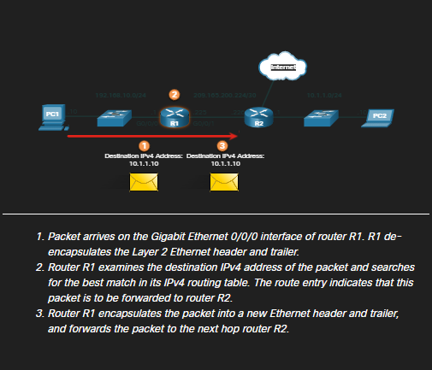
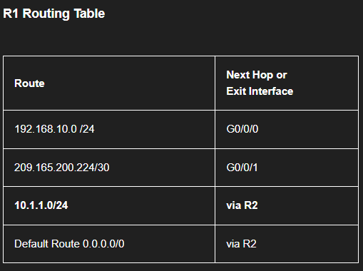

IP Router Routing Table
The routing table of the router contains network route entries listing all the possible known network destinations.
The routing table stores three types of route entries:
- Directly-connected networks – These network route entries are active router interfaces. Routers add a directly connected route when an interface is configured with an IP address and is activated. Each router interface is connected to a different network segment. In the figure, the directly-connected networks in the R1 IPv4 routing table would be 192.168.10.0/24 and 209.165.200.224/30
- Remote networks – These network route entries are connected to other routers. Routers learn about remote networks either by being explicitly configure y an administrator or by exchanging route information using a dynamic routing protocol. In the figure, the remote network in the R1 IPv4 routing table would be 10.1.1.0/24
- Default route – Like a host, most routers also include a default route entry, a gateway of last resort. The default route is used when there is no better (longer) match in the IP routing table. In the figure, the R1 IPv4 routing table would most likely include a default route to forward all packets to router R2.

The figure identifies the directly connected and remote networks of router R1.
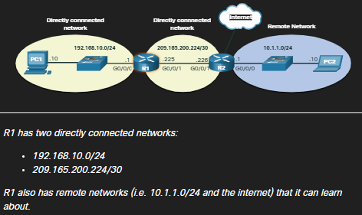

A router can learn about remote networks in one of two ways:
- Manually – Remote networks are manually entered into the route table using static routes.
- Dynamically – Remote routes are automatically learned using a dynamic routing protocol.

Static Routing
Static routes are route entries that are manually configured. The figure shows an example of a static route that was manually configured on router R1. The static route includes the remote network address and the IP address of the next hop router.
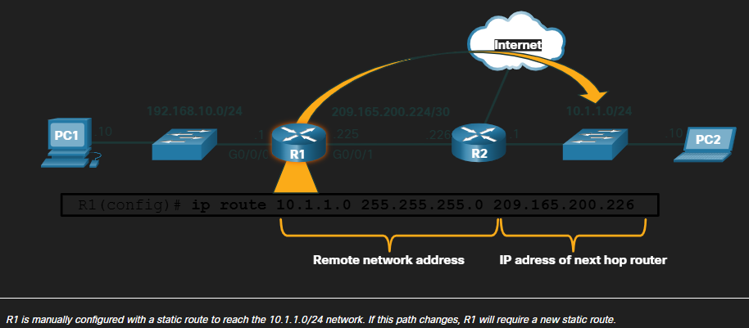

IF there is a change in the network topology, the static route is not automatically updated and must be manually reconfigured. For example, in the figure R1 has a static route to reach the 10.1.1.0/24 network via R2 If that path is no longer available, R1 would need to be reconfigured with a new static route to the 10.1.1.0/24 network via R3. Router R3 would therefore need to have a route entry in its routing table to send packets destined for 10.1.1.0/24 to R2

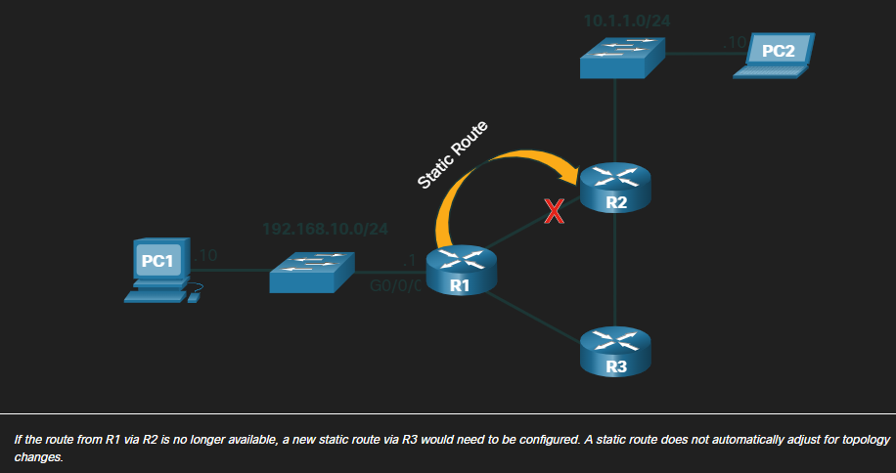

Static routing has the following characteristics:
- A static route must be configured manually.
- The administrator needs to reconfigure a static route if there is a change in the topology and the static route is no longer viable.
- A static route is appropriate for a small network and when there are few or no redundant links.

Dynamic Routing
A dynamic routing protocol allows the routers to automatically learn about remote networks, including a default route, from other routers. Routers that use dynamic routing protocols automatically share routing information with other routers and compensate for any topology changes without involving the network administrator. If there is a change in the network topology, routers share this information sing the dynamic routing protocol and automatically update their routing tables.
Dynamic routing protocols include OSPF and Enhanced Interior Gateway Routing Protocol (EIGRP). The figure shows an example of router R1 and R2 automatically sharing network information using the routing protocol OSPF.
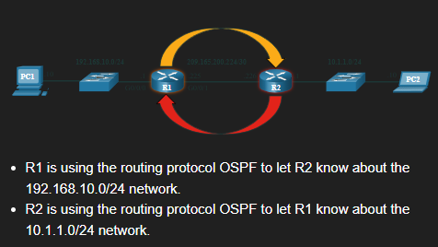

Basic configuration only requires the network administrator to enable the directly connected networks within the dynamic routing protocol. The dynamic routing protocol will automatically do as follows:
- Discover remote networks
- Maintain up-to-date routing information
- Choose the best path to destination networks
- Attempt to find a new best path if the current path is no longer available

When a router is manually configured with a static route or learns about a remote network dynamically using a dynamic routing protocol, the remote network address and not hop address and entered into the IP routing table. As shown in the figure if there is a change in the network topology, the routers will automatically adjust and attempt to find a new best path.
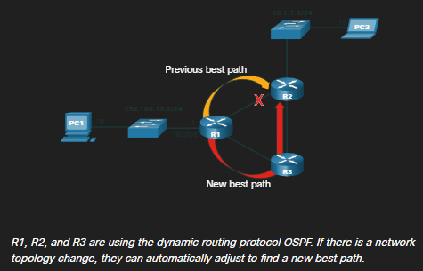
Note It is common for some routers to use a combination of both statics routes and a dynamic routing protocol.

Introduction to an IPv4 Routing Table
Notice in the figure that R2 is connected to the internet. Therefore, the administrator configured R1 with a default static route sending packets to R2 when there is no specific entry in te routing table that matches the destination IP address. R1 and R2 are also using OSPF routing to advertise directly connected networks.
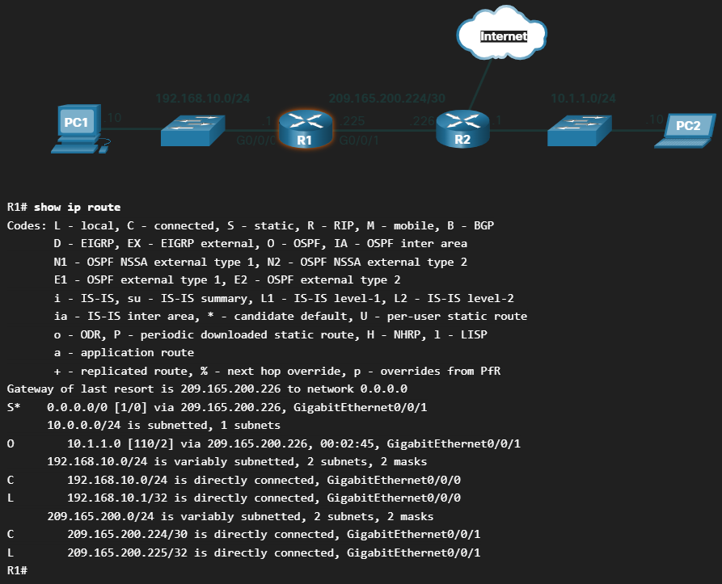
The show ip route privileged EXEC mode command is used to view the IPv4 routing table on a Cisco IOS router. The example shows the IPv4 routing table of router R1 At the beginning of each routing table entry is a code that is used to identify the type of route or ho the route was learned. Common route sources (codes) include these:
- L – Directly connected local interface IP address
- C – Directly connected network
- S – Static route was manually configured by an administrator
- O – OSPF
- D – EIGRP

The routing displays all the known IPv4 destination routes or R1.
A directly connected route is automatically created when a router interface is configured with IP address information and is activated. The router adds two route entries with the codes C (i.e., the connected network) and L (i.e., the local interface IP address of the connected network.). The route entries also identify the exit interface to use to reach the network. The two directly connected networks in this example are 192.168.10.0/24 and 209.165.200.224/30.
Routers R1 and R2 are also using the OSPF dynamic routing protocol to exchange router information. In the example routing table, R1 has a route entry for he 10.1.1.0/24 network that is learned dynamically from router R2 via the OSPF routing protocol.
A default route has a network address of all zeroes. For example, the IPv4 network address is 0.0.0.0. A static route entry in the routing table begins with a code of S*, as highlighted in the example.

Address Resolution

MAC and IP

Destination on Same Network
Sometimes a host must send a message, but it only knows the IP address of the destination device. The host needs to know the MAC address of that device, but how can it be discovered? That is where address resolution becomes critical.
There are two primary addresses assigned to a device on an Ethernet LAN:
- Physical Address (the MAC address) – Used for NIC to NIC communications on the same Ethernet network.
- Logical address (the IP address) – Used to send the packet from the source device to the destination device. The destination IP address may be on the same IP network as the source, or it may be on a remote network.

Layer 2 physical addresses (i.e., Ethernet MAC addresses) are used to deliver the data link frame with the encapsulated IP packet from one NIC to another NIC that is on the same network. If the destination IP address is on the same network, the destination MAC address will be that of the destination device.
Consider the following example using simplified MAC address representations:
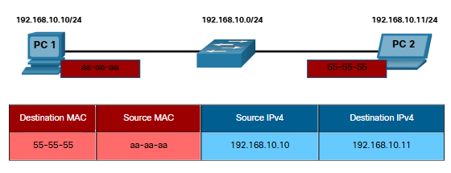
In this example, PC1 wants to send a packet to PC2 The figure displays the Layer 2 destination and source MAC addresses and the Layer 3 IPv4 addressing that would be included in the packet sent from PC1.
The Layer 2 Ethernet frame contains the following:
- Destination MAC address – This is the simplified MAC address of PC2, 55-55-55.
- Source MAC address – This is the simplified MAC address of the Ethernet NIC on PC1, aa-aa-aa

The Layer 3 IP packet contains the following:
- Source IPv4 address – This is the IPv4 address of PC1, 192.168.10.10
- Destination IPv4 address – This is the IPv4 address of PC2, 192.168.10.11

Destination on Remote Network
When the destination IP address (IPv4 or IPv6) is on a remote network, the destination MAC address will be the address of the host default gateway (i.e., the router interface).
Consider the following example using a simplified MAC address representation:

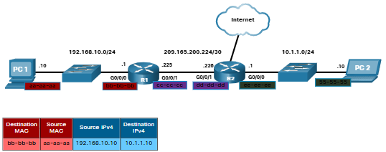

In this example, PC1 wants to send a packet to PC2. PC2 is locate on a remote network. Because the destination IPv4 address is not on the same local network as PC1, the destination MAC address is that of the local default gateway on the router.
Routers examine the destination IPv4 address to determine the best path to forward the IPv4 packet. When the router receives the Ethernet frame, it de-encapsulates the Layer 2 information. Using the destination IPv4 address, it determines the net-hop device and then encapsulates the IPv4 packet in a new data link frame for the outgaining interface.
In our example, R1 would ne encapsulate the packet with new Layer 2 address information as shown in the figure:
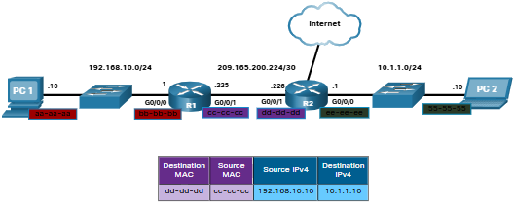
The new destination MAC address would be that of the R2 G0/0/1 interface and the new source MAC address be that of the R1 G0/0/1 interface.
Along each link in a path, an IP packet is encapsulate in a frame. The frame is specific to the data link technology that is associated with that link, such as Ethernet. If the next-hop device is the final destination, the destination MAC address will be that of the device Ethernet NIC, as shown in the figure:
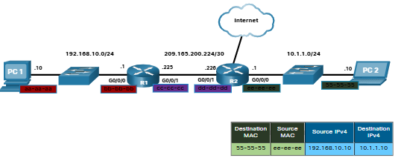
How are the IP address of the IP packets in a data flow associated with the MAC addresses on each link along the path to the destination? For IPv4 packets, this is done through a process called Address Resolution Protocol (ARP). For IPv6 packets, the process is ICMPv6 Neighbor Discovery (ND).

Address Resolution Protocol (ARP)

ARP Overview
If your network is using the IPv4 communications protocol, the Address Resolution Protocol, or ARP, is what you need to map IPv4 addresses to MAC addresses. This topic explains how ARP works.
Every IP device on an Ethernet network has a unique Ethernet MAC address. When a device sends an Ethernet Layer 2 frame, it contains these two addresses:
- Destinaton MAC address – The Ethernet MAC address of the destination device on the same local network segment. I the destination host is on another network, then the destination address in the frame would be that of the default gateway (i.e., the router)
- Source MAC address – The MAC address of the Ethernet NIC on the source host.
The figure illustrates the problem when sending a frame to another host on the same segment on an IPv4 network.
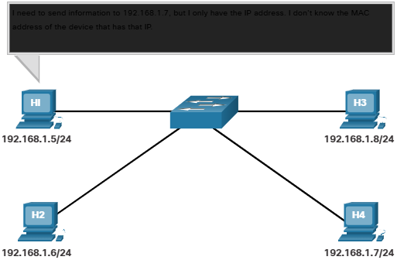

To send a packet to another host on the same local IPv4 network, a host must know the IPv4 address and the MAC address of the destination device. Device destination IPv4 addresses are either known or resolved by device name. However, MAC addresses must be discovered.
A device uses Address Resolution Protocol (ARP) to determine the destination MAC address of a local device when it knows its IPv4 address
ARP provides two basic functions:
- Resolving IPv4 addresses to MAC addresses
- Maintaining a table of IPv4 address mappings.

ARP Functions
When a packet is sent to the data link layer to be encapsulated into an Ethernet frame, the device refers to a table in its memory to find the MAC address that is mapped to the IPv4 address. The table is stored temporarily in RAM memory and called the ARP table or the ARP cache.
The sending device will search its ARP table for a destination IPv4 address and a corresponding MAC address.
- If the packet’s destination IPv4 address is on the same network as the source IPv4 address, the device will search the ARP table for the destination IPv4 address.
- If the destination IPv4 address is on a different network than the source IPv4 address, the device will search the ARP table for the IPv4 address of the default gateway.
In both cases, the search is for an IPv4 address an a corresponding MAC address for the device.
Each entry, or row, of the ARP table binds an IPv4 address with a MAC address. We call the relationship between the two values, a map. This simply means that you can locate an IPv4 address in the table and discover the corresponding MAC address The ARP table temporarily saves (caches) the mapping for the device on the LAN.
If the device locates the IPv4 address its corresponding MAC address is used as the destination MAC address in the frame If there is no entry found, then the device sends an ARP request.

ARP Request
An ARP request is sent when a device needs to determine the MAC address that is associated with an IPv4 address, and it does not have an entry or the IPv4 address in its ARP table.
ARP messages are encapsulated directly within an Ethernet frame. There is no IPv4 header. The ARP request is encapsulated in an Ethernet frame using the following header information:
- Destination MAC address – This is a broadcast address FF-FF-FF-FF-FF-FF requiring all Ethernet NICs on the LAN to accept and process the ARP request.
- Source MAC address – This is the MAC address of the sender of the ARP request.
- Type – ARP messages have a type field of 0x803. This informs the receiving NIC that the data portion of the frame needs to be passe to the ARP process.

Because ARP requests are broadcasts, they are flooded out all ports by the switch, except the receiving port. All Ethernet NICs on the LAN process broadcasts and must deliver the ARP requests to its operating system for processing. Every device must process the ARP request to see if the target IPv4 address matches its own. A router will not forward broadcasts out other interfaces.
Only one device on the LAN will have an IPv4 address that matches the target IPv4 address in the ARP request. All other devices will not reply.

ARP Operation – ARP Reply
Only the device with the target IPv4 address associated with the ARP request will respond with an ARP reply. The ARP reply is encapsulated in an Ethernet frame using the following header information:
- Destination MAC address – This is the MAC address of the sender of the ARP request.
- Source MAC address – This is the MAC address of the sender of the ARP reply.
- Type – ARP messages have a type field of 0x806. This informs the receiving NIC that the data portion of the frame needs to be passed to the ARP process.
Only the device that originally sent the ARP request will receive the unicast ARP reply. After the reply is received, the device will add the IPv4 address and the corresponding MAC address to the ARP table. Packets destined for that IPv4 address can now be encapsulated in frames using its corresponding MAC address.
If no device responds to the ARP request, the packet is dropped because a frame cannot be created.
Entries in the ARP table are time stamped. If a device does not receive a frame from a particular device before the timestamp expires, the entry for this device is removed from the ARP table.
Additionally, static map entries can be entered in an ARP table, but this is rarely done. Static ARP table entries do not expire over time and must be manually remove.
Note: IPv6 uses a similar process to ARP for IPv4, known as ICMPv6 Neighbor Discovery (ND). IPv6 uses neighbors’ solicitation and neighbor advertisement messages, similar to IPv4 ARP requests and ARP replies.

ARP Role in Remote Communications
When the destination IPv4 address is not on the same network as the source IPv4 address, the source device needs to send the frame to its default gateway. This is the interface of the local router. Whenever a source device has a packet with an IPv4 address on another network, it will encapsulate that packet in a frame using the destination MAC address of the router.
The IPv4 address of the default gateway is stored in the IPv4 configuration of the hosts. When a host creates a packet for a destination, it compares the destination IPv4 address and its own IPv4 address to determine if the two IPv4 addresses are located on the same Layer 3 network. If the destination host is not on its same network, the source checks its ARP tale for an entry with the IPv4 address of the default gateway. If there is not an entry, it uses the ARP process to determine a MAC address of the default gateway.

Removing Entries from an ARP Tables
For each device, an ARP cache timer removes ARP entries that have not been use or a specified period. The times differ depending on the operating system of the device. For example, newer Windows operating systems store ARP table entries between 15 and 45 seconds, as illustrated in the figure.
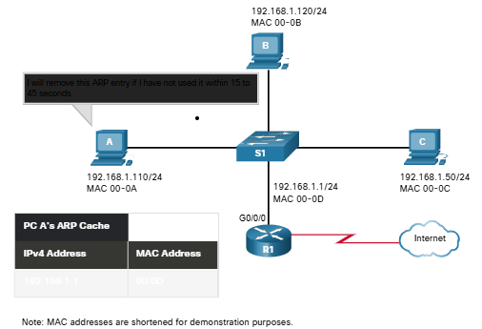
Commands may also be used to manually remove some or all of the entries in the ARP table. After an entry has been removed, the process for sending an ARP request and receiving an ARP reply must occur again to enter the map in the ARP table.

ARP Tables on Networking Devices
On a Cisco router, the show ip arp command is used to display the ARP table, as shown in the figure.
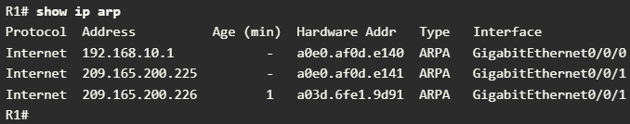
On a Windows 10 PC, the arp -a command is used to display the ARP table, as shown in the figure.
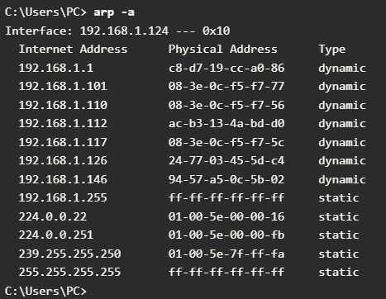

ARP Issues – ARP Broadcasts and ARP Spoofing
AS a broadcast frame, an ARP request is received and processed by every device on the local network. On a typical business network, these broadcasts would probably have minimal impact on network performance. However, if many o devices were to be powered up and all start accessing network services at the same time, there could be some reduction in performance for a short period of time, as shown in the figure. After the devices send out the initial ARP broadcasts and have learned the necessary MAC addresses, any impact on the network will be minimized.
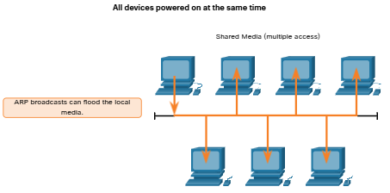
In some cases, the use of ARP can lead to a potential security risk. A threat actor can use ARP spoofing to perform an ARP poisoning attack. This is a technique used b a threat actor to reply to an ARP request for an IPv4 address that belongs to another device, such as the default gateway, as shown in the figure. The threat actor sends an AP reply with its own MAC address. The receiver of the ARP reply will add the wrong MAC address to its ARP table and send these packets to the threat actor.
Enterprise level switches include mitigation techniques known as dynamic ARP inspection (DAI). DAI is beyond the scope of this course.
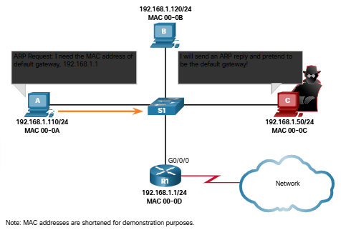

IPv6 Neighbor Discovery

IPv6 Neighbor Discovery Messages
IPv6 Neighbor Discovery protocol is sometimes referred to as ND or NDP. In this course, we will refer to it as ND. ND provides address resolution, router discovery and redirection services for IPv6 using ICMPv6. ICMPv6 ND uses five ICMPv6 messages to perform these services.
- Neighbor Solicitation messages
- Neighbor Advertisement messages
- Router Solicitation messages
- Router Advertisement messages
- Redirect message

Neighbor Solicitation and Neighbor Advertisement messages are used for device-to-device messaging such as address resolution (similar to ARP for IPv4). Devices include both host computers and routers.
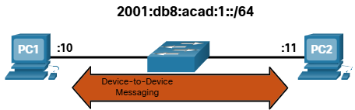
Router Solicitation and Router Advertisement messages are for messaging between devices and routers. Typically router discovery is used for dynamic address allocation and stateless address autoconfiguration (SLAAC)
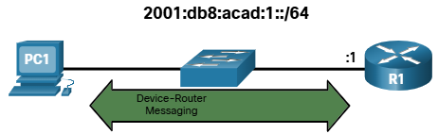
Note: The fifth ICMPv6 ND message is a redirect message which is use for better next-hop selection. This is beyond the scope of this course.
IPv6 ND is defined in the IETF RFC 4861

IPv6 Neighbor Discovery – Address Resolution
Much like ARP for IPv4, IPv6 devices use IPv6 ND to determine the MAC address of a device that has a known IPv6 address.
ICMPv6 Neighbor Solicitation and Neighbor Advertisement messages are used for MAC address resolution. This is like ARP Request and ARP Replies used by ARP for IPv4. For example, assume PC1 wants to ping PC2 at IPv6 address 2001:db8:acad::11. To determine the MAC address for the known IPv6 address, PC1 sends an ICMPv6 Neighbor Solicitation message as illustrated in the figure.
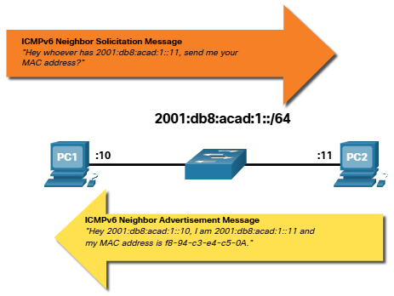

ICMPv6 Neighbor Solicitation messages are sent using special Ethernet and IPv6 multicast addresses. This allows the Ethernet NIC of the receiving devices to determine whether the Neighbor Solicitation message is for itself without having to send it to the operating system for processing.
PC2 replies to the request with an ICMPv6 Neighbor Advertisement message which includes its MAC address.

Basic Router Configuration

Configure Initial Router Settings

Basic Router Configuration Steps
The following steps should be completed when configuring initial settings on a router
- Configure the device name:
  - Router(config)# hostname <hostname>
- Secure privileged EXEC mode:
  - Router(config)# enable secret <password>
- Secure user EXEC mode:
  - Router(config)# line console 0
  - Router(config-line)# password <password>
  - Router(config-line)# login
- Secure remote Telnet/SSH access:
  - Router(config-line)# line vty 04
  - Router(config-line)# password <password>
  - Router(config-line)# login
  - Router(config-line)# transport input { ssh | telnet }
- Secure all passwords in the config file:
  - Router(config-line)# exit
  - Router(config)# service password-encryption
  - Router(config)# banner motd <message>
- Save the configuration
  - Router(config)# end
  - Router# copy cunning-config startup-config

Basic Router Configuration Example
In this example, Router R1 in the topology diagram will be configured with initial settings.
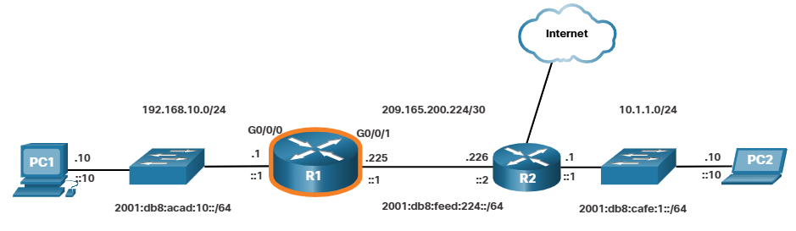
To configure the device name for R1, use the following commands.
- Router> enable
- Router# configure terminal
- Enter configuration commands, one per line.
- End with CNTL/Z
- Router(config)# hostname R1
- R1(config)#
Note: Notice how the router prompt will display the router hostname.
All router access should be secured. Privileged EXEC mode provides the user with complete access to the device and its configuration. Therefore, it is the most important mode to secure.
The following commands secure privileged EXEC mode and user exec mode enable the Telnet and SSH remote access and encrypt all plaintext (i.e. user EXEC and VTY line) passwords.
- R1(config)# enable secret class
- R1(config)#

- R1(config)# line console 0
- R1(config-line)# password cisco
- R1(config-line)# login
- R1(config-line)# exit
- R1(config)#
- R1(config)# line vty 0 4
- R1(config-line)# password cisco
- R1(config-line)# login
- R1(config-line)# transport input ssh telnet
- R1(config-line)# exit
- R1(config)#
- R1(config)# service password-encryption
- R1(config)#

The legal notification warns users that the device should only be accessed by permitted users. Legal notification is configured as follows:
- R1 (config)# banner motd #
- Enter TEXT message. End wit a new line and the #
*****************************************
WARNING: Unauthorized access is prohibited!
*****************************************
#
- R1(config)#

If the previous commands were configured and the router accidentally lost power, all configured commands would be lost. For this reason, it is important to save the configuration when changes are implemented. The follow commands saves the configuration to NVRAM.
- R1# copy running-config startup-config
- Destination filename [startup-config]?
- Building configuration…
- [OK]
- R1#

Configure Interfaces

Configure Router Interfaces
At this point, your router have their basic configurations. The next step is to configure their interfaces. This is because routers are not reachable by end devices util the interfaces are configured. There are many different types of interfaces available on Cisco routers. For example, the Cisco ISR 4321 router is equipped with two Gigabit Ethernet interfaces:
- GigabitEthernet 0/0/0 (G0/0/0)
- GigabitEthernet 0/0/1 (G0/0/1)
The tasks to configure a router interface is very similar to management SVI o a switch. Specifically, it includes issuing the following commands.

- Router(config)# interface <type-and-number>
- Router(config-if)# description <description-text>
- Router(config-if)# ip address <ipv4-address subnet-mask>
- Router(config-if)# ipv6 address <ipv6-address/prefix length>
- Router(config-if)# no shutdown

Note: When a router interface is enabled, information messages should be displayed confirming the enabled link

Although the description command is not required to enable an interface, it is good practice to use it. It can be helpful in troubleshooting on production networks by providing information about the type of network connected. For example, if the interface connects to an ISP or service carrier, the description command would be helpful to enter the third-party connection and contact information.
Note: The description-text is limited to 240 characters.
Using the no shutdown command activate the interface and is similar to powering on the interface. The interface must also be connected to another device, such as a switch or a router, for the physical layer to be active.
Note: On inter-router connections where there is no Ethernet switch, both interconnecting interfaces must be configured and enabled.

Configure Router Interfaces Example
In this example, the directly connected interface of R1 in the topology diagram will be enabled.
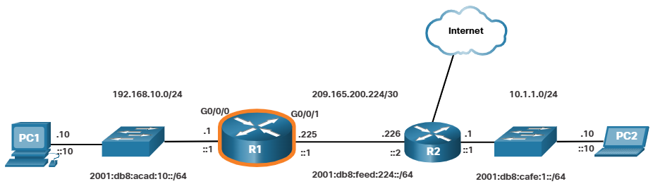
To configure the interfaces on R1, use the following commands
- R1> enable
- R1# configure terminal
- Enter configuration commands, one per line.
- End with CNTL/Z.
- R1(config)# interface gigabitEthernet 0/0/0
- R1(config-if)# description Link to LAN
- R1(config-if)# ip address 192.168.10.1 255.255.255.0
- R1(config-if)# ipv6 address 2001:db8:acad:10::1/64
- R1(config-if)# no shutdown
- R1(config-if)# exit
- R1(config)#
- *Aug 1 01:43:53.435: %LINK-3-UPDOWN: Interface GigabitEthernet0/0/0, changed state to down
- *Aug 1 01:43:56.447: %LINK-3-UPDOWN: Interface GigabitEthernet0/0/0, changed state to up
- *Aug 1 01:43:57.447: %LINEPROTO-5-UPDOWN: Line protocol on Interface GigabitEthernet0/0/0, changed state to up
- R1(config)#
- R1(config)#
- R1(config)# interface gigabitEthernet 0/0/1
- R1(config-if)# description Link to R2
- R1(config-if)# ip address 209.165.200.225 255.255.255.252
- R1(config-if)# ipv6 address 2001:db8:feed:224::1/64
- R1(config-if)# no shutdown
- R1(config-if)# exit
- R1(config)#
- *Aug 1 01:46:29.170: %LINK-3-UPDOWN: Interface GigabitEthernet0/0/1, changed state to down
- *Aug 1 01:46:32.171: %LINK-3-UPDOWN: Interface GigabitEthernet0/0/1, changed state to up
- *Aug 1 01:46:33.171: %LINEPROTO-5-UPDOWN: Line protocol on Interface GigabitEthernet0/0/1, changed state to up
- R1(config)#

Note: Notice the informational messages informing us that G0/0/0 and G0/0/1 are enabled

Verify Interface Configuration

There are several commands that can be use to verify interface configuration. The most useful of these is the show ip interface brief and show ipv6 interface brief commands, as shown in the example:
- R1# show ip interface brief
- Interface IP-Address OK? Method Status Protocol
- GigabitEthernet0/0/0 192.168.10.1 YES manual up up
- GigabitEthernet0/0/1 209.165.200.225 YES manual up up
- Vlan1 unassigned YES unset administratively down down
- R1# show ipv6 interface brief
- GigabitEthernet0/0/0 [up/up]
- FE80::201:C9FF:FE89:4501
- 2001:DB8:ACAD:10::1
- GigabitEthernet0/0/1 [up/up]
- FE80::201:C9FF:FE89:4502
- 2001:DB8:FEED:224::1
- Vlan1 [administratively down/down]
- unassigned
- R1#

Configuration Verification Commands
The table summaries the more popular show commands used to verify interface configuration:
Show ip interface brief  Show ipv6 interface brief | The output displays all interfaces, their ip addresses and their current status. The configured and connected interfaces should display a Status of “up” and Protocol of “up. Anything else with indicate a problem with either the configuration or the cabling
Show ip route  Show ipv6 route | Displays the contents of the IP routing tables stored in RAM
Show interfaces | Displays the statistic for all interfaces on the device. However, this command will only display the IPv4 addressing information
Show ip interfaces | Displays the IPv4 statistics for all interfaces on a router.
Show ipv6 interfaces | Displays the IPv6 statistics for all interfaces on a router

Configure the Default Gateway

Default Gateway on a Host
If your local network has only one router, it will be the gateway router and all hosts and switches on your network must be configured with this information. If your local network has multiple routers, you must select one of them to be the default gateway router. This topic explains how to configure the default gateway on hosts and switches.
For an end device to communicate over the network, it must be configured with the correct IP address information, including the default gateway address. The default gateway is only used when the host wants to send a packet to a device on another network. The default gateway address is generally the router interface address attached to the local network of the host. The IP address of the host device and the router interface address must be in the same network.
For example, assume an IPv4 network topology consisting of a router interconnecting to separate LANs. G0/0/0 is connected to network 192.168.10.0, while G0/0/1 is connected to network 192.168.11.0. Each host device is configured with the appropriate default gateway address.
In this example, if PC1 sends a packet to PC2, then the default gateway is note used. Instead, PC1 addresses the packet with the IPv4 address of PC2 and forwards the packet directly to PC2 through the switch.
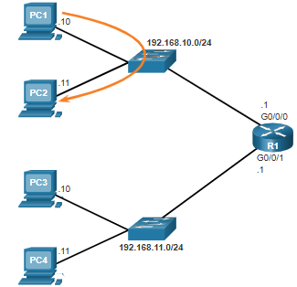

What if PC1 sent a packet to PC3? PC1 would address the packet with the IPv4 address of PC3, but would forward the packet to its default gateway, which is the G0/0/0 interface of R1. The router accepts the packet and accesses its routing table to determine that G0/0/1 is the appropriate exit interface based on the destination address. R1 then forwards the packet out of the appropriate interface to reach PC3.
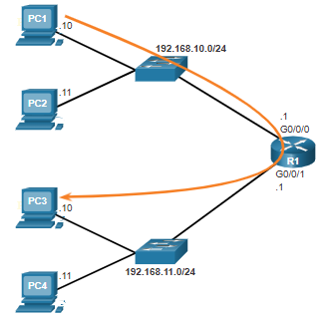

The same process would occur on an IPv6 network, although this is not shown in the topology. Devices would use the IPv6 address of the local router as their default gateway.

Default Gateway on a Switch
A switch that interconnects client computers is typically a Layer 2 device. As such, a Layer 2 switch does not require an IP address to function properly. However, an IP configuration can be configured on a witch to give an administrator remote access to the switch.
To connect to and manage a switch over a local IP network, it must have a switch virtual interface (SVI) configured. The SVI configured with an IPv4 address and subnet mask on the local LAN. The switch must also have a default gateway address configured to remotely manage the switch from another network.
The default gateway address is typically configured on all devices that will communicate beyond their local network.
To configure an IPv4 default gateway on a witch, use the ip default-gateway <ip-address> global configuration command. The ip-address that is configured is the IPv4 address of the local router interface connected to the switch.
The image shows an administrator establishing a remote connection to switch S1 on another network.
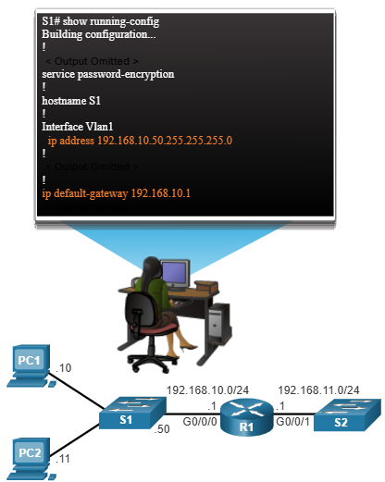

In this example, the administrator host would use its default gateway to send the packet to the G0/0/1 interface of R1. R1 would forward the packet to S1 out of its G0/0/0 interface. Because the packet source IPv4 address came from another network, S1 would require a default gateway to forward the packet to the G0/0/0 interface of R1 Therefore, S1 must be configured with default gateway to be able to reply and establish an SSH connection with the administrative host
Note: Packets originating from host computers connected to the switch must already have the default gateway address configured on their host computer operating systems.
A workgroup switch can also be configured with an IPv6 address on an SVI. However, the switch does not require the IPv6 address of the default gateway to be configured manually. The switch will automatically receive its default gateway from the ICMPv6 Router Advertisement message from the router.

OSYS1200 Introduction to Windows Administration

The Evolving Role of System Administrators in the Future of Computing

Introduction
System administrators have historically been the gatekeepers of IT infrastructure. Their role has been pivotal in ensuring the smooth operation and security of computer systems. However, with the rapid advancements in technology, the responsibilities of system administrators are evolving. This essay will explore how the role of system administrators is changing and what the future holds for this critical professions

The Impact of Cloud Computing
Cloud computing has revolutionized the way businesses and organizations utilize IT resources. The shit towards cloud based infrastructure has significantly altered the traditional responsibilities of system administrators. Instead of managing physical servers and data centers, system administrators now often oversee cloud environments, ensuring optimal performance, security, and cost-efficiency. This transition requires new skills and expertise, such as cloud platform knowledge and automation techniques.

Automation and DevOps
Automation is another major trend reshaping the role of system administrators. DevOps practices, which emphasize collaboration between development and operations teams, have gained widespread adoption. Automation tools and scripting languages are being used to automate routine tasks, allowing system administrators to focus on more strategic and complex challenges. This shift towards automation can improve efficiency, reduce errors and accelerate innovation.

Security and Risk Management
As cyber threats continue to evolve, the responsibility of system administrators to protect sensitive data has become paramount. They must stay informed about emerging security threats and implement appropriate measures to safeguard systems and networks. This includes tasks such as vulnerability assessment, intrusion detection, and incident response. Additionally, system administrators play a crucial role in managing risks associate with data privacy and compliance regulations.

Emerging Technologies and Skill Requirements
The future of computing is marked by the emergence of new technologies, such as artificial intelligence, machine learning and the internet of things (IoT). These technologies present both opportunities and challenges for system administrators. They must adapt their skill sets to understand and manage these emerging technologies effectively. This may involve learning about AI frameworks, data analytics and IoT security protocols.

Conclusion
The role of system administrators is undergoing a significant transformation in response to technological advancements. The shift towards cloud computing, automation and emerging technologies require system administrators to develop new skills and adopt new approaches. By embracing these changes and staying ahead of the curve, system administrators can continue to play a vital role in shaping the future of computing and ensuring the successful operation of IT infrastructure.

Windows: Using System and Utilities

Settings Overview
Most configuration options for Windows 11 can be accessed through “Settings”.
To access “Settings”: Click the Start Button > Click Settings
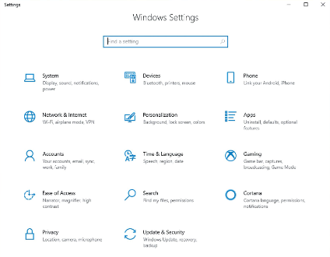

Administrative Tools
Administrative tools are a collection of system configuration utilities found in System and Security in Control Panel.
Most tools in this category use the Microsoft Management Console (MMC). Microsoft Management Console is a framework that simplifies the development of administrative tools.
The tools include:
Component Services | Performance Monitor
Defragment and Optimize Drives | Print Management
Disk Cleanup | Resource Monitor
Event Viewer | Service
iSCSI Initiator | System Configuration
Local Security Policy | Task Scheduler
Open Database Connectivity (ODBC) | Windows Firewall with Advanced Security
Windows Memory Diagnostics

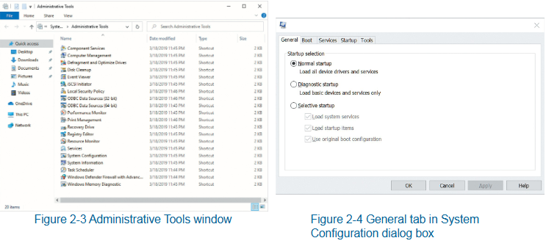

Microsoft Management Console
Microsoft Management Console (MMC) is a graphical interface shell that provides a structured environment to build management utilities. Network administrators use MMC consoles with snap-ins to perform management tasks. Each console can host one or more snap-ins.
A snap-in is a component that adds control mechanisms to the MMC console for a specific service or object.
You can create a customized MMC console. You can do this by adding the snap-ins you want to a single console and then saving the console as a .msc file.
You can share .msc files between other users and computers.
The MMC console is divided into three sections:
System Tools | Storage | Services and Applications
Task Scheduler | Disk Management | Services
Event Viewer |  | WMI Control
Shared Folders
Local Users and Groups
Performance
Device Manager

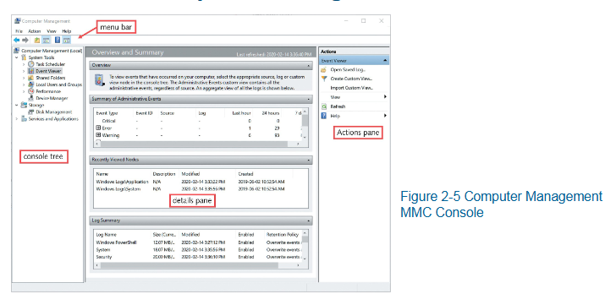

Services
Services is a type of Windows application that runs in the background without user interactions. Typically performs tasks for other software applications.
Services Administration Tool is used to manage Windows 11 services.
Service information:
- Name
- Description
- Status
- Start-up type
- Log On As
Properties of a service:
- General
- Log On
- Recovery
- Dependencies
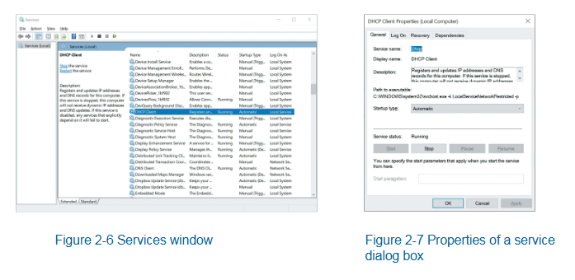

Command-Line Administration Tools
Command-Line Administration tools include Command Prompt and Windows PowerShell. These are “text-based” interfaces that require you to type in all commands.
Command Prompt:
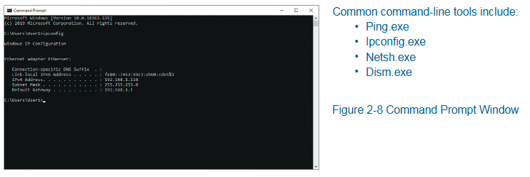
Windows PowerShell:
A command-line interface (CLI) for performing system configuration in Windows 11.
- It is an effective replacement for batch scripts and Visual Basic scripts.
- Some things you can do with Windows PowerShell include:
  - Manage services
  - Manage processes
  - Manage networking
  - Edit the registry
  - Manipulate files and folders
  - Retrieve event log events

Installing and Configuring Apps

The Windows App Landscape
Types of Windows Applications
- Packages Apps
  - Modern apps often from Microsoft Store
  - Run in a sandboxed environment for security
  - User experience can scale based on the device
- Progressive Web Apps (PWAs)
  - Websites that can be installed like native apps
  - Work offline
  - Run independently of the browser
- Traditional Desktop Applications
  - Executable files (.exe, .msi)
  - Installed directly onto the system

Managing Apps and Processes with Task Manager
- Open Task Manager
- Processes Tab
  - Lists running applications, background processes and Windows processes.
  - Displays resource usage (CPU, Memory, Disk, Network)
  - “End Task” option to close unresponsive applications.
  - Grouping by type (default) or a single list (View > Group By Type).
- PWAs manage options identical to Store apps. Accessing PWSs via edge://apps

Managing Startup Apps
- Accessing the Startup apps list in Task Manager.
- Viewing the impact of startup apps on system performance
- Disabling unnecessary startup apps to improve boot time

Managing Disks and File System

Disk Technology
Can be categorized by
  - How it is connected to the computer
  - How it is presented in Windows 11
When reviewing disk technology for use with Windows 11, consider these technologies:
  - Internal Disk
    - Electromechanical drives
    - Solid-state drives (SSD)
    - Custom embedded chip memory (flash memory)
  - External Disk
    - Used to connect removable disk storage. Avoid using ext. disks as a location for operating systems
  - Virtual Hard Disk (VHD)
    - All versions of Windows 11 support VHD operations. Files can be stored in a VHD storage location just like any other disk technology.
  - Multiple disks as one logical disk.
    - Logical disks appear to the Windows 11 operating system as if it is one disk drive
    - Can combine multiple disks as one logical disk.

Disk Partition Styles
Windows 11 can organize data on disk drives using a partition style. When a blank disk is first configured for use by Windows, you can select one of these styles:
- GUID Partition Table (GPT)
- Master Boot Record (MBR)
In Windows Recovery, use the command-line tool MBR2GPT to upgrade from BIOS.MBR to UEFI/GPT

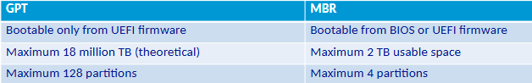

Disk Types
Empty space on the drive can be organized using three different methods in Windows 11
- Basic disks
  - This is hard disks initialized to use basic storage technology. Basic disks can have their space organized into one or more defined areas of storage call partitions. These are defined by the size and type of data it holds. The partition’s attributes are stored in a data table on the disk that is part of the MBR or GPT specifications. This is called the Partition Table.
- Dynamic disks
  - Dynamic disks provide flexibility to logically organize disk space across one or more disk drives. Blocks of space are call volumes.
- Storage spaces
  - Storage Spaces are an inexpensive way to combine, or pool, storage of multiple physical disk drives. These can also provide fault tolerance with data redundancy across multiple disks. Software-based storage technology that doesn’t need specialized storage hardware.

Disk Management Tools
Windows 11 tools for Disk Management
- Disk Management Console
  - MMC Console Snap-in (diskmgmt.msc)
  - Part of the Computer Management utility
  - Allows a member of the Administrators group to observe and make changes to the computer’s disk configuration.
  - Allows changes to be made interactively
    - Usually takes effect immediately without restart
- DiskPart
  - Command-line tool
    - Allows disk, partition, volume and virtual hard disk management operations to be performed
      - From a text-based screen interactively
      - From a scripted file
  - Operations are driven by a sequence of commands
    - As part of a scheduled task
    - As an automated response on the local computer or remotely on another computer
- Storage Cmdlets in Windows PowerShell

Adding a New Drive
New drives are typically connected via SATA or via USD
A brand-new drive is typically not initialized by Windows.

Configuring Storage Spaces Fault Tolerance
A storage space volume can be configured for fault tolerance when it is initially created if the proper starting conditions are met. Different levels of tolerance are available.
Resiliency Type | Description
Simple (no resilience) | - Needs one drive minimum in the pool  - Good for temporary data and where performance is more important than resilience.  - If a drive in the pool fails and contains part of the this volume, the volume is not available to the end user
Two-way Mirror | - Needs two drives minimum  - A volume’s data is copied to at least two separate disks in the pool; each disk holds a synchronized copy of the volume’s data  - Good performance with disk read and write operations  - Can handle single drive failure and still be operational.  - Supported volume size is limited to the size of the smallest drive member
Three-way Mirror | - Needs five drives minimum  - Three copies of a volume’s data are spread across all five drives  - Good performance with disk read and write operations.  - Can handle multiple drive failures and still be operational.
Parity | - Similar to RAID 5 in that parity information is calculated and can determine data that is lost from a drive failure.  - Needs three drives minimum to handle a single drive failure.  - Needs seven drives minimum to handle a double drive failure  - Slow performance during a disk failure while the system calculates missing data; best used for low data that needs fault tolerance but not high performance, such as archive data.

User Accounts, Passwords and Credentials and User Management

User Profiles
A collection of desktop and environment configurations for specific user or group of users.
By default, each user has a separate profile stored in C:\Users
Profile folders and information

3D objects | Local Setting | SendTo
AppData | Music | Start Menu
Application Data | My Documents | Templates
Contacts | NetHood | Videos
Cookies | OneDrive | NTUSER.DAT
Desktop | Pictures | NTUSER.DAT.LOG
Documents | PrintHood | NTUSER.DAT[guid} TM.bif
Downloads | Recent | Ntuser.ini
Favorites | Saved Games
Links | Searches

The Default Profile
Default profile is created when a new user profile is created.
Windows copies the default user profile to create a profile for the new user.
To configure the default profile:
- Create new local user with admin privileges
- Sign in as the designated local user
- Modify the new user’s profile as desired
- Create an answer file with CopyProfile parameter set to true
- Run Sysprep with the /generalize option
- Image the computer and deploy the image

Mandatory Profile
This profile cannot be modified.
Users can make changes to their desktop settings while they are logged on but are not saved.
Most mandatory profiles are implemented as roaming user profiles.
To change a profile to a mandatory profile, you rename the file NTUSER.DAT to NTUSER.MAN

Roaming Profile
Roaming profile
- Stored in a network location rather than on the local hard drive
- Settings move with a user from computer to computer on the network

To configure roaming profile
- You must edit the user account to point the profile directory at a network location.
Each time a user signs in
- A roaming profile is copied to the local computer

Public Profile
Public Profile
- Different from other profiles because it is not a complete profile
- Does not include NTUSER.DAT file an consequently does not include any registry settings
Public Profile Folders
- Libraries
- Public Account Pictures
- Publick Desktop
- Public Documents
- Public Downloads
- Public Music
- Public Pictures
- Public Videos

Managing Hardware Devices/Application Support

Application Environments
Apps are written to interact with specific application environment subsystems
  - Application environment subsystem provides access to operating system services through an application programming interface (API)
All the application environments in Windows restrict apps to running in user mode
  - Where they are isolated from the core functionality of the OS
  - Ensures a poorly written app does not affect system stability

The Registry
The Registry is a central store for application and OS configuration information
In most cases, you do not need to manually edit or view the registry.
The Registry is divided into sections and levels of data.
Multiple sections exist to organize data by purpose.
  - Individual sections are called hives
Within a single hive, data is stored in keys and values

Registry Structure: Registry Hives
HKEY_CLASSES_ROOT | This hive defines file types (classes) and properties associated with those types. For example, file type associations are stored here. This hive is a combination of HKCU\Software\Classes and HKLM\Software\Classes. If settings for a file type are defined in both locations, the user-specific settings take precedence.
HKEY_CURRENT_USER | This hive contains the user-specific registry information for ntuser.dat stored in the user profile. Any application or operating system settings that are user specific are stored in this hive. If you are attempting to fix a user-specific application issue, the support document will have you review and modify keys here.
HKEY_LOCAL_MACHINE | This hive contains global settings for the entire computer and the applications installed on it. If you are attempting to fix any operating system or application issue that is not user specific, the support document will have you review and modify keys here. Ore details about HKLM are provided later in this module.
HKEY_USERS | This hive contains the user-specific settings for the current user and several system services The name of the registry key for the currently signed-in user is the security identifier (SID). The content of the key of the currently signed-in user is also available in HKCU
HKEY_CURRENT_CONFIG | This hive contains details about the current hardware profile in use. The details report the differences between the standard configuration defined the HKL\System and HKLM\Software and those in the active hardware profile. This hive is also a mapped view to information stored in HKLM\System\CurrentControlSet\Hardware\Profile\Current.

Registry Editing Tools
- Back up the portion of the registry you will be changing before you make any changes
- Restrict the number of changes made at one time to limit and identify which change worked
- When possible use a test system rather than a user’s computer to verify changes to resolve the issue
- If you are adjusting registry entries for services for drivers, ensure that the computer can boot properly after changes have been made.

- Graphical Registry editor

- Can use this tool to:

  - Search the registry and modify permissions
  - Export and import sections of registry

DBAS1007 Data Fundamentals
Data is raw. It is pure fact. We require context to turn data into something.
Data = pure fact. Information = interpretation of fact. Knowledge = network of information. Insight = novel crosslinking point between information. Wisdom = connection of information.

Databases
A Database Management System (DBMS) is a software application that interacts with end-users, application, and the database itself to capture and analyze data. The primary role of a DBMS is to provide a systematic and efficient way to store, retrieve, and manage data in databases. It ensures data integrity, security and consistency while supporting multiple users and applications simultaneously. In IT infrastructure, a DBMS is crucial as it underpin the data architecture, enabling organizations to handle large volumes of data, perform complex queries, and generate insights that drive decision-making and operational efficiency. By centralizing data management, a DBMS enhances data accessibility and reliability, which are essential for modern business operations and digital services.
SQL (sequel) is a Database Management System (DBMS) that is often used for banking and military purposes for its rigidity.
A database is a place where information is stored. This allows the information to be easily found, used and updated. They are used in websites, apps, and businesses to manage everything from customer details to class schedules.
Databases come in various types, each suited to different applications.
Relational databases (MySQL, PostgreSQL) use structured tables and are ideal for transactional systems like banking and e-commerce.
NoSQL databases (MongoDB, Cassandra) handle unstructured data and are perfect for big data application and real-time analytics.
In-memory databases (Redis) store data in RAM (Random Access Memory) for fast access, making them suitable for caching and real-time applications.
Object-oriented databases (db40) store data as object, which is useful for applications requiring complex data representations.
Graph databases (Neo4) excel in managing interconnected data, making them ideal for social networks and recommendation systems.
Each type of database is designed to meet specific needs, ensuring efficient data management and retrieval for various use cases.

Database diagrams are visual representations of a database’s structure, showcasing tables, columns, relationships and constraints. They help in understanding how data is organized and interconnected within the database.
Database objects include tables, views, indexes, stored procedures, and triggers, each serving a specific function in data management. Tables store data in rows and columns, views provide virtual tables for querying, indexes enhance search performance, stored procedures encapsulate business logic, and trigger automate actions based on events.
Together, database diagrams and objects facilitate efficient design, implementation and maintenance of databases, ensuring data integrity and accessibility.

ACID Properties
Atomicity - All parts of a transaction must succeed or none-at-all. If something fails, the database goes back to its original state.
Consistency - A transaction must bring the database from one valid state to another, following all rules and constraints.
Isolation - Transaction happen independently. One transaction doesn’t affect another while it’s running.
Durability - Once a transaction is complete, the changes are saved permanently, even if the system crashes.

Best Practices
Best practices in structuring data components involve organizing data to ensure efficiency, scalability, and maintainability. This includes normalizing data to eliminate redundancy defining clear primary and foreign keys (Keys are used to uniquely identify data) to establish relationships and using indexes to speed up query performance.
It’s essential to design consistent naming conventions for tables and columns, implement data integrity constraints to maintain accuracy and regularly backup and secure data to prevent loss and unauthorized access.
Additionally, documenting the database schema and changes helps in maintaining clarity and facilitating collaboration among developers and database administrators. These practices collectively enhance reliability and performance of the database system.

Normalization
Normalization is a process in database design aimed at organizing data to reduce redundancy and improve data integrity. It involves dividing a database into smaller, well-structured tables and defining relationships between them.
The primary goal I to ensure that each piece of data is stored only once, minimizing duplication and potential inconsistencies. Normalization typically follows a series of steps, known as normal forms, each addressing specific types of redundancy and dependency.
By adhering to normalization principles, databases become more efficient, easier to maintain, and capable of supporting complex queries and updates without compromising data accuracy.

Normal Forms
Normal forms are a series of guidelines used in database normalization to reduce redundancy to dependency by organizing fields and table relationships.
Each normal form addresses specific types of anomalies and inefficiencies.
The most commonly used normal forms are the First Normal Form (1NF), which ensures that all columns contain atomic, indivisible values; the Second Normal Form (2NF), which removes partial dependencies on a composite primary key; and the Third Normal Form (3NF), which eliminates transitive dependencies.
Higher normal forms, like Boyce-Codd Normal Form (BCNF), further refine these principles. Adhering to normal forms is crucial for maintaining data integrity, optimizing query performance and simplifying database maintenance.

Normalization Steps
To go from First Normal Form (1NF) to Third Normal Form (3NF) in normalization, follow these steps:
- First Normal Form (1NF)
  - Ensure that all columns contain atomic, indivisible values
  - Remove any repeating groups of arrays, so each columns contain only one value per row.
- Second Normal Form (2NF)
  - Ensure the table is already in 1NF
  - Remove partial dependencies, where non-key attributes are dependent on pat of a composite primary key. This involves creating separate tables for sets of values that apply to multiple records.
- Third Normal Form (3NF)
  - Ensure the table is already in 2NF
  - Remove transitive dependencies, where non-key attributes depend on other non-key attributes. This involves creating separate tables to ensure that non-key attributes depend only on the primary key.

By following these steps, you can systematically reduce redundancy and improve data integrity in your database.
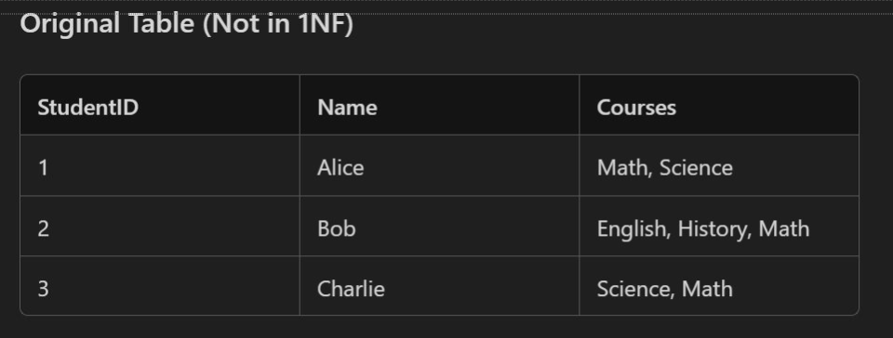
The above is an example of an unnormalized table.
The hallmark of an unnormalized table is that there is repeating information as well as multiple data points in a row. Take “Courses” for example; for Alice, it has “Math, Science” and for Bob it has “English, History, Math.” Through Normalization we will get this broken down to be more concise,”
The first step to this is to re-write this as First Normal Form (1NF).
To do this, we need to identify the Primary Key. This is the central data point that we are going to base our tables off. For this example, we will be using “StudentID.”
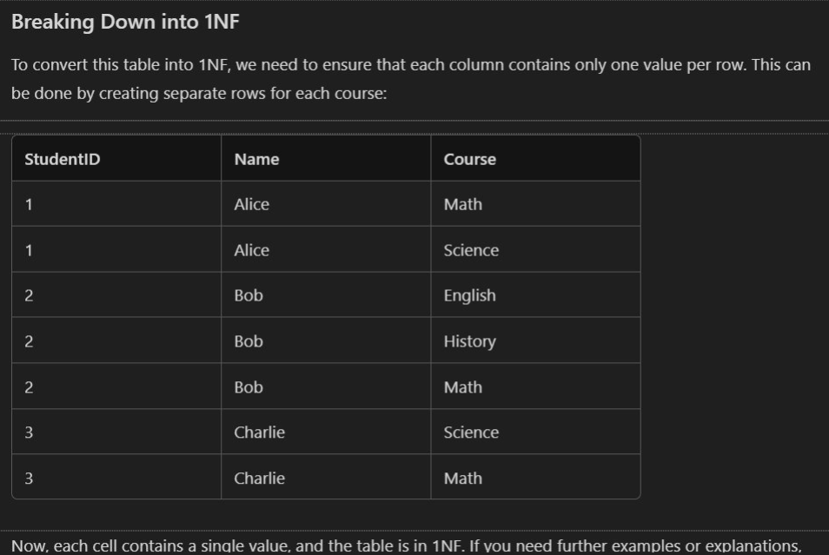
Now that we have broken the original table down to First Normal Form (1NF) we can see that there is still some repeating information, however, “Courses” has been re-named to “Course” and no longer has multiple entries per row.
However, we can still break this down further, into Second Normal Form (2NF).
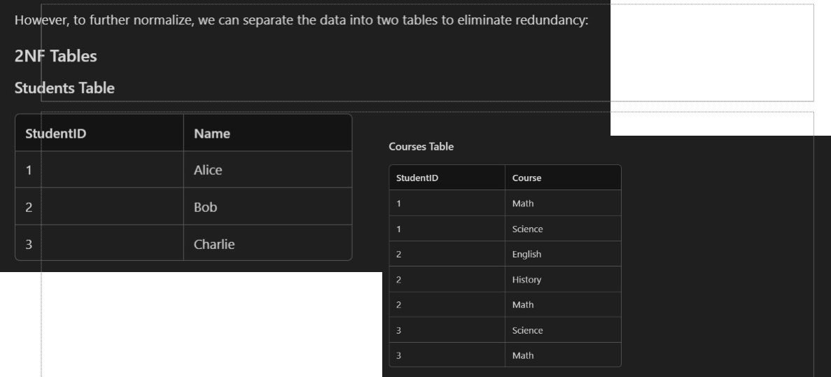

To go to Second Normal Form (2NF) we have split the table into two different tables, to reduce redundancy. Note that the “Students Table” contains unique information and the “Courses Table” lists the courses each student is enrolled in. This structure ensures that each non-key attribute is fully dependent on the Primary Key, satisfying the 2NF.
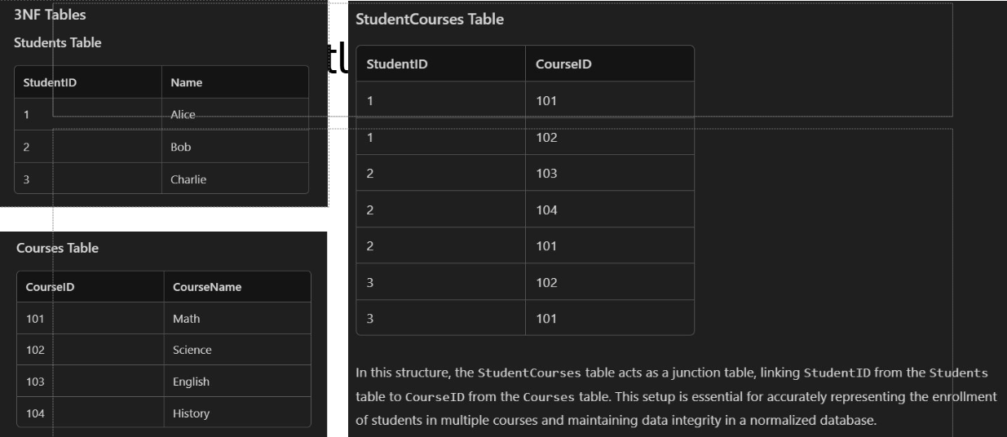
Now we have entered Third Normal Form (3NF). In this structure, the “StudentCourses Table” acts as a junction table, linking “Student ID” from “Students Table” to “CourseID” from the “Courses Table.” This setup is essential for accurately representing the enrollment of students in multiple courses and maintaining data integrity in a normalized database.

This structure is in Third Normal Form (3NF) because:
- Students Table
  - Contains only atomic values
  - Each non-key attribute (Name) I fully dependent on the Primary Key (StudentID)
- Course Table
  - Contains only atomic values.
  - Each non-key attribute (CourseName) is fully dependent on the Primary Key (CourseID)
- StudentCourses Table
  - Contains only atomic values
  - The composite Primary Key (StudentID, CourseID) ensures that each non-key attribute is fully dependent on the entire Primary Key.
  - There are no transitive dependencies, as the table only links StudentID to CourseID.

ERDs and ERMs
In the database world, Entity Relationship Modeling (ERM) and Entity Relationship Diagrams (ERD) are closely related but serve different purposes.

Entity Relationship Modeling (ERM)
In the context of Relational Database Management System (RDBMS), ERM stans for Entity Relationship Model. This model is a fundamental concept used in database design to visually represent the structure of data and the relationships between different data entities.
- Conceptual Framework: ERM is a high-level conceptual framework used to outline the entities relevant to a system and their interrelationships.
- Purpose: It focuses on the overall structure and organization of data, ensuring that all necessary components are identified before diving into specifics.
- Usage: ERM is typically utilize in the initial stages of database design to conceptualize the data structure.
Using an Entity Relationship Model (ERM) in database design offers several advantages.
- Clear Structure
  - ERM provides a clear and organized way to represent data and its relationship, making it easier to understand the database structure
- Improved Communication
  - ER diagrams server as a visual tool that helps stakeholders, including developers and business analysts, communicate effectively about the database design.
- Simplified Maintenance
  - A well-designed ERM makes it easier to maintain and update the database as changes in requirements or data structures occur.
- Enhanced Query Performance
  - Properly structure databases based on ERM can lead to optimized query performance, as relationships and data dependencies are clearly defined.
- Scalability
  - ERM facilitates the design of scalable databases that can grow and adapt to changing business needs without significant restructuring.
An ER model usually results from systematic analysis to define and describe the data created and needed by processes in a business area. Typically, it represents records of entities and events monitored and directed by business processes, rather than processes themselves. It is usually drawn in a graphical form as boxes (entities) that are connected by lined (relationships) which express the associations and dependencies between entities. It can also be expressed I a verbal form, for example: one building may be divided into zero or more apartments, but one apartment can only be located in one building.
Entities may be defined not only by relationships, but also by additional properties (attributes), which include identifiers called “primary keys”. Diagrams created to represent attributes as well as entities and relationships may be called entity-attribute-relationship diagrams, rather than entity-relationship models.
An ER model is typically implemented as a database. In a simple relational database implementation, each row of a table requests one instance of an entity type, and each field in a table represents an attribute type. In a relational database, a relationship between entities is implemented by storing the primary key of one entity as a point or “foreign key” in the table of another entity.
There is a tradition for ER/data models to be built at two or three levels of abstraction. The conceptual-logical-physical hierarchy below is used in other kinds of specification and is different from the three scheme approach to software engineering.

Entity Relationship Diagrams (ERD)
- Visual Representation: ERD is a graphical depiction of the ERM, illustrating how entities interact with one another through relationships.
- Detail Level: ERDs include specific attribute and cardinalities, providing a detailed view of the data structure
- Usage: ERDs are employed for communication and documentation purposes, helping stakeholders understand the relationship between entities.

Key Differences
- Purpose: ERM is used for conceptualizing the data structure, while ERD provides a graphical depiction of that structure.
- Detail Level: ERM outlines entities and relationships broadly, whereas ERD includes specific attributes and cardinalities.
- Usage ERM is often utilized in the initial stages of database design, while ERD is employed for communication and documentation

Components
- Entities: Primary objects or concepts within the system, such as “Customer”, “Order”, or “Product.
- Relationships: Define how entities interact with one another, classified as one-to-one, one-to-many, or many-to-many.\
- Attributes: Properties or details that describe an entity, like “Name”, “Email”, and “Pone Number” for a “Customer” entity.

Chen Notation
- Chen Notation is a way to visually represent entities and their relationships in an Entity Relationship Diagram (ERD). Named after Peter Chen, who introduced it in 1976, this notation uses specific symbols to illustrate the structures of a database.
- Key Elements of Chen Notation
  - Entities: Represented by rectangles, entities are objects or concepts that store data.
  - Attributes: Represented by ovals, attributes are properties or details about entities.
  - Relationships: Represented by diamonds, relationships show how entities are connected.
  - Primary Keys: Underlined attributes within an entity rectangle indicate primary keys.
- Chen Notation is particularly useful for conceptual database design, helping to clearly define the data structure and relationships before implementation.
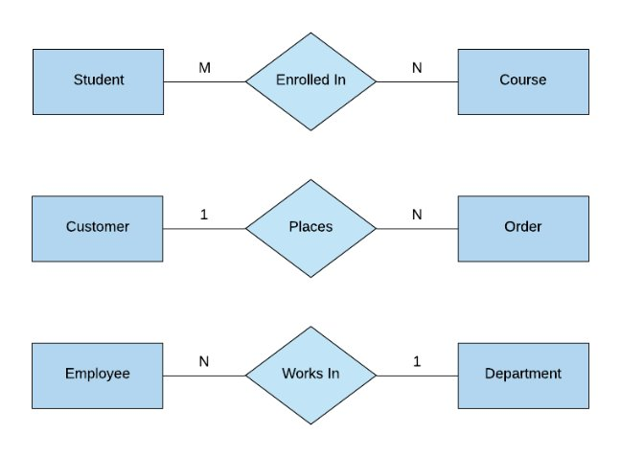

Three Types of Data Models

Conceptual Data Model
- Purpose: Provides a high-level overview of the system, focusing on the entities and their relationships without detailing attributes or keys.
- Components: Entities and relationships
- Audience: Business stakeholders and analysts
- Example: An ER diagram showing entities like Customer, Order and Product with relationships between them.

Logical Data Model
- Purpose: Adds more detail so the conceptual model by specifying attributes, primary keys, and foreign keys, but still independent of physical implementation
- Components: Entities, attributes, primary keys, foreign keys and relationships.
- Audience: Database designers and developers
- Example: An ER diagram showing Customer with attributes like CustomerID, Name and Address, Order with attributes like OrderID, OrderDate ad CustomerID

Physical Data Model
- Purpose: Translates the logical model into a physical structure, detailing how data will be stored in the database, including tables, columns, data types, indexes, and constraints.
- Components: Tables, columns, data types, indexes, constraints and relationships.
- Audience: Database administrator and developers.
- Example: A database scheme showing the Customer table with columns CustomerID (INT), Name (VARCHAR), and Address (VARCHAR) and the Order table with columns OrderID (INT) OrderDate(DATE) and CustomerID (INT)
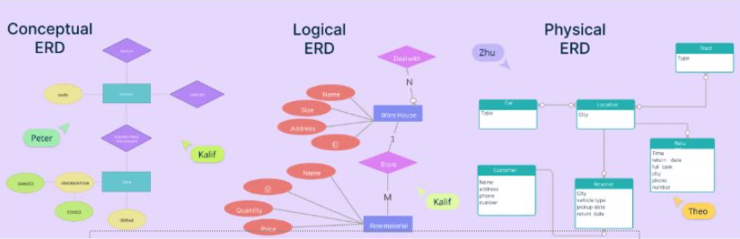

SQL
SQL or Structured Query Language, was developed in the early 1970s by IBM researches Raymond Boyce and Donald Chamberlin.
It was initially called SEQUEL (Structured English Query Language) and was designed to manage and retrieve data stored in IBM’s original relational database management system, System R.
Over time, SQL evolved and became the standard language for relational database management systems, with its first commercial implementation appearing in the late 1970s. The American Standards Institute (ANSI) adopted SQL as the standard in 1986, solidifying its role as a fundamental tool in database management and manipulation.
Today, SQL remains a critical skill for data professionals and is widely used across various industries.

SQL Statements & Execution
A SQL statement is a command used to interact with a database, performing tasks like querying, updating, and managing data.
In MySQL Workbench, you can execute these statements individually by writing them in the query editor, highlighting the specific statement you want to run, and then clicking the “Execute” button or pressing Ctrl + Enter
This method allows for precise control and testing of each command, ensuring accurate database operations.

SQL DDL
SQL DDL, or Data Definition Language, is a subset of SQL used to define and manage database structures.
It includes commands such as CREATE, ALTER, DROP and TRUNCATE, which are used to create, modify, delete and truncate database objects like tables, indexes and views.
Essentially, DDL commands help in setting up and organizing the schema of a database, ensuring that the data is stored in a structured and efficient manner.

Logical Data Model
Data Types in a logical data model:
    - VARCHAR(n) – Variable-length string
    - INT / BIGINT – Whole numbers
    - DECIMAL(p, s) – Precise decimal values
    - DATE, TIME, DATETIME
    - BOOLEAN
    - TEXT, BLOB - Large text or binary data

WEBD1000 Website Development

Web Development History

Introduction to Web Development
- What is web development?
  - The process of creating websites and web applications for the internet
  - Involves coding, designing and maintaining websites.
- Importance of Understanding History
  - Knowing the evolution of web technologies helps in appreciating current standards and trends.

The Birth of the Web (1989 – 1991)
- Tim Berners-Lee’s Vision
  - 1989: Proposed a project at CERN for a system of linked information.
  - 1990: Developed the first web browser (WorldWideWeb) and the first website (info.cern.ch
  - 1991: Public release of the World Wide Web, allowing people to create and share documents globally.

The Rise of Web Browsers (1993 – 1995)
- Mosaic (1993)
  - The first widely used web browser with a graphical interface, making the web accessible to non-technical users.
- Netscape Navigator (1994)
  - Improved user experience with faster loading times and features like cookies.
  - Become the dominant browser, sparking the “Browser Wars.”

The Browser Wars and Standards (1995 – 1998)
- Internet Explorer Vs. Netscape
  - Microsoft launched Internet Explorer in 1995, integrating it with Windows.
  - The competition le to rapid advancement but also inconsistencies in web standards.
- Formation of W3C (1994)
  - World Wide Web Consortium (W3C) established by Tim Berners-Lee to develop standardized protocols and guidelines.

The Dot-Com Boom and Bust (1997 – 2001)
- Rapid Growth
  - Late 1990s. Explosion of web Startups, e-commerce and online services.
  - Introduction of CSS (1996) for better design control and JavaScript (1995) for interactivity.
- The Dot-Com Bust (2000)
  - Overinvestment in internet companies led to a market crash, reshaping the industry towards sustainable business models.

The Modern Web (2002 – Present)
- Web 2.0 and Beyond
  - Early 2000s: Rise of dynamic content, user-generated content and social media platforms.
  - HTMLS (2014) and CSS3 (2012): Introduced new features for multimedia, responsive design and more
- Mobile Revolution
  - 2010s: Shift towards mobile-first design as smartphones and tablets become prevalent.
  - Emphasis on responsive web design, accessibility and performance optimization.

Introduction to Usability
- What is Usability?
  - Usability refers to how easy and efficient it is for users to navigate and interact with a website or application
- Importance of Usability
  - Enhances user experience, satisfaction, and accessibility.
  - Reduces errors and increases the effectiveness of the website.
- Core Components
  - Learnability, efficiency, memorability, errors and satisfaction.

Principles of Good Usability
- Understand your Users
  - Identify target audience needs and preferences.
  - Conduct user research and testing.
- Consistency
  - Maintain consistency in design, navigation and interaction across the website.
- Feedback
  - Provide users with immediate and clear feedback on their actions. (Button clicks, form submissions, etc)

Principle of Contrast
- What is Contrast?
  - Contrast is the difference in visual properties (color, brighten) that makes an object distinguishable from other objects and the background.
- Importance in Design
  - Helps draw attention to key elements.
  - Improves readability and accessibility.
- Examples
  - Text colour vs background colour (black text on white background)
  - Button colours that stand out from the page (A red “Submit” button on a white form)

Applying Contrast Effectively
- Best Practices:
  - Use sufficient contrast between test and background to ensure readability.
  - Use contrast to highlight important elements (call-to-action buttons)
  - Avoid too many contrasting elements that can lead to visual clutter
- Tools
  - Contrast check tools (WebAIM Contrast Checker) to ensure compliance with accessibility standards.

Principle of Repetition
- What is Repetition
  - Repetition involves reusing the same or similar elements throughout the design to create a sense of unity and consistency.
- Importance in Design
  - Reinforces brand identity and improves use recognition.
  - Enhances visual organization and flow
- Examples
  - Consistent use of fonts, colours and button styles across all pages.
  - Repeating logos or icons to maintain brand consistency.

Applying Repetition Effectively
- Best Practices
  - Repeat navigation menus, headers and footers on every page for a cohesive look
  - Use consistent typography and colour schemes.
  - Ensure that repeated elements maintain the same meaning and function throughout the site.

Principle of Alignment
- What is Alignment
  - Alignment refers to the placement of elements on a page in relation to each other, creating a visual connection between them
- Importance in Design
  - Creates a structured and organized layout
  - Guides the user’s eye and improves readability
- Examples
  - Text aligned to the let, center or right for clear reading paths.
  - Images and buttons aligned with text to create harmony.

Applying Alignment Effectively
- Best Practices
  - Align elements to a grid the ensure consistency across the layout
  - Use alignment to create a clear hierarchy and flow of information.
  - Avoid arbitrary or mixed alignment, which can lead to a disorganized appearance.

Principle of Proximity
- What is Proximity?
  - Proximity involves placing related elements close together to signify their connection and make the layout easier to scan.
- Importance in Design
  - Helps user quickly identify relationships between elements.
  - Reduces cognitive load by grouping similar information.
- Examples
  - Grouping form labels and input fields together
  - Placing related links or buttons near each other.

Applying Proximity Effectively
- Best Practices
  - Group related items together (Contact information, navigation links)
  - Use white space strategically to separate unrelate elements)
  - Ensure that proximity reflects the logical relationships between elements

What is Web Accessibility?
Consider out website visitors. They may have different visual, auditory, physical, speech, cognitive and/or neurological abilities.

Definition
  - Web accessibility ensures that websites, tools and technologies are designed and developed so that people with disabilities can use them.
Scope
  - Includes visual, auditory, physical, speech, cognitive and neurological disabilities.
Core Principles
  - Making the web usable for everyone, regardless of ability.

Importance of Accessibility
- Legal compliance
  - Adhering to laws such as Americans with Disabilities Act (ADA) and Web Content Accessibility Guideline (WCAG)b
- Ethical Responsibility
  - Ensuring equal access to information and services.
- Business Benefits
  - Reaching a broader audience and improving user experience for all users.
- SEO Benefits
  - Accessible websites often rank better in search engines due to clean, well-structured content.

Understanding WCAG (Web Content Accessibility Guidelines)
- Introduction to WCAG
  - WCAG provides a set of guidelines to make web content more accessible
- WCAG Principles
  - Perceivable: Information must be presented in ways that all users can perceive.
  - Operable: Interface components and navigation must be operable.
  - Understandable: Information and the operation of the interface must be understandable.
  - Robust: Content must be robust enough to be interpreted by a wide variety of user agents, including assistive technologies.

Accessible Design Components: Perceivable Content
- Text Alternatives
  - Provide text alternatives (ALT attributes) for non-text content such as images.
- Captions and Transcripts
  - Include captions for videos and transcripts for audio content.
- Colour Contrast
  - Ensure sufficient colour contrast between text and background for readability.
- Text Resizing
  - Allowing users to resize text without losing content of functionality.

Accessible Design Components: Operable Interface
- Keyboard Accessibility
  - Ensure all functionalities are accessible via keyboards (navigation, forms)
- Focus Indicators
  - Provide visible focus indicators to guide users through interactive elements.
- Navigable Content
  - Use logical and clear navigation structures, such as heading and landmark.
- Time-based Media Controls
  - Provide users with control to pause, stop or adjust time-based media.

Accessible Design Components: Understandable Content
- Clear and Simple Language
  - Write content in a clear, simple and concise manner.
- Consistent Navigation
  - Ensure navigation is consistent across pages to avoid confusion.
- Error Identification and Suggestion
  - Provide helpful error messages and suggestions for fixing errors in forms or other interactive elements.
- Readable Fonts
  - Use fonts that are easy to read and avoid overly decorative typefaces

Accessible Design Components: Robust Content
- Semantic HTML
  - Use HTML elements according to their intended purpose (<header>, <nav>, <main>
- ARIA Landmarks
  - Implement ARIA (Accessible Rich Internet Applications) roles to enhance accessibility for assistive technologies.
- Cross-Browser and Cross-Device Compatibility
  - Ensure your website functions correctly across various browsers and devices.
- Support for Assistive Technologies
  - Ensure compatibility with screen readers, magnifiers and other assistive technologies.

Tools and Resources for Testing Accessibility
- Automated Tools
  - Wave: Web Accessibility Evaluation Tool for checking accessibility issues.
  - AXE: Accessibility testing tool that integrates with browsers
  - Lighthouse: Built-in Chrome tool for auditing accessibility
- Manual Testing:
  - Keyboard navigation testing.
  - Screen reader testing using tools like NVDA or VoiceOver
- Online Resources
  - WCAD 2.1 Guidelines and tutorial available on W3C website.
  - Accessible design examples and case studies.

Planning and Designing Websites

Understanding Project Requirements
What are Project Requirements?
  - Specific goals, tasks and functionalities that a website must achieve.
Types of Requirements
  - Functional requirements: What the website should do (e.g., user login, search functionality.
  - Non-functional Requirements: How the website should perform (e.g., speed, scalability, security.)
Importance
  - Clear requirements ensure that the project meets the client’s or stakeholder’s needs and expectations

Gathering Project Requirements
Stakeholder Interviews
  - Conduct interviews with clients, users and other stakeholders to understand their needs.
User stories
  - Develop user stories to capture what different types of users need from the website
  - Example: “As a [user type], I want to [action] so that [goal]
Surveys and Research
  - Use surveys and research to gather data on user needs and market trends.

Analyzing Content Requirements
What is contact analysis?
    - The process of identifying and organizing the content that needs to be included on the website
Types of Content
    - Text: Articles, blog posts, product descriptions
    - Media: Images, videos, infographics
    - Interactive Elements: Forms, calculators, maps
Content Strategy
    - Develop a strategy for organizing and delivering content that aligns with user needs and business goals.

Designing Based on Criteria
Design Criteria
  - User Experience (UX): How easy and enjoyable it is for users to interact with the site
  - Visual Design: Aesthetic aspects like color schemes, typography and layout
  - Technical Criteria: Performance, compatibility and accessibility

Setting Priorities
  - Rank design criteria based on product goals, user needs and technical constraints.

Translating Requirements into Design
Wireframes and Mockups
    - Create wireframes to visual the structure of the website
    - Develop mockups to show the visual design and layout
Information Architecture (IA)
    - Organize content into a logical structure that’s easy for users to navigate
Navigation Design
    - Plan the navigation to ensure that users can find what they’re looking for quickly and easily

Designing for Content First
Content-First Design Approach
    - Start by understanding and organizing content before focusing on design elements
Benefits
    - Ensures that design supports content, rather than content being forced to fit the design
Practical Steps
    - Identify core content elements
    - Design layouts that prioritize and highlight important content.

Balancing Aesthetics and Functionality
Aesthetic Design
    - Focus on creating visually appealing website that align with the brand’s identity
Functional Design
    - Ensure that the website is usable, accessible and provides a seamless experience across all devices.
Achieving Balance
    - Use visual design to enhance, not overpower, functionality.
    - Test design to ensure they meet both aesthetics and functional criteria

Importance of Wireframes in Web Design
Planning and Communications
    - Provides a visual representation of the website’s structure, helping communicate ideas clearly to stakeholders.
User Experience (UX)
    - Ensures that the user journey is intuitive and efficient before moving on to a detailed design.
Cost and Time Efficiency
    - Identifies potential design issues early in the process, saving time and resources.

Wireframing Process
Step 1 – Understanding Requirements
    - Review project requirements and user needs
Step 2 – Sketching Basic Layouts
    - Start with low-fidelity sketches to outline the general layout and structure
Step 3 – Refining the Wireframe
    - Transition to high-fidelity wireframes, adding more detail and refining the layout
Step 4 – Feedback and Iterations
    - Share wireframes with stakeholders for feedback and make necessary adjustments

Key Components of a Wireframe
Navigation
    - Placement of menus, links and buttons for easy site navigation
Content Areas
    - Designated spaces for text, images, videos and other content types
Call-to-Action (CTA)
    - Highlighted buttons or links that guide users to take specific actions
Footer
    - Contains secondary navigation, contact information and other utilities.

Tools for Wireframing
Popular Wireframing Tools
    - Balsamiq: Known for its simplicity and low-fidelity wireframes
    - Figma: Offers both wireframing and design capabilities with collaborative features
    - Adobe XD: Provides high-fidelity wireframing and prototyping
    - Sketch: Favored for high-fidelity designs and a wide range of plugins
Choosing the Right Tool
    - Consider the complexity of the project, team collaboration needs, and integration with other design tools

Creating Web Structure Diagram
What are Web Structure Diagrams
    - Visual representations of the website’s information architecture, showing how pages and organized and linked together
Purpose
    - Helps in planning the overall structure of the website, ensuring logical flow and easy navigation
Types of Diagrams
    - Site Map: High-level overview showing the main pages and their relationships
    - Flowchart: Detailed diagram showing the user’s journey through different pages

Steps to Create a Web Structure Diagram
Step 1: Identify Key Pages
    - Determine the main pages of the website, such as Home, About, Services and Contact
Step 2: Define Page Hierarchy
    - Organize pages into a hierarchical structure, showing parent-child relationships
Step 3: Map Out Navigation Paths
    - Illustrate how users will navigate between pages, ensuring logical and intuitive flow
Step 4: Review and Refine
    - Collaborate with stakeholder to review the structure and make necessary adjustments.

Best Practices or Wireframing and Structure Diagrams
Keep it Simple
    - Focus on layout and functionality, avoiding distractions from design details
User-Centered Design
    - Always consider the user’s needs and how they will interact with the site
Iterate Based on Feedback
    - Regularly review and update wireframes and diagrams based on user testing and stakeholder feedback
Consistency
    - Maintain consistency in layout, navigation, and interaction patterns across the site.

HTML

Understanding HTML Tags an Attributes
  - HTML Tags
    - Tags define the structure and content of the web page.
    - Common tags: <h1> to <h6> for headings. <p> for paragraphs. <div> for divisions, and <span> for inline elements
  - Attributes
    - Provide additional information about an element (e.g, class, id, style)
    - Example: <img src=”image.jpg” alt=”A description of the image”>
  - Self-closing Tags
    - Tags that don’t have a closing part (e.g., <img/>, >br />

Introduction to Semantic HTML Tags
  - What are semantic Tags?
    - Semantic tags clearly describe their meaning both to the browser and the developer
  - Importance
    - Improves code readability and accessibility
    - Helps search engines and assistive technologies understand the content structure
  - Common Semantic Tags
    - <header>: Represents the header of a document or section
    - <nav>: Defines navigation block
    - <main>: Represents the main content of the document
    - <article>: Defines an independent, self-contained content
    - <footer>: Represents the footer of a document or section

Understanding URLS
- What is a URL?
  - URL stands for Uniform Resource Locator, which is the address used to access resources on the web
- Components of a URL
  - Scheme – The protocol (e.g. http, https)
  - Host – The domain name (e.g, www.example.com)
  - Path - The specific resource on the server (e.g., /about.html)
  - Query String – Optional parameters for data (e.g., ?id=123).
- Example
  - https://www.example.com/about.html?id-123

Creating Hyperlinks with HTML
- What is a Hyperlink?
  - A hyperlink is an element in HTML that allows users to click and navigate to another page or resource.
- Basic Syntax
  - Use the <a> (anchor) tag to create hyperlinks.
  - Example
    - <a href=”https://www.example.com”> Visit Example </a?
- Attributes
  - href: Specifies the destination URL
  - target: Defines where to open the linked document (e.g., _blank opens a new tab).

Absolute Vs. Relative URLS
- Absolute URLS
  - Includes the full path to the resource, starting from the protocol (e.g., https://www.example.com/page.html)
  - Use case: Linking to externa sites or resources
- Relative URLS
  - Path relative to the current document (e.g., about.html, ../images/photo.jpg)
  - Use case: Linking to internal pages within the same website.
- Example Comparisons
  - Absolute:
    - <a href=”https://www.example.com/contact.html”>Contact us</a
  - Relative:
    - <a href=”contact.html”>contact us</a?

Adding Images to Web Pages
- Basic Syntax
  - Use the <img> tag to include images to HTML
  - Example
    - <img src=”images/logo.png” alt=”Company logo”>
- Attributes
  - src: Specifies the path to the image file
  - alt: Provides alternative text for accessibility and SEO
  - width and height: Specify the dimensions of the image.
- Best Practices
  - Always include the alt attribute for better accessibility.
  - Optimize images for web to reduce load times.

Using Special Characters in HTML
- What are Special Characters?
  - Special characters are symbols that have specific meaning sin HTML (e.g., <, >, &) and must be encoded to be displayed correctly.
- Common Special Characters
  - &lt – For < (less than sign)
  - &gt – For > (greater than sign)
  - &amp – For & (ampersand)
  - &copy – For copyright symbol
- Example Usage
  - Displaying code:
    - &lt; div&t Hello Worldd&lt;/div&gt
  - Special symbols
    - &copy; 2024 My Website

Introduction to CSS (Cascading Style Sheets)
- What is CSS?
  - CSS is used to style and layout webpages including changing colours, fonts and spacing.
- CSS Syntax
  - Selector: Defines which HTML elements the styles apply to.
  - Property: The style attribute you want to change
  - Value: The specific setting for the property

Responsive Web Design

What is Responsive Web Design?
  - Definition – Responsive Web Design (RWD) is an approach to web design that ensures websites look good and function well on devices of all sizes, from desktop to mobile phones
  - Key Characteristics - Flexible layouts that adapt to different screen sizes.
  - Goal – To provide an optimal user experience across a wide range of devices

Why Responsive Design is Important.
  - User Experience
    - Ensures that users have a seamless experience
    - Reduces the need for zooming, panning and scrolling
  - SEO Benefits
    - Google favors mobile-friendly websites, improving search rankings.
  - Cost Efficiency
    - A single responsive website reduces the need for separate mobile and desktop versions
  - Accessibility
    - Makes content accessible to a broader audience including those using assistive technologies.

Introduction to Media Queries

What are Media Queries?
  - CSS technique used to apply styles base on the characteristics of the user’s device, such as screen with, height and orientation.
  - Basic Syntax
    - Example:
@media (max-width: 768pcs)
{
Body
{
Font-size: 14px;
}
}
  - Breakpoints
    - Specific screen widths where the layout of the website changes.
      - Example breakpoints; 320px, 768px, 1024px
  - Usage
    - Apply different styles for mobile, tablet and desktop views.

Creating Fluid Layouts
What are Fluid Layouts?
  - Layouts that use percentage-based widths rather than fixe pixel sizes, allowing elements to resize relative to the screen size.
Benefits
  - More flexible than fixe layouts.
  - Automatically adapts to different screen sizes without the need for horizontal scrolling.

Example of a Fluid Layout:
.container
{
width: 80%;
margin: 0 auto;
}

Img
{
max-width: 100%;
height: auto;
}

Practical Tips:
  - Use percentage-based widths for containers.
  - Ensure images and videos are responsive by setting max-width to 100%

Using Media Queries for Responsive Design
You can target difference devices based on the sizes
@media (min-width: 1200px)
{
.container
{
width: 1170px;
}
}

@media (max-width: 768px)
{
.container
{
width: 100%
padding: 0 15px;
}
}

Common Breakpoints;
  - Mobile: max-width 480px
  - Tablet: 481px – 768px
  - Desktop: 769px and above

Responsive Images and Media
Making Images Responsive:
  - Use the max-width: 100%; property to ensure images resize within their containers.
Img
{
max-width: 100%
height: auto
}

Wrap videos in a container and use padding techniques to maintain aspect ratios
  - Example
.video-container
{
position: relative;
padding-bottom: 56.25%; /* 16:9 aspect ratio */
height: 0;
overflow: hidden;
}

.video-container video
{
position: absolute;
top: 0;
left: 0;
width: 100%;
height: 100%;
}

    - The .video-container div is given a padding-bottom of 56.25%, which corresponds to a 16:9 aspect ration (you can adjust this value for different aspect ratios). The height is set to 0 to ensure the padding creates the height. The video element inside the container is positioned absolutely to fill the container

Fluid Typography
- What is Fluid Typography
  - Adjust font sizes relative to the viewport width to ensure readability on all devices
- Using vw Units
  - Vw (viewport width) units allow text to scale based of the width of the viewport
- Example
h1
{
font-size: 5vw;
}

Responsive Font Sizing
You can combine vw unites with media queries for more control
@media (max-width: 768px)
{
h1
{
font-size: 6vw;
}
}

@media (min-width: 769px)
{
h1
{
font-size: 3vw;
}
}

Practical Example: Building a Responsive Layout
Creating a simple responsive web page with a fluid layout and media queries.

HTML
<div class=”container”>
<header>
<h1>Responsive Design</h1>
</header>
<section>
<p>This layout adjusts to different screen sizes.</p>
</section>
</div>

CSS
.container
{
width: 80%;
margin: 0 auto;
}

@media (max-width: 768px)
{
.container
{
width: 100%;
padding: 0 10px;
}
}

Introduction to Flexbox
What is Flexbox? Flexbox is a one-dimensional layout method that allows you to distribute space along a single axis (horizontal or vertical). It is ideal for creating flexible, responsive layouts.
- Flex Container
  - The parent element where Flexbox is applied.
- Flex Items
  - The child elements inside the flex container
- Main Axis
  - The primary axis along which the flex items are laid out
- Cross Axis
  - The axis perpendicular to the main axis.
Basic Structure
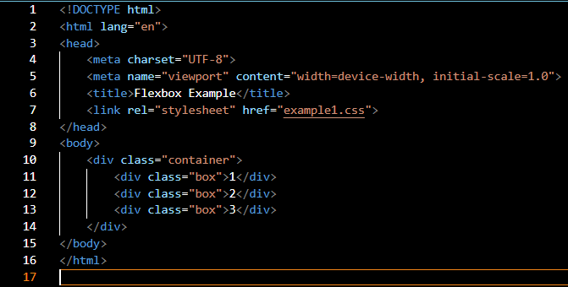
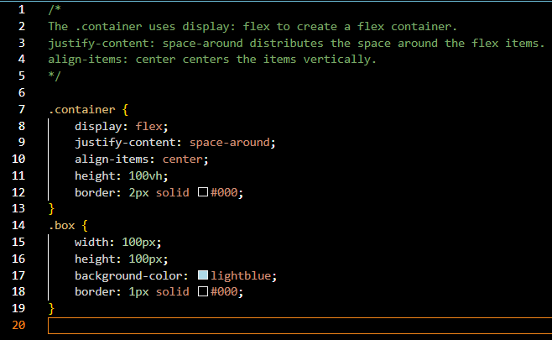

Creating Layout with Flexbox
- Use justify-content to align items along the main axis
- Use align-items to align items along the cross axis.
- Use flex-grow, flex-shrink, and flex-basis to control how items grow, shrink or maintain a base size.

Using Float for Layouts
What is Float? The float property is used to wrap text around an image or to create simple layouts.
How does it work? Elements can be “floated” to the let or right, allowing text or other elements to flow around them.

Frameworks

Summaries

PROG1700 Logic and Programming

NETW1027 Introduction to Networking and Security

Networking Summary 1.0
- Through the use of networks, we are connected link never before.
- All computers that are connected to a network and participate directly in network communications are classified as hosts.
- Diagrams of networks often use symbols to represent the different devices and connections that make up a network.
- A diagram provides an easy way to understand how devices connect in a large network.
- The two types of network infrastructure are Local Area Network (LANs) and Wide Area Networks (WANs).
- SOHO (Small Office, Home Office) internet connections include cable, cellular, satellite, and dial-up telephone.
- Business internet connections include Dedicated Leased Line, Metro Ethernet, Business DSL and Satellite.
- Network architecture refers to the technologies that support the infrastructure and the programme services and rules, or protocols, that move data across the network.
- There are four basic characteristics of network architecture: Fault tolerance, Scalability, Quality of Service (QoS) and Security.
- Recent networking trends that affect organizations and consumers: Bring Your Own Device (BYOD), online collaboration, video communications and cloud computing.
- There are several common external and internal threats to networks.
- Larger networks and corporate networks use antivirus, antispyware and firewall filtering, but they also have other security requirements: Dedicated firewall systems, Access control lists (ACL), Intrusion Prevention System (IPS), and Virtual Private Network (VPN)
- The Cisco Certified Network Associate (CCNA) certification demonstrates your knowledge of foundational technologies.

Networking Summary 2.0
- All end devices and network device require an operating system (OS)
- Cisco IOS software separates management access into the following two command modes: User EXEC Mode and Privilege EXEC Mode.
- Global configurations mode is access before other specific configuration modes. Rom global config mode, the user can enter different sub-configuration modes.
- Each IOS command has a specific format or syntax and can only be executed in the appropriate mode.
- Basic device configurations: hostname, password, encrypt passwords and banner.
- There are two system files that store the device configurations: startup-config and running-config
- IP addresses enable devices to locate one another and establish end-to-end communication on the internet. Each end device on a network must be configured with an IP address.

Networking Summary 3.0
- Rules
  - Protocols must have a sender and a receiver
  - Common computer protocol include these requirements: message encoding, formatting and encapsulation, size, timing, and delivery options.
- Protocols
  - To send a message across the network requires the use o several protocols
  - Each network protocol has its own functions, format and rules for communications.
- Protocol Suites
  - A protocol suite is a group of inter-related protocols.
  - TCP/IP protocol suites are protocols use today.
- Standards Organizations
  - Open standards encourage interoperability, competition and innovation.
- Reference models
  - The two models used in networking are the TCP/IP and the OSI model.
  - The TCP/IP model has 4 Layers and the OSI model has 7 Layers
    - TCP/IP
      - Application
      - Transport
      - Internet
      - Network Access
    - OSI
      - Application
      - Presentation
      - Session
      - Transport
      - Network
      - Data Link
      - Physical
- Data Encapsulation
  - The form that a piece of data takes at any layer is called a protocol data unit (PDU).
  - There are five different PDUs used in the data encapsulation process: data, segment, packet, frame, and bits.
- Data Access
  - The Network and Data Link Layers are going to provide addressing to move data through the network
  - Layer 3 will provide IP addressing and Layer 2 will provide MAC addressing
  - The way these layers handle addressing will depend on whether the source and the destination are on the same network or if the destination is on a different network from the source.

Networking Summary 4.0
- Before any network communications can occur, a physical connection to a local network, either wired or wireless, must be established.
- The Physical Layer consists of electronic circuitry, media and connectors developed by engineers.
- The Physical Layer standards address three function areas: physical components, encoding, and signaling.
- Three types of copper cabling are: UTP, STP, and coaxial cable (coax)
- UTP cabling conforms to the standards established jointly by the TIA/EIA. The electrical characteristics of copper cabling are defined by the Institute of Electrical and Electronics Engineers (IEEE)
- The main cable types that are obtained by using specific wiring conventions are Ethernet Straight-through and Ethernet Crossover
- Optical fiber cable transmits data over longer distances and at higher bandwidths than any other networking media.
- There are four topes of fiber-optic connectors: ST, SC, LC and Duplex Multimode LC.
- Fiber-optic patch cords include SC-SC multimode, LC-LC single-mode, ST-LC multimode, and SC-ST single-mode
- Wireless media carry electromagnetic signals that represent the binary digits of data communications using radio or microwave frequencies. Wireless does have some limitations, including coverage area, interference, security, and the problems that occur with any shared media.
- Wireless stands include the following: Wi-Fi (IEEE 802.11), Bluetooth (IEEE 802.15), WiMax (IEEE 802.16) and Zigbee (IEEE 802.15.4)
- Wireless LAN (WLAN)b requires a wireless AP and wireless NIC adapters.

Number System Summary
- Binary is a base two numbering system that consists of the numbers 0 and 1, called bits.
- Decimal is a base ten numbering system that consists of the numbers 0 through 9
- Binary is what hosts, servers and networking equipment use to identify each other
- Hexadecimal is a base sixteen (16) numbering system that consists of the numbers 0 through 9 and the letters A to
- Hexadecimal is used to represent IPv6 address and MAC addresses.
- IPv6 addresses are 128 bits long and every 4 bits is represented by a hexadecimal digit or a total of 32 hexadecimal digits.
- To convert hexadecimal to decimal, you must first convert the hexadecimal to binary, then convert the binary to decimal.
- To convert decimal to hexadecimal, you must first convert the decimal to binary and then the binary to hexadecimal.

Data Link Layer Summary
- The data link layer of the OSI Model (Layer 2) prepares network data for the physical network
- The data link layer is responsible for network interface card (NIC) to network interface card (NIC) communications.
- The IEEE 802 LAN/MAN data link layer consists of the following two sublayers: LLC and MAC.
- The two types topologies used in LAN and WAN networks are physical and logical.
- Three common types of physical WAN topologies are: Point-To-Point, hub and spoke and mesh.
- Half-duplex communications exchange data in one direction at a time. Full-duplex sends and receives data simultaneously.
- In contention-based multi-access networks, all nodes are operating in half-duplex.
- The examples of contention-based access methods include: CSMA/CD for buss-topology Ethernet LANs and CSMA/CA for WLANS.
- The data link frame has three basic parts: header, data and trailer.
- The frame fields include: frame start and stop indicator flags, addressing, type, control, data, and error detection.
- Data link addresses are also know as physical addresses
- Data link address are only used for link local delivery frames.

Ethernet Switching Summary
- Ethernet operates in the data link layer and the physical layer
- It is a family of networking technologies defined in the IEEE 802.2 and 802.3 standards.
- The 802 LAN/MAN standards, including Ethernet, use two separate sublayers of the data link layer to operate:
  - LLC Sublayer: (IEEE 802.2) Places information in the frame to identify which network layer protocol is used for the frame.
  - MAC Sublayer: (IEEE 802.2 802.11 or 802.15) Responsible for data encapsulation and media access control, and provides a data link layer addressing.
- The MAC sublayer is responsible for data encapsulation and accessing the media.
- IEEE 802.3 data encapsulation includes the following:
  - Ethernet frame – This is the internal structure of the Ethernet frame.
  - Ethernet addressing – The Ethernet frame includes both a source and destination MAC address to deliver the Ethernet frame from Ethernet NIC to Ethernet NIC on the same LAN
  - Ethernet error detection – The Ethernet frame includes a frame check sequence (FCS) trailer use for error detection.
- The IEEE 802.3 MAC sublayer includes the specifications for different Ethernet communication standards over various types of media, including copper an fiber.
- Legacy Ethernet using a bus topology or hubs is a shared, half-duplex medium uses a contention-base access method, carrier sense multiple access/collision detection (CSMA/CD).
- Ethernet LANs of today use switches that operate in full-duplex. Full-duplex communications with Ethernet switches do not require access control through CSMA/CD.
- The minimum Ethernet frame size is 64 bytes and the maximum is 1518 bytes The preamble field is not included when describing the size of the frame.
- Any frame less than 64 bytes in length is considered a “collision fragment” or “runt frame” and is automatically discarded. Frame with more than 1500 bytes of data are considered “jumbo” or “baby giant frames”.
- If the size of a transmitted frame is less than the minimum, or greater than the maximum, the receiving device drops the frame. Dropped frames are likely to be the result of collisions or other unwanted signals. They are considered invalid. Jumbo frames are usually supported by most Fast Ethernet and Gigabit Ethernet switches and NICS.
- An Ethernet MAC address consists of a 48-bit binary value, expressed using 12 hexadecimal values.
- Given that 8 bits (one byte) is a common binary grouping, binary 00000000 to 11111111 can be represented in hexadecimal as the range 00 to FF.
- When using hexadecimal, leading zeroes are always displayed to complete the 8-bit representation. For example the binary value 0000 1010 is represented in hexadecimal as 0A.
- Hexadecimal numbers are often represented by the value preceded by 0x (e.g., 0x73) to distinguish between decimal and hexadecimal values in documentation.
- Hexadecimal may also be represented by a subscript 16, or a hex number followed by an H (e.g., 73H)
- In Ethernet LAN, every network device is connected to the same, shared media. MAC addressing provides a method for device identification at the data link layer of the OSI model.
- An Ethernet MAC address is a 48-bit address expressed using 12 hexadecimal digits. Because a byte equals 8 bits, we can also say that a MAC address is 6 bytes in length.
- All AMC addresses must be unique to the Ethernet device or Ethernet interface. TO ensure that, all vendors that sell Ethernet devices must register with the IEEE to obtain a unique 6 hexadecimal (i.e., 24-bit or 3-byte) code called the organizationally unique identifier (OUI).
- An Ethernet MAC address consists of a 6-hexadecimal vendor OUI code followed by a 6-hexadecimal vendor-assigned value.
- When a device is forwarding a message to an Ethernet network, the Ethernet header include a Source MAC address and a Destination MAC address.
- When a NIC receives an Ethernet frame, it examines the destination MAC address to see if it matches the physical MAC address that is stored in RAM. If there is no match the device discards the frame If there is a match it passes the frame up the OSI layers, where the de-encapsulation process takes place.
- Any device that is the source or destination of an Ethernet frame, will have an Ethernet NIC and therefore, a MAC address. This includes workstations, servers, printers, mobile devices an routers.
- A unicast MAC address is the unique address that is used when a frame is sent from a single transmitting device to a single destination device.
- The process that a source host uses to determine the destination MAC address associate with an IPv4 address is known as Address Resolution Protocol (ARP). The process that a source host uses to determine the destination MAC address associated with an IPv6 address is known as Neighbor Discovery (ND)
- An Ethernet broadcast frame is received and processed by every device on the Ethernet LAN. The features of an Ethernet broadcast are as follows:
  - It has a destination MAC address of FF-FF-FF-FF-FF-FF in hexadecimal (48 ones in binary)
  - It is flooded out all Ethernet switch ports except the incoming port. It is not forwarded by a router.
  - If the encapsulated data is in IPv4 broadcast packet, this means the packet contains a destination IPv4 address that has all ones (1s) in the host portion. This numbering in the address means that all hosts on the local network (broadcast domain) will receive and process the packet.
- AN Ethernet multicast frame is received and processed by a group of devices that belong to the same multicast group
  - There is a destination MAC address of01-00-5E when the encapsulated data is an IPv4 multicast packet and a destination MAC address of 33-33 when the encapsulated data is an IPv6 multicast packet.
  - There are other reserved multicast destination MAC addresses or when the encapsulated data is not IP, such as Spanning Tree Protocol (STP).
  - It is flooded out all Ethernet switch ports except the incoming port, unless the switch is configured for multicast snooping IT is not forwarded by a router, unless the router is configured to route multicast packets.
  - Because multicast addresses represent a group of addresses (sometimes called a host group), they can only be use as the destination of a packet the source will always be a unicast address.
  - As with the unicast ad broadcast addresses, the multicast IP address requires a corresponding multicast MAC address.
- A Layer 2 Ethernet switch uses Layer 2 MAC addresses to make forwarding decisions. It is completely unaware of the data (protocol) being carried in the data portion of the frame, such as an IPv4 packet, an ARP message, or an IPv6 ND packet. The switch makes its forwarding decisions based solely on the Layer 2 Ethernet MAC addresses.
- An Ethernet switch examines its MAC address table to make forwarding decision for each frame, unlike legacy Ethernet hubs that repeat bits out all ports except the incoming port.
- When a switch is turned on, the MAC address is empty.
- Every frame that enters a switch is checked for new information. It does this by examining the source MAC address o the frame and the port number where the frame entered the switch. IF the source MAC address does not exist, it is added to the table along with the incoming port number. If the source MAC address does exist, the switch updates the refresh timer for that entry. By default, most Ethernet switches keep an entry in the table for 5 minutes.
- If the destination MAC address is a unicast address, the switch will look for a match between the destination MAC address of the frame and an entry in its MAC address table. If the destination MAC address is in the table, it will forward the frame out the specified port. IF the destination MAC address is not in the table, the switch will forward the frame out all ports except the incoming port. This is called unknown unicast.
- As a switch receives frames from different devices, it can populate its MAC address table by examining the source MAC address of every frame. When the MAC address table of the switch contains the destination MAC address , it can filter the frame and forward out a single port
- Store-and-forward switching – This frame forwarding method receives the entire frame and computes the CRC. If the CRC is valid, the switch looks up the destination address, which determines the outgoing interface. Then the frame is forwarded out of the correct port.
  - An advantage to store-and forward switching is that it determines if a frame has errors before propagating the frame. When an error is detected in a frame, the switch discards the frame. Discarding frames with errors reduces the amount of bandwidth consumed by corrupt data.
  - Store-and-forward switching is required for quality of service (QoS) analysis on converged networks where frame classification for traffic prioritization is necessary. For example; voice over IP (VoIP) data streams need to have priority over web-browsing traffic.
- Cut through switching – This frame forwarding method forwards the frame before it is entirely received. At a minimum, the destination address of the frame must be read before the frame can be forwarded.
  - In cut-through witching, the switch acts upon the data as soon as it is received, even if the transmission is not complete. The switch buffers just enough of the frame to read the destination MAC address so that it can determine to which port it should forward out the data. The switch does not perform any error checking on the frame.
  - There are two variants of cut-through switching:
    - Fast-forward switching – Offers the lowest level of latency by immediately forwarding a packet after reading the destination address. Because fast-forward switching starts forwarding before the entire packet has been received, there may be times when packets are relayed with errors. The destination NIC discards the faulty packet upon receipt. Fast-forward switching is the typical cut-through method of switching.
    - Fragment-free switching – A compromise between the high latency and high integrity of store-and-forward switching and the low latency and reduced integrity of fast-forward switching, the switch stores and performs an error check on the first 64 bytes of the frame before forwarding. Because most network errors and collisions occur during the first 64 bytes, this ensures that a collision has not occurred before forwarding the frame.
- An Ethernet switch may use a buffering technique to store frames before forwarding them or when the destination port is busy because of congestion.
  - Port-based memory
    - Frames are stored in queues that are linked to specific incoming and outgoing ports.
    - A frame is transmitted to the outgoing port only when all the frames ahead in the queue have been successfully transmitted.
    - It is possible for a single frae to delay the transmission of all frames in memory because of a busy destination port.
    - It is possible for a single frame to delay the transmission of all the frames I memory because of a busy destination port.
    - This delay occurs even if the other frames could be transmitted to open destination ports.
  - Shared memory
    - Deposits all frames into a common memory buffer shared by all switch ports and the amount of buffer memory required by a port is dynamically allocated.
    - The frames in the buffer are dynamically linked to destination port enabling a packet to be receive on one port and then transmitted on another port, without moving it to a different queue.
- Shared memory buffering also results in larger frames that can be transmitted with fewer dropped frames. This is important with asymmetric switching which allows or different data rates on different ports. Therefore, more bandwidths can be dedicated to certain ports (e.g., server ports.)
- There are two types of duplex settings used for communications on Ethernet network
  - Full duplex – Both ends of the connection can send and receive simultaneously.
  - Half-duplex – only one end of the connection can send at a time.
- Autonegotiation is an optional function found on most Ethernet switches and NICs. It enables two devices to automatically negotiate the best speed and duplex capabilities.
- Duplex mismatch is one of the most common causes of performance issues on 10/100 Mbps Ethernet links. It occurs when one port on the link operates at half-duplex while the other port operates at full duplex.
- This can occur when one or both ports on a link are reset, and the autonegotiation process does not result in both link partners having the same configuration.
- It also can occur when users reconfigure one side of a link and forget to reconfigure the other. Both sides of a link should have autonegotiation on, or both sides should have it off. Best practice is to configure both Ethernet switch ports as full-duplex.
- Most switching now support the automatic medium-dependant interface crossover (auto-MDIX) feature. When enabled, the switch automatically detects the type of cable attached to the port and configures the interfaces accordingly.
- The auto-MDIX feature is enabled by default on switches running Cisco IOS Release 12.2.(18) SE or later. However, the feature could be disabled.

Network Layer Summary
- Best Effort – Delivery method that does not guarantee that the packet will be delivered fully without errors.
- Fragmentation – Term for splitting up an IP packet when forwarding it from one medium to another medium with a smaller Maximum Transmission Unit (MTU)
- Data Link Layer – Layer responsible for taking an IP packet ad preparing it for transmission over the communications medium.
- Transport Layer – OSI layer that sends segments to be encapsulated in an IPv4 or IPv6 packet.
- Destination IP address and Source IP address – Are the two most commonly referenced fields in an IPv4 packet header that indicate where the packet is coming from and where it is going.
- Regarding IPv4 packet header fields – The source and destination IPv4 addresses remain the same while travelling from source to destination.
- Header Checksum – Is the field used to detect corruption in the IPv4 header.
- Protocol – The field includes common values such as ICMP (1), TCP (6), and UDP (17).
- IP address depletion, Increased network complexity and internet routing table expansion, lack of end-to-end connectivity – These are the three major issues associate with IPv4.
- Increased the IP address space and it uses a simpler header to provide improved packet handling – These are improvements provided by IPv6 compared to IPv4
- IPv6 headers consist of 40 octets an contains 8 header fields.
- The Hop Limit field replaces the IPv4 Time to Live field.
- Local hosts can reach each other without the need of router.
- The default gateway address is the IP address of the router on the local network.
- Netstat -r and route print – Commands that can be entered on a Windows host to view its IPv4 and IPv6 table.
- It is true that a router can be configured with a combination o both static routes and a dynamic routing protocol.
- An “O” next to a route in a routing table indicates that the route learned dynamically from OSPF
- Static routes are manually configured
- Default route is known as a “gateway of last resort.”
- Show ip route used on a Cisco IOS router will show the routing table.

Address Resolution Summary
- There are two primary addresses assigned to a device on an Ethernet LAN: Layer 2 physical address (the MAC address) and Layer 3 logical address (the IP address).
- ARP (Address Resolution Protocol) provides to basic functions: Resolving IPv4 addresses to MAC addresses and maintaining an ARP table of IPv4 to MAC address mappings.
- To send a frame, a device will search its ARP (Address Resolution Protocol) table for a destination IPv4 address and a corresponding MAC address
  - If the packet’s destination IPv4 address is on the same network, the device will search the ARP (Address Resolution Protocol) table for the destination IPv4 address
  - If the destination IPv4 address is on a different network, the device will search the ARP (Address Resolution Protocol) table for the IPv4 address o the default gateway.
  - If the device locates the IPv4 address, its corresponding MAC address is used as the destination MAC address in the frame.
  - If there is no ARP (Address Resolution Protocol) table entry found, then the device sends an ARP request.
- Entries in the ARP (Address Resolution Protocol) table are not permanent and are removed when an ARP cache timer expires.
- The duration of the ARP (Address Resolution Protocol) cache timer differs depending on the operating system.
- ARP (Address Resolution Protocol) tables entries can also be removed manually by the administrator.
- The show ip arp command displays the ARP table on a Cisco router.
- The arp -a command displays the ARP table on a Windows PC.
- ARP (Address Resolution Protocol) requests are received and processed by every device on the local network.
- Excessive ARP (Address Resolution Protocol) broadcasts can cause some reduction in performance.
- ARP (Address Resolution Protocol) replies can be spoofed by a threat actor to perform an ARP poisoning attack.
- Enterprise level switches include mitigation techniques to protect against ARP attacks.
- IPV6 Neighbor Discovery (ND) protocol provides:
  - Address resolution
  - Router discovery
  - Redirection services
  - ICMPv6 Router Solicitation (RS) and Router Advertisement (RA) messages are used for messaging between devices and routers for router discovery.
  - ICMPv6 redirect messages are used by routers for better next-hop selection.
- IPv6 devices use ND (Neighbor Discovery) to resolve the MAC address of a known IPv6 address.
- ICMPv6 Neighbor Solicitation messages are sent using special Ethernet and IPv6 multicast addresses.
- Layer 2 physical addresses are used to delivery the data link frame with the encapsulated IP packet from one NIC to another NIC on the same network.
- If the destination IP address is on the same network, the destination MAC address will be that of the destination device.
- When the destination IP address (IPv4 or IPv6) is on a remote network, the destination MAC address will be the address o the host default gateway
- An IPv4 device uses ARP to determine the destination MAC address of a loal device when it knows its OPv4 address.

Basic Router Configuration Summary
- These tasks should be completed with configuring initial settings on a router
  - Configure the device name
    - (config)#Hostname <hostname>
  - Secure privileged EXEC mode
    - (config)#Enable secret <password>
  - Secure user EXEC mode
    - (config)#Line console 0
    - (config)#Password <password>
    - (config)#login
  - Secure remote Telnet/SSH access
    - (config-line)#Line vty 0 4
    - (config-line)#Password <password>
    - (config-line)#Login
    - (config-line)#Transport input { ssh | telnet }
  - Secure all passwords in the config file.
    - (config)#Service password-encryption
  - Provide legal notification
    - (config)#Banner motd <message>
  - Save the configuration
    - Router# copy running-config startup-config
- For routers to be reachable, the router interfaces must be configured
  - Using the no shutdown command activates the interface. The interface must also be connected to another device, such as a switch or a router, for the physical layer to be active. There are several commands that can be used to verify interface configuration:
    - show ip interface brief
    - show ipv6 interface brief
    - show ip route
    - show ipv6 route
    - show interfaces
    - show ip interface
    - show ipv6 interface
- For an end device to reach other networks, a default gateway must be configured.
  - The IP address of the host device and the router interface address must be in the same network
- A switch must have a default gateway address configured to remotely manage the switch fro another network.
  - To configure an IPv4 default gateway on a switch, use the ip default-gateway ip-address global configuration command.

OSYS1200 Introduction to Windows Administration

DBAS1007 Data Fundamentals

WEBD1000 Website Development

Glossary

PROG1700 Logic and Programming

NETW1027 Introduction to Networking and Security

OSYS1200 Introduction to Windows Administration

DBAS1007 Data Fundamentals

WEBD1000 Website Development

